Valor Sales & Marketing, Incorporated
DBA: Valor Packaging, Inc. (DBA has been filed)
Website: www.valorpackaginginc.com
Logo Samples
The color scheme desired would be vibrant and stands out instantly. Example colors such as tones of Green, Blue, Brown, & Orange, but open to other color scheme options. A multi-color logo with a 3-dimensional look would be ideal. The goal is to use a box/carton as part of the logo. I would like your expertise and recommendation on logos you think will do well.
Sample of Packaging logos that stood out immediately:
- Priority Press – Look of logo and color scheme is appealing.
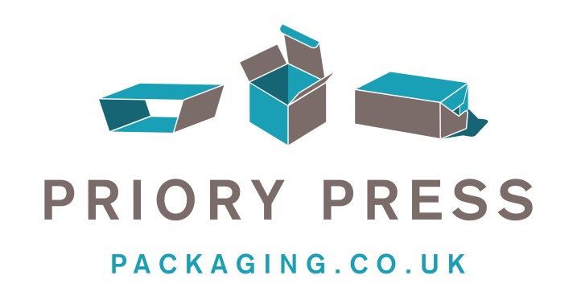
- Eco Box Green Glass – Color scheme is attractive and logo. I like the way the colors on logo overlap giving it a 3-dimentional look. Colors are appealing as well.

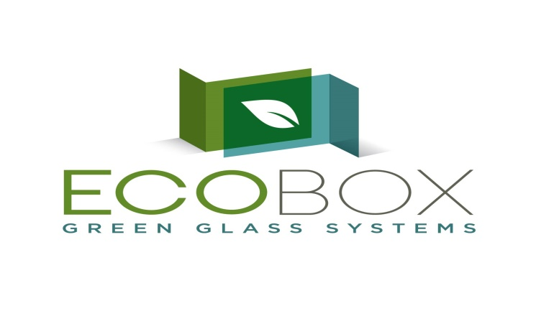
- PrintAPack – Color scheme is appealing as it is multi-colored which stood out instantly. Logo is okay.
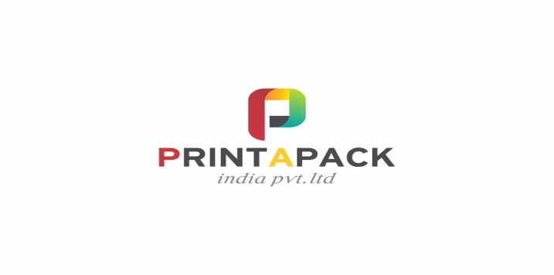
- Mc Nairn Packaging – For some reason, this logo stood out. Black would not be my choice but format of colors yellow, light green and darker shade of green look good.



- A few additional logos that I did like:


