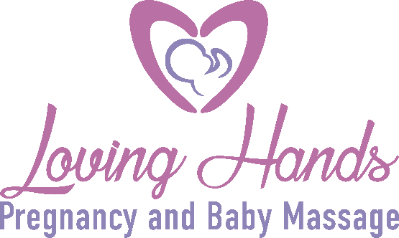

Home
Insert image1.jpg

Loving Hands Pregnancy and Baby Massage was launched in 2017, offering massage for pregnant women, and instruction of baby massage to parents, grandparents and carers.

Insert Image2.jpg
My vision is to provide a professional massage service to pregnant mothers and babies that also benefits from my skills and experience as a midwife.
My expectation is that after each session, my clients should leave feeling relaxed, calm, emotionally nurtured, soothed and supported.
At all times, I will take the utmost care of your privacy, safety and comfort in what is a very personal, intimate time in your life.

Insert IMIS certified Logo

