April 29, 2017
Introducing the Johnstons...
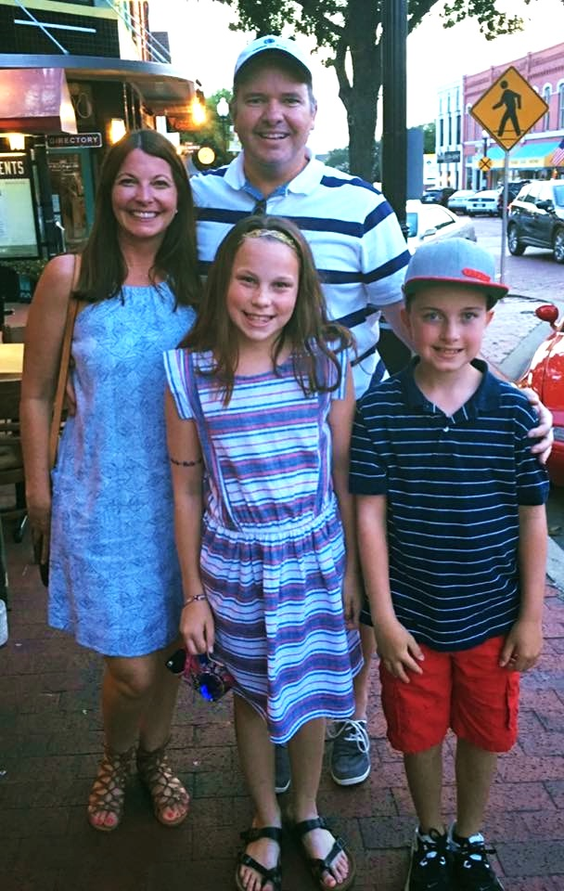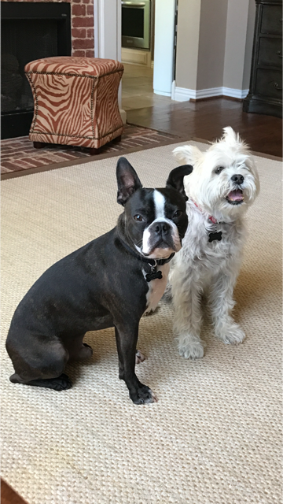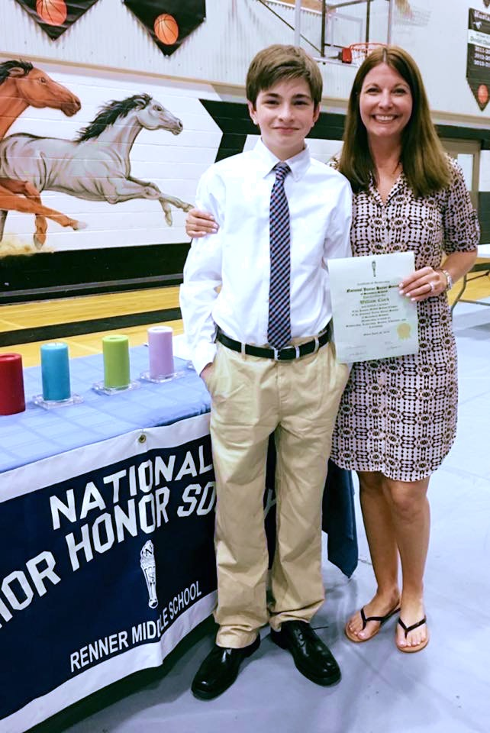

- Bryson: national sales manager for Biolux/ Orthopulse, an orthodontic device company; loves to run, mountain bike and fish; recently discovered Big Bend and will forever love that part of Texas to visit
- Rita: comptroller for family construction business in Carrollton; loves to travel, see live music and discover/taste new wine with her husband in Napa
- Will: 15 year old freshman at Shepton High School, currently taking all Pre AP courses and in National Honor Society; he is going to start Drivers Ed this summer and growing into a fine young man
- Abby: 12 year old 6th grader at Renner Middle School, everyone’s friend with such a caring heart and quite an athlete on the soccer field and volleyball court
- Jack: 10 year old 4th grader at Goshen Elementary, he is in PACE classes, an avid reader and a beast on the basketball court
- Charlie and Finn: Charlie is a new addition to our family this past Christmas, he’s a 1 year old Boston Terrier, a total snuggle love bug and Finn is our 10 yr old Brussels Griffon/ Schnauzer mix that is a giant teddy bear and sweetheart; they are best buds and a big part of the family

Dear Beery family:

We truly love your beautiful home and hope to raise our family there. The moment we saw your house we knew it had all the amenities we have been looking for! For a family of five and two dogs, we love the large kitchen and family room we can all be together in. We have three children Will (15), Abby (12) and Jack (10). We want to stay in Plano ISD where they are already established and we need more room. Your house would be perfect for the kids to have their own space and have their friends over in the beautiful pool and awesome game room. It's so important in the teenage years that we can have the kids and their friends under our supervision having fun at home.
My husband works at home and he needs an office space to himself. Your beautiful study is a perfect space. I hope you choose us to be the next family in your gorgeous home. It has everything we've been looking for!

Sincerely,
Rita and Bryson Johnston

