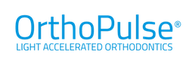
Welcome to SAO
Visit us at Booth #920
Bryson Johnston
Business Development Mngr.
Southern Area
407.733.4495
SAO Show Special
Place an order at the show between October 5-7th and receive an additional 12.5% discount on your current premier level pricing.
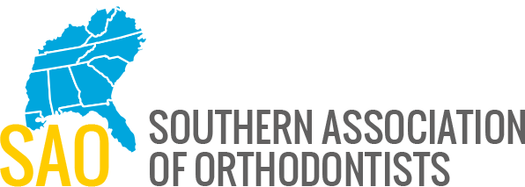
Enter to Win TWO OrthoPulse® Devices
(Total Retail Value $1895)
Come by our booth to enter a drawing where one winner will receive TWO OrthoPulse® Devices for their practice. *One entry per practice, rules apply.

We’re Different
See why Orthodontic Acceleration with cutting edge LIGHT Technology is different and how your practice will benefit by reducing treatment times up to 50%, Just 10 minutes a day.

