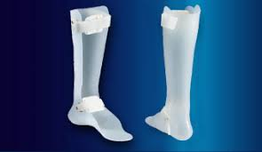
Custom AFO’s Solid/Semi Solid/PLS Design with strap and padding included $135

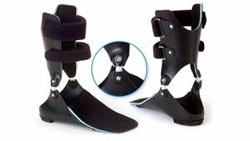
Custom Articulating AFO includes joint of choice Tamarack or Oklahoma $195

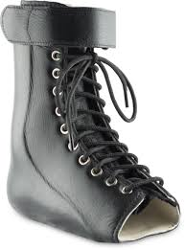
Leather/Plastic AFO Velcro Lace 7” Standard $265

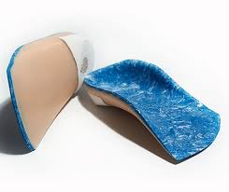
Custom Foot Orthotics/UCBL from foam box $120

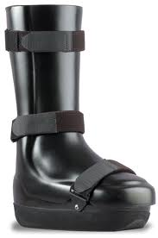
Custom Crow Walker $385

