Ingrid Salamon
IDC certified Coach
Reiss Profile Master & Reiss Profile Coach
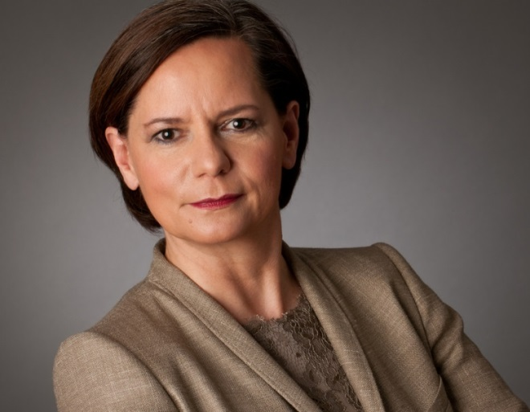
EMBA General Management, BA Marketing,
Master of Science in Wine Management

I am an IDC professional coach certified by the International Coach Federation (ICF) and EDUQUA (Switzerland) and I am preparing for the accreditation by the ICF as Associate Certified Coach (ACC).
My coaching is based on the principle that each person has unique talents, considerable abilities as well as the resources needed to succeed in their private and professional life.
Benefits of Using a Coach
Professional coaching brings many benefits: fresh perspectives on personal challenges, enhanced decision-making skills, greater interpersonal effectiveness, and increased confidence. Those who undertake coaching also can expect appreciable improvement in productivity, satisfaction with life and work, and the attainment of relevant goals.
What is coaching?
ICF defines coaching as partnering with clients in a thought-provoking and creative process that inspires them to maximize their personal and professional potential, which is particularly important in today’s uncertain and complex environment. Coaches honor the client as the expert in his or her life and work and believe every client is creative, resourceful and whole.
This process helps clients dramatically improve their outlook on work and life, while improving their leadership skills and unlocking their potential.
Why choosing me as your coach?
My profound experience as a senior executive in a global corporate environment and managing people in challenging and ever changing markets such as China, EU, Russia, South East Asia, Ukraine, UAE, UK, USA are building the platform for my coaching practice.
After more than 25 years in various management roles and many years in Coaching & Consulting, I decided to focus on coaching and consulting of human beings, from young men and women in management roles to senior executives in challenging positions. The special coaching focus is on the “being” with a holistic approach.

