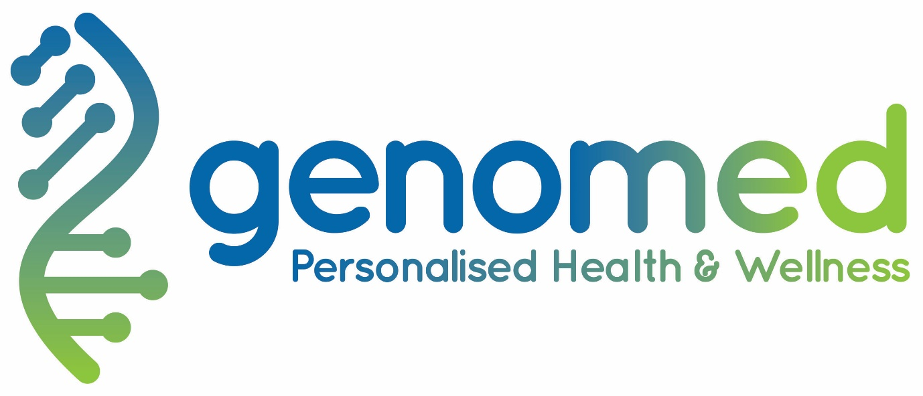

BECOME A GENOMED BUSINESS PARTNER

- CUTTING EDGE GENOMIC & PRECISION MEDICINE

- SEAMLESS TURNKEY INTEGRATATION

- LUCRATIVE NEW REVENUE STREAM

- NO CAPITAL OR RISK INVOLVED

PRECISION MEDICINE

The Mayo Clinic, Johns Hopkins Hospital, Cleveland Clinic and Massachusetts General Hospital. These are just some of the world’s most reputable medical clinics that are already offering genomic and precision healthcare to their patients. Premium healthcare providers around the world, including private hospitals, high-end primary care practices, executive health providers and concierge medicine clinics, are rapidly following suit.

Ever since the human genome was decoded, a plethora of scientific research has been compiled and the amount of new research and actionable data has grown at an exponential rate. The science has been moving much faster than industry can keep up with but precision medicine is now quickly becoming mainstream practise. The revolution has begun and genomic-driven precision medicine is set to become the new standard in healthcare delivery.

GenomedTM partners with premium health providers like you to take yout business to the next level and set you apart from competitors. Our cutting-edge products allow you to offer the same in world-class precision and genomic healthcare. The science is clear, the technology is ready, and the time for clinical implementation is now.

DID YOU KNOW?

Response rates for many prescribed drugs are as low as 50% and that genetic factors can account for up to 95% of drug-response variability and susceptibility!^{2,3} That’s why physicians are turning to precision prescribing!
- IMPROVE PATIENT CARE

- INCREASE THERAPY EFFECTIVENESS

- LIMIT ADVERSE OUTCOMES

- IMPROVE MEDICAL COMPLIANCE

- IMPROVE ECONOMIC EFFICIENY

“Doctors have always recognized that every patient is unique, and doctors have always tried to tailor their treatments as best they can to individuals. You can match a blood transfusion to a blood type — that was an important discovery. What if matching a cancer cure to our genetic code was just as easy, just as standard? What if figuring out the right dose of medicine was as simple as taking our temperature?”

President Obama, at the announcement of a $215 Million Precision-Medicine Genetic Plan, January 30, 2015.¹

LUCRATIVE NEW REVENUE STREAM

Genomic and precision medicine applications open a whole world of lucrative new revenue streams. Increase your businesses’ revenue by hundreds to thousands of United States dollars per patient per year. Upsell to existing patients and attract new customers by offering the latest in world-class technology.

GenomedTM strategically partners with appropriate and reputable healthcare providers to enable their patients access to genomic and precision medicine services. Our partners do not invest any capital so there is no risk. Partners simply stock and sell Genomed products so we only profit when they do. Patients have a variety of products on offer with varying value and corresponding price points. Genomed remains committed to ensuring that our products remain affordably accessible to the self-pay patient market and expect the same from partners.

Effortlessly increase your businesses’ revenues by hundreds to thousands of US dollars per patient per year.

**Use picture of businessman looking at giant DNA background on this page.

PRODUCT LINE

Whole Genome Sequencing
The human genome was first decoded in 2003, taking over 13 years and $2.7 billion to complete.⁴ Thanks to exponential advances in technology, genomedTM can now do the same at only a fraction of the time and cost. Whole Genome Sequencing (WGS) provides a complete analysis of your patients’ DNA and future proofs them so that dynamic updates can be generated as scientific discovery continues at its rapid pace.

Whole Exome Sequencing
The “exome” is the known gene coding region of an individual’s entire genome. In other words, it is where the real action takes place. Whole exome sequencing will provide most of the important answers that patients and physicians are seeking. Whole exome sequencing can therefore be considered to be more efficient, but less thorough, than whole genome sequencing.

Disease Risk Genotyping
Prevention is always better than cure. Scientific research is moving at rapid speed and numerous genes have already been associated with a range of diseases, including cancers, heart conditions and diabetes. There are over 7,500 known inherited diseases affecting millions of individuals worldwide. In many cases, early recognition and management will significantly improve these individuals’ quality and length of life.
Pharmacogenomic Genotyping
Scientific research has shown that the response rate for many prescribed drugs is as low as 50% and that genetic factors can account for up to 95% of drug-response variability and susceptibility!^{2,3} In other words, many of the billions of drugs prescribed every year are inadequately dosed, leading to side effects or no effects at all. This is why physicians around the world are turning to “precision prescribing”. Pharmacogenomic testing allows for the proactive identification of appropriate drugs and dosages for a range of commonly prescribed and over-the-counter medications. In fact, several studies have shown that over 74% of people taking a genetic test for medication compatibility learned information that is relevant to them.⁵⁻⁸
Other Genotyping Products
An ever-growing number of tests are available depending on the specific needs and desires of your business. Microbiome, dietary, and family planning tests are just some examples to name a few.

WHY GENOMED?

- Industry leading partnerships with some of the most reputable names in healthcare & life sciences

- Physician created clinical-grade quality

- FDA cleared genetic testing kits

- Top-tier laboratories – CLIA-certified and/or CAP/NATA/ISO15189-accredited

- Key-turn solution covering everything from A to Z.

- Seamless integration into your existing business

- Rapidly adaptive thanks to our comprehensive market oversight

- Bespoke partnerships based on your unique needs

- New Zealand gold stamp – consistently rated by Transparency International as one of the least corrupt and best places to do business in the world.⁹

WHAT A PARTNERSHIP WITH GENOMED LOOKS LIKE

- Genomed delivers genetic testing kits and marketing material for your business to stock.

- Your patient purchases a Genomed Product

- A simple cheek swab or saliva sample is collected from your patient – this takes less than a minute.

- Details of the patient and kit are entered into your businesses’ online Genomed portal – this takes less than 5 minutes.

- Sample is collected from your business premises.

- Sample undergoes DNA extraction, testing and analysis.

- Clinically actionable reports are delivered to you several weeks later.

**Use images of genomed brochures, brochure stand, genetic testing kits

Contact us to discuss becoming a GenomedTM Business Partener:

enquiries@genomed.co

www.genomed.co

Genomed Limited
Metropolis Tower - Suite 9, Level 26
1 Courthouse Lane
Central Business District
Auckland 1010, New Zealand

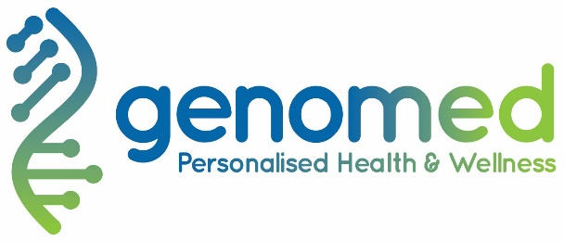

References:
- FACT SHEET: Obama Administration Announces Key Actions to Accelerate Precision Medicine Initiative. Available at: https://obamawhitehouse.archives.gov/the-press-office/2016/02/25/fact-sheet-obama-administration-announces-key-actions-accelerate
- Spear BB, Heath-Chiozzi M, Huff J: Clinical application of pharmacogenetics. Trends Mol. Med.7, 201-204 (2001).
- Kalow W, et al. Pharmacogenetics 1998;8:283-289.
- 2003 Release: International Consortium Completes HGP. Available at: https://www.genome.gov/11006929/2003-release-international-consortium-completes-hgp/
- 2003 Release: International Consortium Completes HGP. Available at: https://www.genome.gov/11006929/2003-release-international-consortium-completes-hgp/
- Spear BB, Heath-Chiozzi M, Huff J: Clinical application of pharmacogenetics. Trends Mol. Med.7, 201-204 (2001).
- Kalow W, et al. Pharmacogenetics 1998;8:283-289.
- Ji Y, et al. Journal of Molecular Diagnostics 2016;18(3):438-45.
- Transparency International – New Zealand. Available at: https://www.transparency.org/country/NZL

