Logo Brief – My Next Advice:

Business background: | My Next Advice is an online marketplace where those who work in the advice industry can improve their service and practice, and those who are seeking advice can source recommendations for up to three of the best advisers (as rated by their clients).
Audience: | Two audiences:  - B2B: advice businesses, financial planning to start (expand to recruiters, accountants, lawyers, insurance brokers, real estate agents)  - B2C: three personas – Kate (40 yr old mum, driving financial decisions based on family outcomes), Michael (48 yr old dad, focusing on wealth creation for the next 15 years until retirement), X (35 yr old small business owner, recognises need for specialist advice to protect and create wealth).
Value proposition: | - B2B: My Next Advice’s service gives you the tools to measure customer satisfaction, identify areas for improvement, and build business via loyalty, referrals and leads.  - B2C: My Next Advice’s service simplifies the process of finding your specialist – simply, quickly and for free.
Required: | Two logo variations – 1 square and 1 landscape. Once final design chosen we then need (of each logo layout):  - Colour  - Greyscale  - Solid background  - Transparent background  - Vector, jpg and png of each option above  So essentially there’s two layouts with twelve files for each.
Brand colours: | Green (HEX #1eb150)  White (#FFFFFF)  Dark Grey  Any variations to the green need to come from the primary colour above. We need to know the final colours used so we can match to designs elsewhere (e.g. presentation headings).
Images We Like (use purely as reference/inspiration): |   Speech bubble and heads refers to marketplace, number of advisers, referrals etc.    Puzzle pieces refers to working on challenges and finding solutions, satisfaction, achievement. Could also be chess pieces, deck of cards etc.    Speech bubble again with hands but this one looks like fighting instead of exchanging.  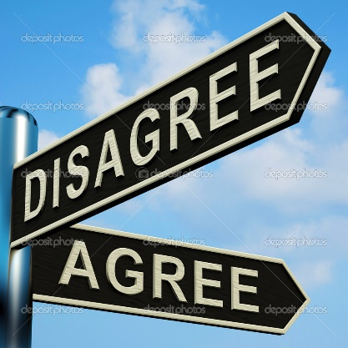  Signpost concept implies making decisions, identifying goals, working out where you want to go. MNA could be on one or across three or not involved at all.  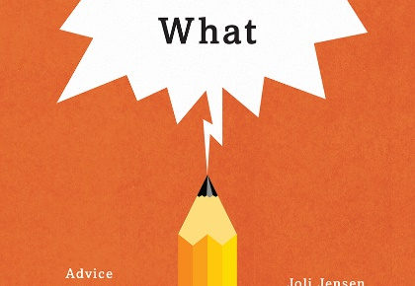  What are the tools advisers use? Pen/pencil?
Concepts We Like:  NOTE we would need to look at using the brand colours and a clean font suitable for B2B marketing. | 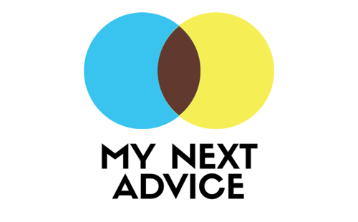    Like this logo – building blocks – but review colours and layout with business name to make more compact.    Marketplace reference – three circles    Marketplace reference, triangular could be used to point to something (open to different triangle shape, direction)    (note graphic of this one would need to reflect advice/service/systems etc)    (note graphic of this one would need three prisms and text aligned with them)

