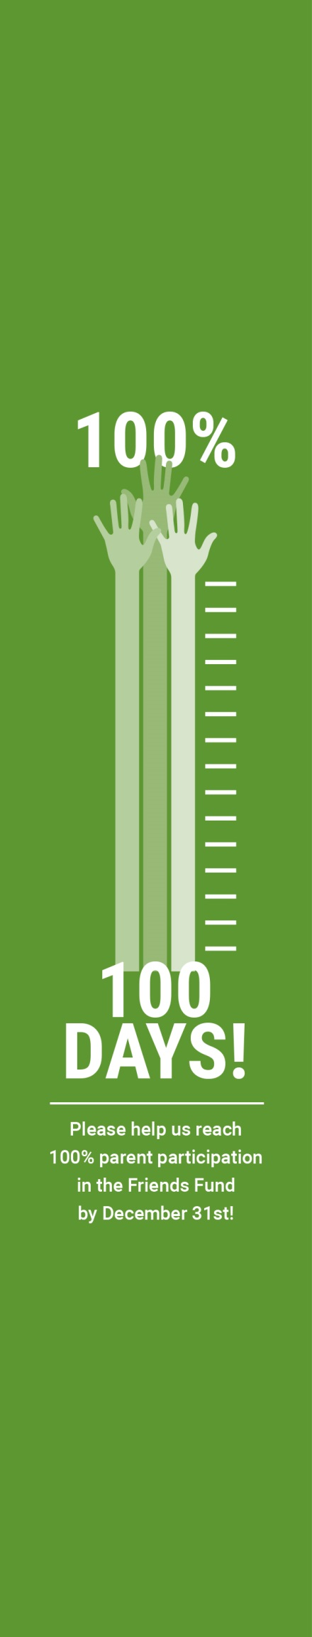


This is where text would go, using a Google Font named Roboto.

PARENTS VERSION!

