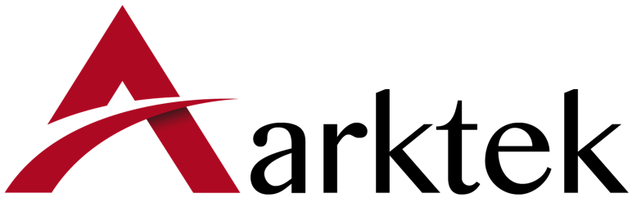

Arktek Group Limited

Company Profile
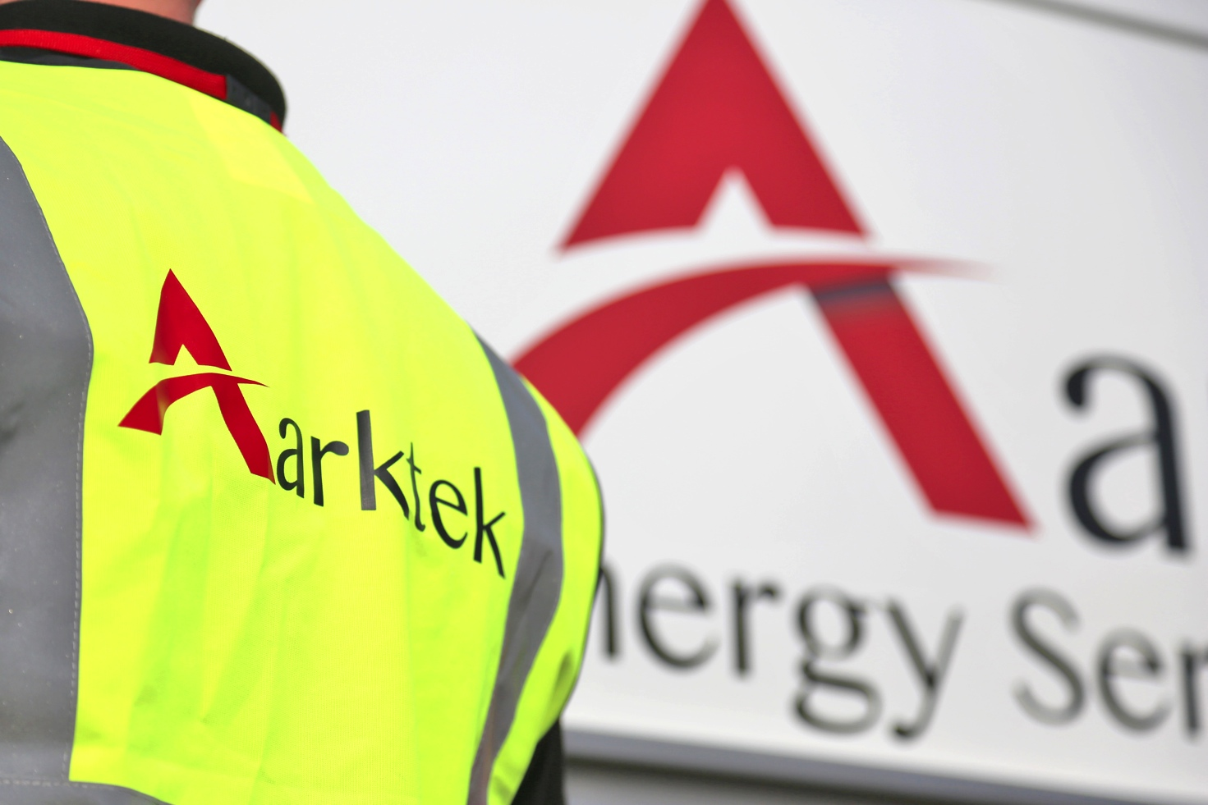
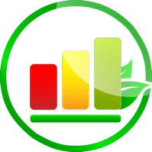

Overview
Arktek Group Ltd was created to provide a range of services to commercial and domestic property owners throughout the North East and North West of England and Scotland.
Arktek specialises in providing a range of energy saving measures through funded and private schemes across the North East, North Yorkshire and Scotland. We aim to provide an approachable, professional and reliable service to all our customers.

Our Services
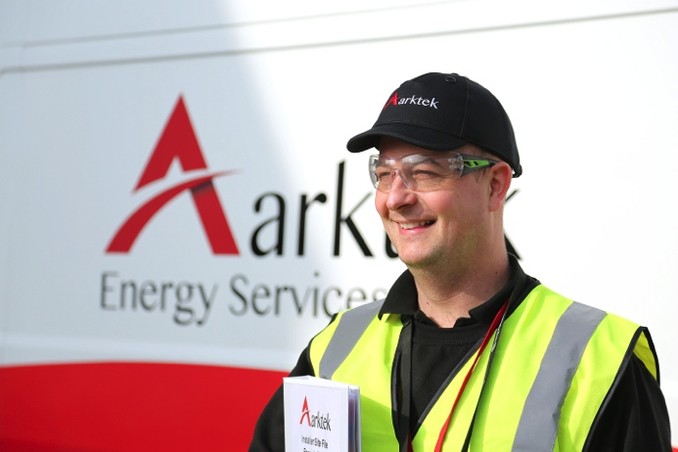
Our staff and senior management have a wealth of experience in the energy and construction sectors, and work closely with major funding partners to deliver a quality service with particular emphasis on the customer journey. With the capability to deliver all measures from a single domestic install to a project-managed commercial scheme, Arktek Group currently provide a one-stop-shop for measures such as Room in Roof Insulation, Loft and Cavity Insulation, External Wall Insulation, Replacement Gas, LPG and Gas Boilers and heating systems. In addition to this, as trained Flood Professionals, Arktek Flood Defences provide flood property level protection throughout the North of England and Scotland.
Our staff are also on hand to provide gas boiler servicing and repairs and energy performance assessments (required if you intend to sell or rent your property).

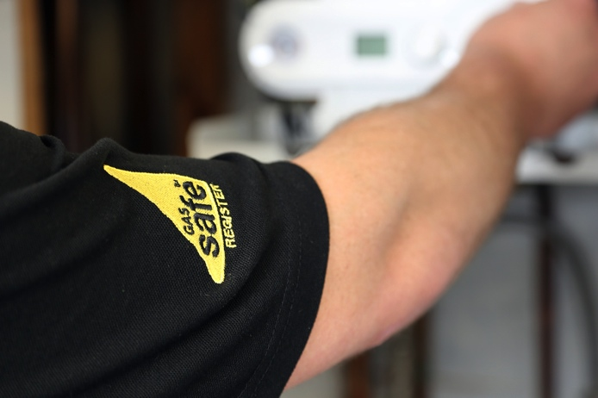
Heating Systems – Gas, LPG and Oil Boilers

Arktek Group Ltd is a North East based Gas Safe accredited installer and emergency repair company specialising in premium boiler installation and all aspects of maintenance and repair work, ranging from routine annual servicing to 24/7 emergency breakdowns.
As a fully accredited installer, Arktek offer a premium range of gas, LPG and oil boilers backed by extended guarantees of up to 10 years on a select range of models.
We have carefully selected a range of boiler brands and models that meet our Company’s high standard of service delivery based upon, quality reliability, service support and length of warranty.
As part of our service for landlords, in addition to providing annual boiler and gas safety checks, Arktek complete Legionella Risk Assessment, which are registered with Stroma.

Room-in-roof insulation
Arktek Group Ltd specialise in insulating attic and other room-in-roof conversions to make them comfortable and habitable year-round.
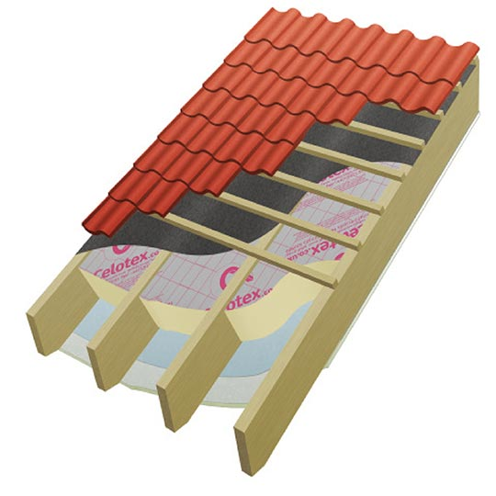
A ‘Room in Roof’ is typically an extra storey on a bungalow or house characterised by a fixed (often narrow) staircase leading to room, which incorporates the roof. The room will have a light source, usually a Velux or Dormer window and be classed as an extra bedroom or bedrooms. Our insulation system is designed to provide the maximum benefit from the insulation measures without encroaching on the living space.
Arktek’s system makes use of the residual eave and loft spaces to install the insulation, which is much less disruptive and more efficient, whilst maintaining the essential air flow to the timbers. A typical install can be completed in as little as 1-2 days. Where the property does not already have access hatches Arktek install lockable, fire rated panels at no extra cost leaving the customer with a convenient, secure storage as an added benefit.

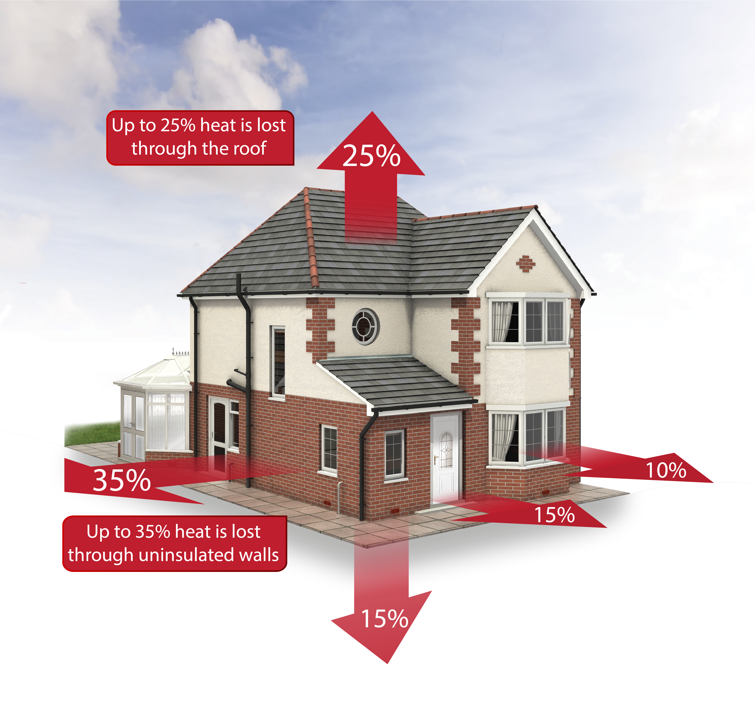
Loft & Cavity Wall Insulation
Heat rises through a property, and if the loft, attic or flat roof is not insulated the owner could be losing a quarter of their heat through the roof. This equates to around 25% of the money you spend on the cost of heating being wasted.
If a property has cavity walls and they are not insulated, the owner will be losing around 35% of the home’s heat through the walls.
Cavity wall insulation helps to start heating a property more efficiently and by doing so can help the owner to start saving energy and money on their heating bills.
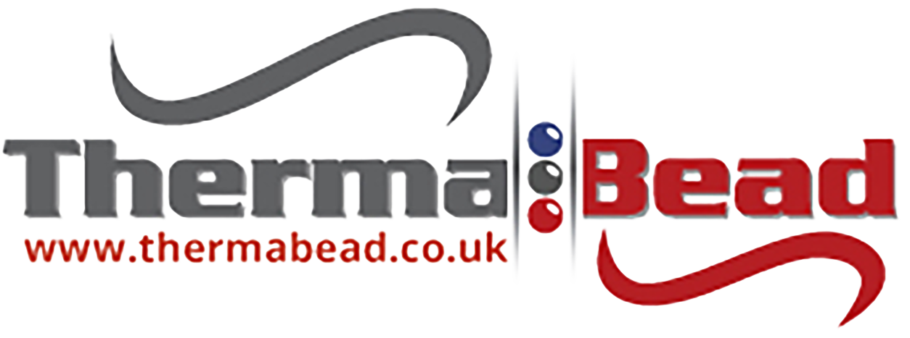
Being more energy efficient also means that a person’s carbon footprint can be reduced, which will help fight climate change.
Approved Installer
Arktek is an approved Thermabead Installer.
Installation Process
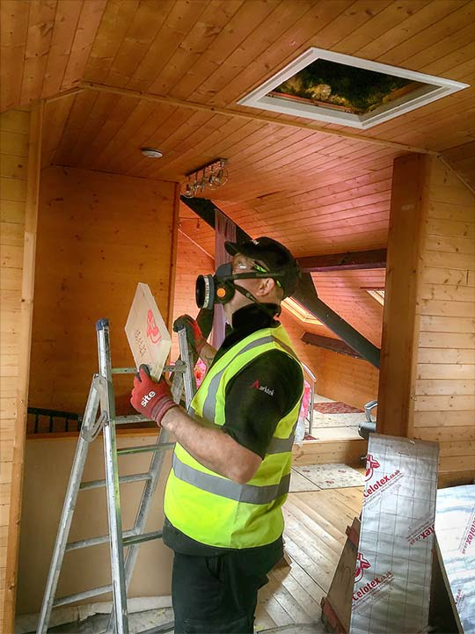
From initial enquiry, our surveyors will visit the property and carry out a survey to check if the property is eligible for funding.
An energy performance assessment (EPC) is then completed for the property.
All loft insulation is completed with a certificate detailing the date of installation and insulation specification and can be installed in as little as an hour.
Installing cavity wall insulation involves drilling into the mortar between the bricks in the property wall at specific locations on each level of the property. Insulating wool or beads are then pumped into the cavity in the property walls, with our specialist operatives carefully monitoring the installation to ensure the property is fully and correctly insulated. Any holes drilled are fully reinstated and where necessary, the replacement mortar being dyed to match that of the original mortar. The whole operation can be completed in as little as 2 hours.
Arktek claim the grant on the customer’s behalf, ensuring that there is no paperwork or a lengthy claims process for the customer worry about.
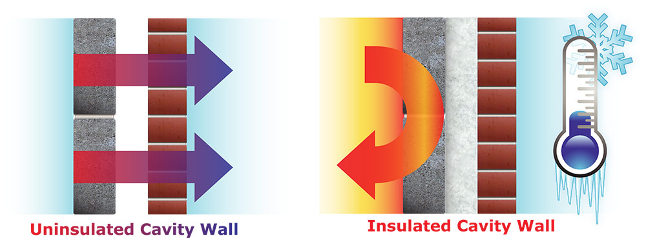

Flood Defences
The environment agency estimates around 5.2 million properties in England, or one in six properties, are at risk of flooding. More than 5 million people live and work in 2.4 million properties that are at risk of flooding from rivers or the sea, one million of which are also at risk of surface water flooding. A further 2.8 million properties are susceptible to surface water flooding alone.

Arktek Flood Defences provides property level protection services for domestic and commercial properties that are at risk of flooding, in the North of England and Scotland. The services include; full property survey, the design of a complete system to help protect the property, full installation and repair & inspection services.

We offer a wide range of measures including: flood barriers, flood doors, airbrick protection, sewer protection, sump and pump systems and wall coatings.

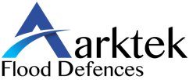
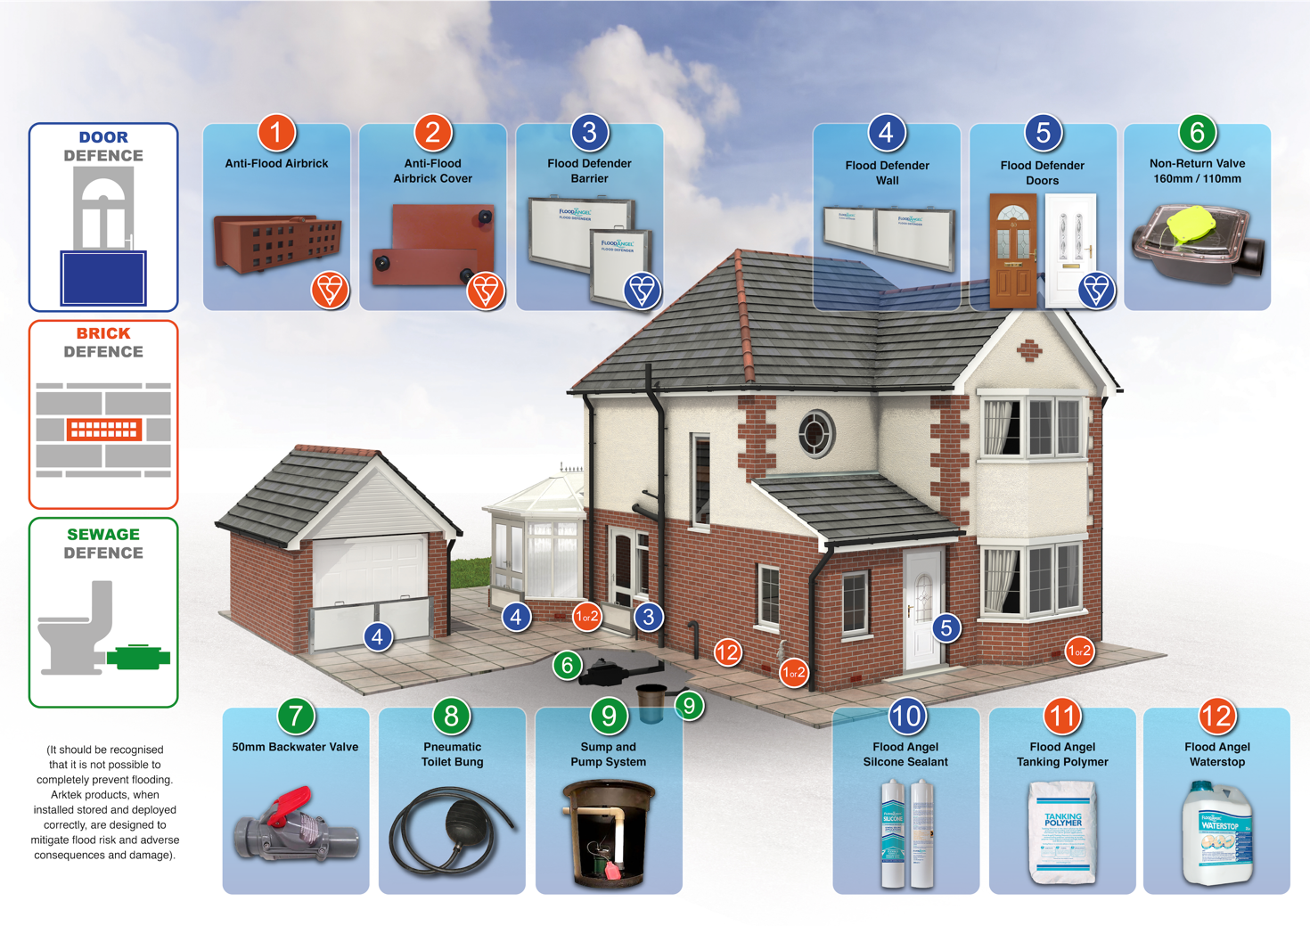

Our BSI certified installers and surveyors are approved to survey and install the Flood Angel® range of products. The product range holds 10 BSI Kitemark certifications PAS 1188-1:2009.

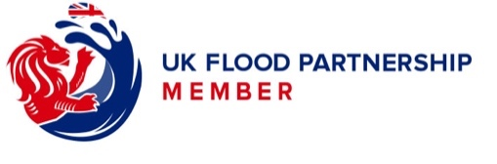
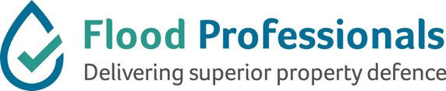

For more information please visit www.arktekflooddefences.co.uk

Energy Performance Certificates
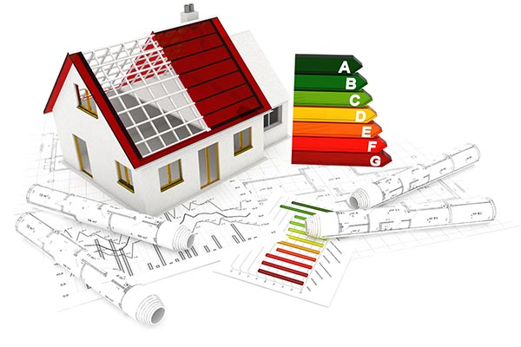
All domestic and commercial buildings in the UK available to buy or rent must have an Energy Performance Certificate (EPC). An energy performance survey helps homeowners to identify ways to save money on their energy bills and improve the comfort of their home.
As part of the assessment to check whether customer’s properties are eligible for free insulation, gas boiler or any other energy saving measures, the property owner will require an Energy Performance Certificate (EPC) for the property. Arktek will complete this free of charge whilst assessing and surveying the property.
The EPC will also state what the energy-efficiency rating could be if improvements are made, and highlights cost-effective ways to achieve a better rating. Even if the property is rented, some improvements noted on the EPC may be worth implementing, such as switching to more energy-efficient light bulbs. EPCs are valid for 10 years from issue.
As from the 1st April 2018 there will be a requirement for any properties rented out in the private rented sector to normally have a minimum energy performance rating of E on an Energy Performance Certificate (EPC).

Arktek Core Values


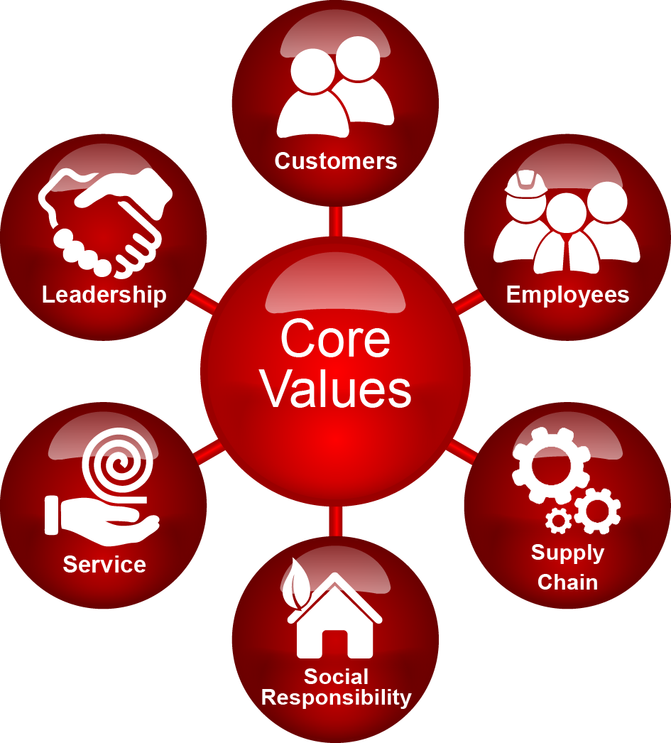

Customers
We aim to treat our customers with respect at all times, acknowledging any customer specific needs and expectations and plan to complete our works punctually and to a high-quality standard. This will be achieved whilst ensuring the safety and welfare safety of our customers and personnel at all times.

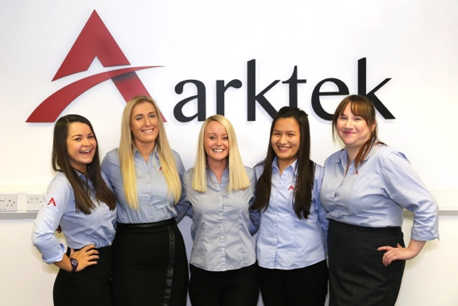
Employees
One of our primary employee selection criteria is for individuals who will fit within our culture of professionalism and a close working team. It is our aim to select employees who will enjoy being long-term members of the Arktek family, who will grow professionally and help to continuously develop the company.

Supply Chain
Arktek recognises the importance of our suppliers in the successful growth of our business. As such, we aim to develop close working relationships with each of our suppliers, ensuring clear lines of communication and timely payments. As a result of this we have come to expect a high standard of service from our suppliers.

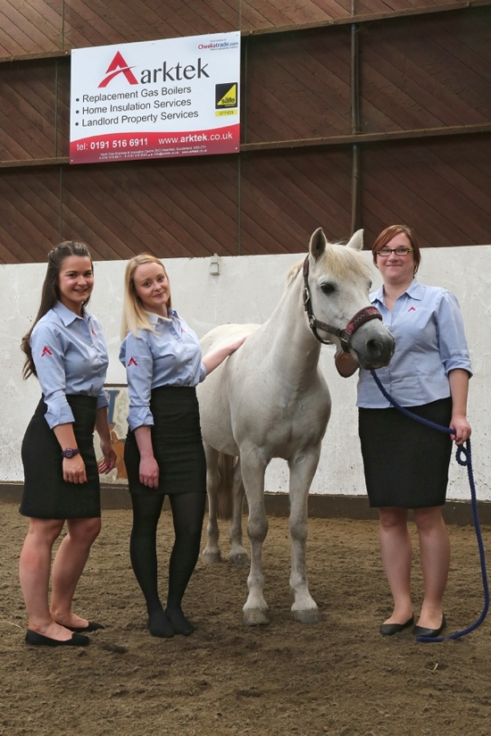
Social Responsibility
All our employees are trained to ensure that they take responsibility for all actions on and off site, being fully aware that what we do can impact on the health, safety and welfare of themselves, others and the environment in which they live and work.

Service
All works we undertake are subject to meticulous planning; our aim being simply to “get it right first time, every time”, thereby exceeding customer and client expectations.

Leadership
We listen to our staff and place a high value on their ideas, creativity, professionalism, and experience. By fully engaging with our staff we aim to empower them and help them achieve their full potential through training and mentoring. It is through effective leadership that we expect to achieve our vision for the future of Arktek.

Continuous Improvement
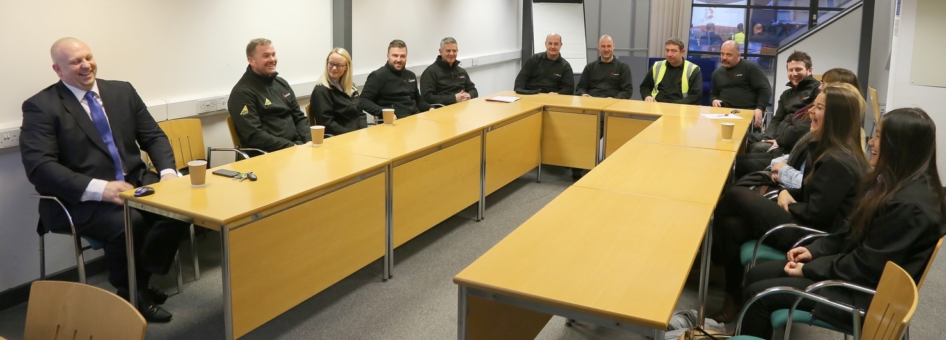
In keeping with our focus on continuous improvement the delivery a high standard of service, we actively promote training throughout all aspects of our operations. All our staff and operatives are involved in a continuous training programme to help them develop in their roles and achieve their maximum potential.
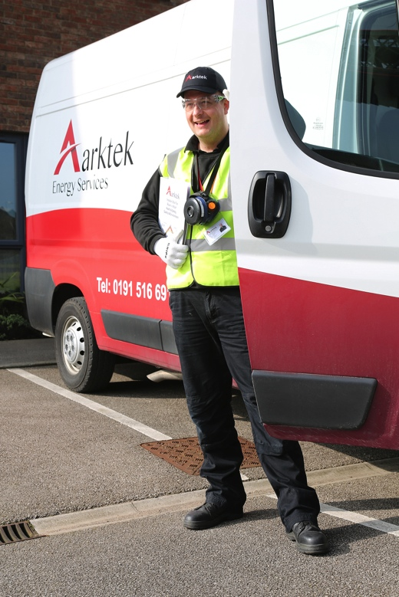
In addition to industry standard courses required for our specialist installers, as a minimum all our staff receive certified training on a range of courses including:
- Health & Safety Awareness
- Working at Heights
- COSHH Awareness
- Personal Protective Equipment Training
- Asbestos Awareness
- Environmental Awareness
- Customer Care
- Safe Manual Handling
- Role specific training / accreditations

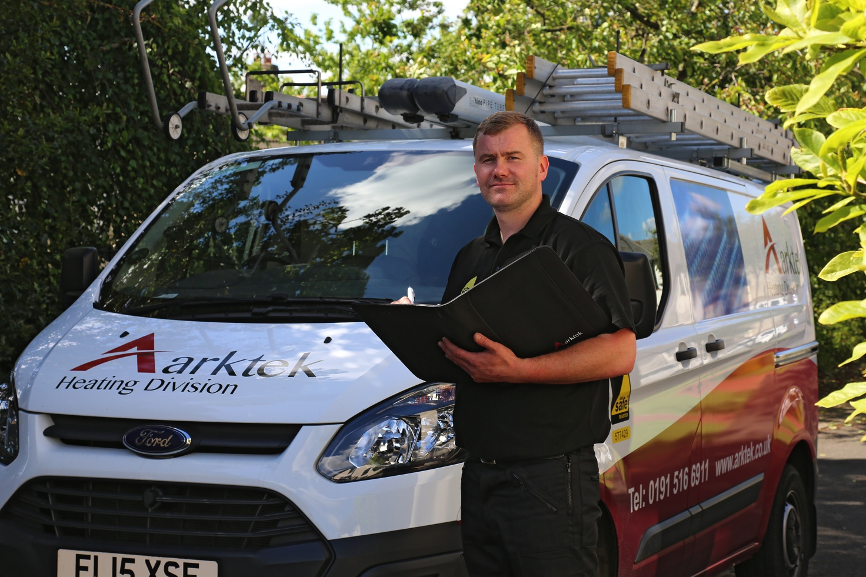
For more information please visit www.arktekheating.co.uk

Accreditations
As part of our focus on providing the highest levels of service and continuous improvement, Arktek Group Limited maintains the following accreditations:
- ISO9001:2015
- ISO14001:2015
- OHSAS18001:2007
- Gas Safe Register
- NICEIC Approved Contractor & Competent Person Registration
- PAS2030 Green Deal Approved Installer
- The Contractors Health and Safety Assessment Scheme (CHAS)
- Constructionline
- UK Flood Partnership Member
- Flood Professionals
- Citation Registered Member
- Checkatrade
- Which Trusted Trader
- Trust Mark
- Safe Contractor

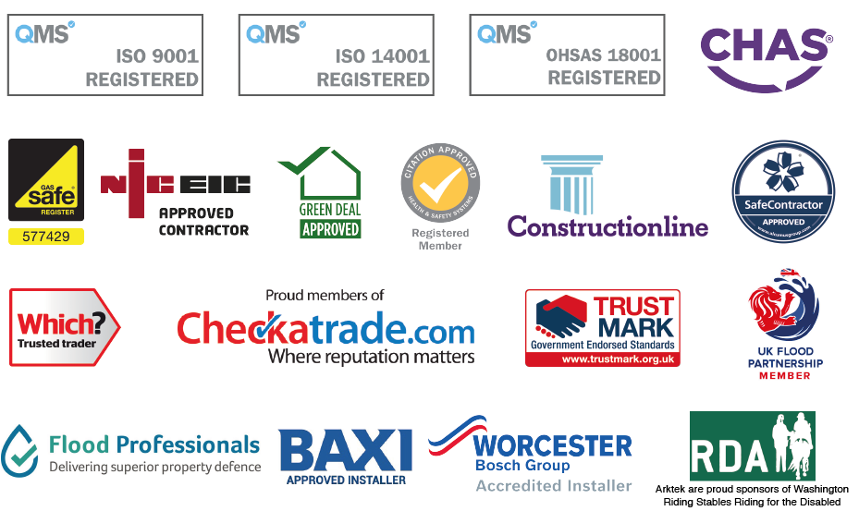

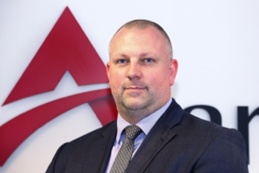
Key Staff – Arktek Group Limited
Mark Bewick BSc (Hons) - Managing Director
Experience
Nissan Motors UK Ltd
Experience from line work to management. Implemented and managed Kaisen, Kanban, 5 ‘s’ systems. Coordinated multiple supply chains ensuring synchronous delivery and output targets. Various in-house management and H&S courses.
Hertel Construction Ltd
Involved in major overhaul of Buxton Lime Quarry. Project included all phases from foundations to sheet cladding, with a permanent HSE presence on site and involvement with local councils.
Laing O’Rourke Ltd
Phase 1 & 2 of the new maternity wing on the Royal Victoria Infirmary in Newcastle, from demolition of the existing wing to completion of foundations and internal structure of the new structure. Involved in project management, site safety and liaising with both the public and NHS trust during completion of works to minimise disruption and ensure safety in the main hospital which was operational during the operation.
Mark Group Ltd
Northern Area Director for the largest home energy firm in the UK. Responsible for over 2000 domestic and 1200 New Build installs per week. The company expanded into the US, Australia and New Zealand and won the award for the fastest growing overseas business in 2013. Total operational responsibility for 6 Service Delivery Centres covering Aberdeen to Birmingham. Aberdeen Branch was opened by Alex Salmond and was the provider of Solar PV systems for many schools, nursing homes and private houses – a pilot project in Scotland. Delivered an External Wall Insulation Project in Hawick, Scottish Borders, in conjunction with the local council. Direct contact with all ‘big 6’ power companies and responsible for large proportions of the ECO budgets. Worked directly with the HSE to produce retrofit Working at Height Guidance for the Cavity Wall industry.
Arktek Group Ltd
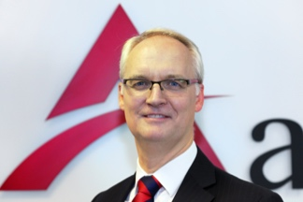
After Mark Group was bought out by Sun Edison, worked on a small project with Nigel Jones and decided to set up Arktek with a view to setting a new standard of delivery and professionalism which we both felt was lacking in other companies in the industry.
Nigel Jones – Business Standards Director
BEng MSc PgDip MCIM MIDM Tech IOSH
Experience
Grove Coles Cranes
Employed as a design engineer, designing various mechanical and hydraulic systems for a range of mobile cranes. After 5 years then completed a CIM Post Graduate Diploma in Marketing and then a Masters Degree in Marketing and moved into sales and marketing.
Domnick Hunter Filters
Working in Export Sales Key Accounts sales at Domnick Hunter responsible for; North America, Canada and assisting in Japan and Germany. Involved with the design and development of BA Packs and specials gas filters.
Herrenknech International Ltd – Tunneling Equipment Manufacturer
Employed as a Project Manager but also involved in Sales and Marketing. Managing and supplying and managing tunneling equipment for projects in: UK, Europe, UAE, Egypt, India, Korea, Hong Kong / China, Taiwan, Thailand and South America.
Norland Construction Limited – Civil Engineering / Utilities Contractor
Employed as Business Development Manager / General Manager for Norland Construction, involved with utility projects including: water, gas, electricity, telecoms and fibre optics. This involved dealing with several large utility companies including NEDL, YEDL, National Powergrid, National Grid, SEC, British Gas, Energis, Cable & Wireless, BT etc.
Fastflow Pipleine Services Ltd – Utilities Contractor
Business Development / Marketing Director for Fastlow. Responsible for developing business for water and gas utilities with: Yorkshire Water, Scottish Water, Northumbrian Water, Severn Trent, Yorkshire Water, United Utilities, British Gas, National Grid etc. I was also responsible for the design, development and Patent of trunk mains cleaning equipment for a contract with Northumbrian Water.
Drilcorp – Water well and Geothermal Drilling Conractor
Employed as Managing Director. Working in London with Transport for London, responsible for securing the “Cooling the Tube” contract for drilling to provide cooling in the London Underground prior to the Olympics.
Herdman Jones Associates Ltd
Project Management, Business Development and Marketing consultancy. Included working part time lecturing at several Universities in the North East, covering Project Management and Marketing on MBA and various post graduate Marketing and Business Management Courses.
Arktek Group Limited
Whilst working for one client who was working as a Green Deal Provider, I met up with Mark Bewick, and having both seen how badly other companies were performing we agreed to set up Arktek, with a simple approach to basically striving to doing everything to best of our own and the company’s ability. Please see our company overview for further details.
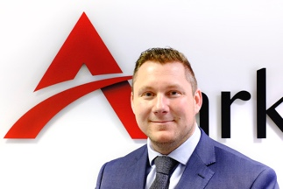
David Richardson - Operations Director
Experience
Unipress UK Limited - Supervisor
Supervisory role responsible for Health and Safety, KPI reporing, Synchronous delivery and recruitment. Implemented and managed Kanban, 5 ‘s’ and Total Productive Maintenance (TPM) systems.
Mark Group Limited – Operational Management
Held middle management and field operations roles, having operational responsibility for field operatives. Reporting to Area Director. Responsible for setting and delivering KPI’s including; Productivity, H&S, Quality, Customer Care, Recruitment.
British Gas - Northern Area Insulation Manager
Responsible for setting up new ECO Delivery Business Unit, from inception through to successful delivery against British Gas Standards for lead fed customer. Full operational responsibility for; delivery, H&S, Recruitment / HR, Profit & Loss etc.
National Scaffolding (British Gas) -
Responsible for setting up Contract Division to delivery scaffolding to British Gas business unites across the whole of the UK. Reporting to senior British Gas Management on all aspects.
Warm Up North (British Gas) – ECO Lead
ECO Lead for the nine local authorities in the North East of England, delivering a range of energy efficiency products. Ensuring in successful delivery via weekly liaison with all Local Authorities and Housing Associations. Onsite management with Clerk of Works on full energy efficient Schemes.
JLA – Regional Operations Manager North
Full responsibility for Business Acquisition and Transition Management covering the area from Scotland to the Midlands. Full responsibility for Profit & Loss, Health & Safety and Customer Care.
I played a key role in working with newly acquired businesses to help improve their standards and integrate the companies as part of the JLA family.

