LOGO :

Examples for the fluorescent green color and the TEXTURE rope and wood :
- Web site « terreo canyoning »,
http://www.terreo-canyoning.com/
I like it for the E fluo from de « terreo »

- An another example just for the color green fluo https://www.100canyon.com/

example of nice logos :
- logo « picture » : http://www.picture-organic-clothing.com/fr/ I like it for : clear logo

- Esprit d’aventure : http://espritdaventure.fr/
I like for the texture of the rope

- And 4 links with mountains, I like it because it’s a simple and clear design
Weibka : http://www.valhallacreativedesign.com.au/weibka.html#wa-anchor-top Mountains : https://fr.pinterest.com/pin/370772981804764485/
Mountain : https://fr.pinterest.com/pin/510454939002845247/
Mountain : https://www.dreamstime.com/stock-illustration-mountain-logo-vintage-retro-blurred-background-linear-design-image73120382#

Flyer of competitive compagnies canyoning :
The first one on the left is mine. (The ring)
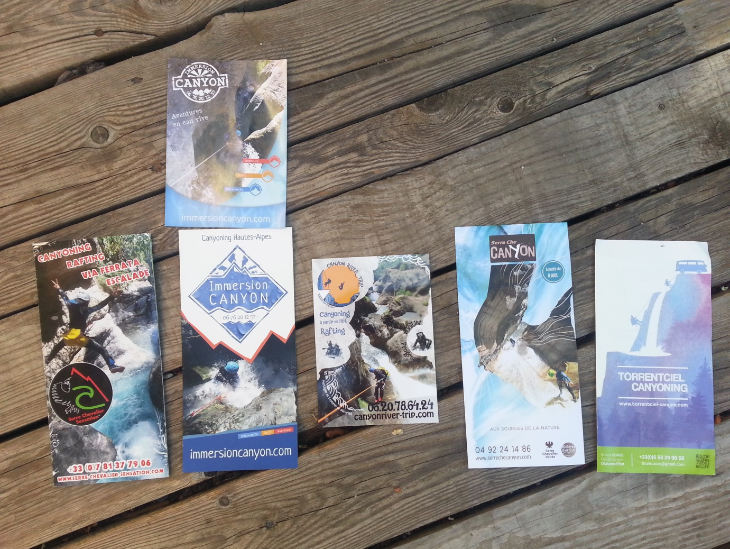

Flyer of competitive compagnies Rafting :

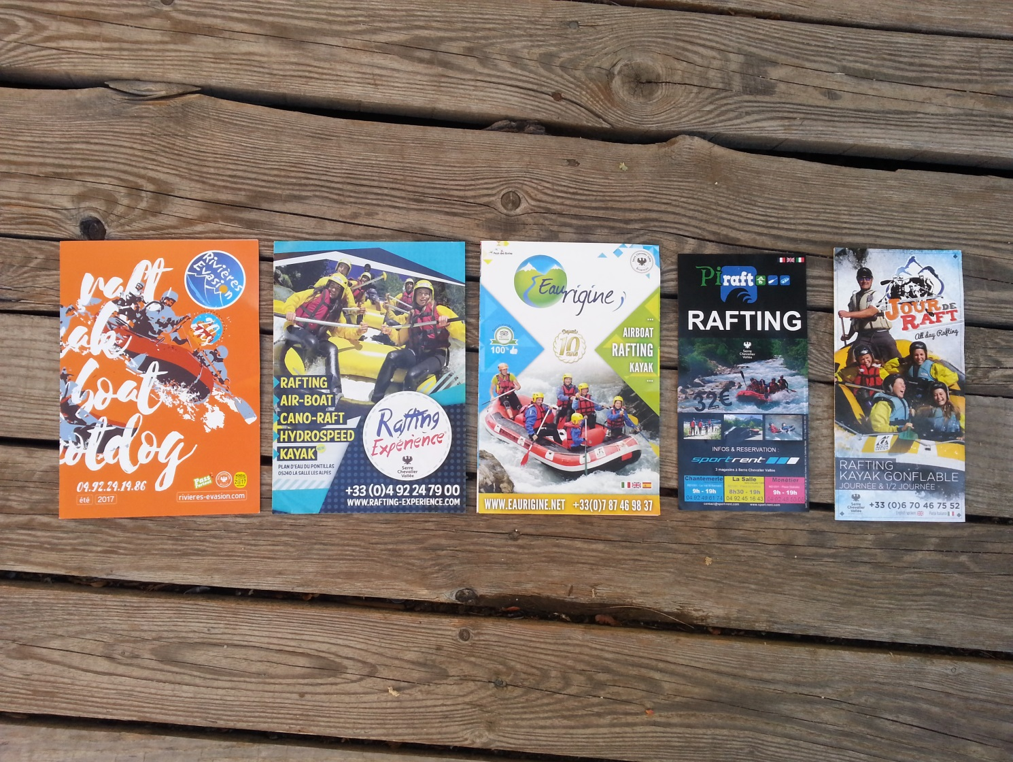

And to finish, here’s a flyer than I like, with green fluo color. 