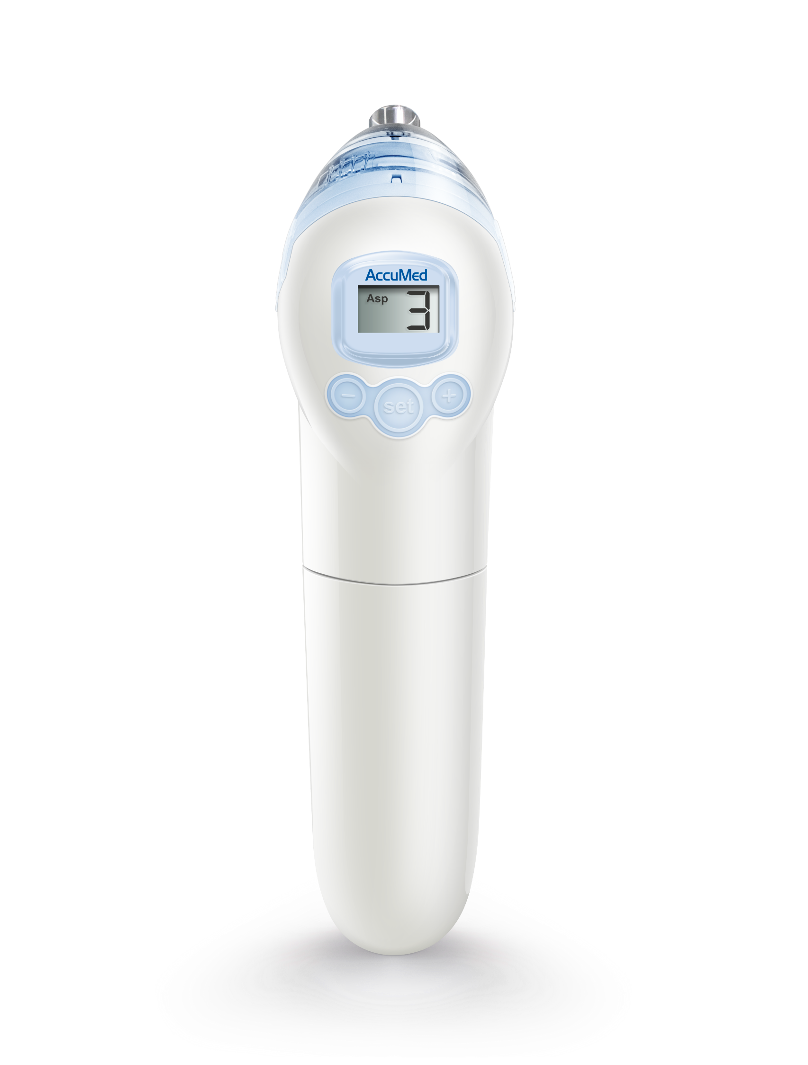
Air Inlet
LCD Screen
“-“ and “+” keys to set options
Set Key

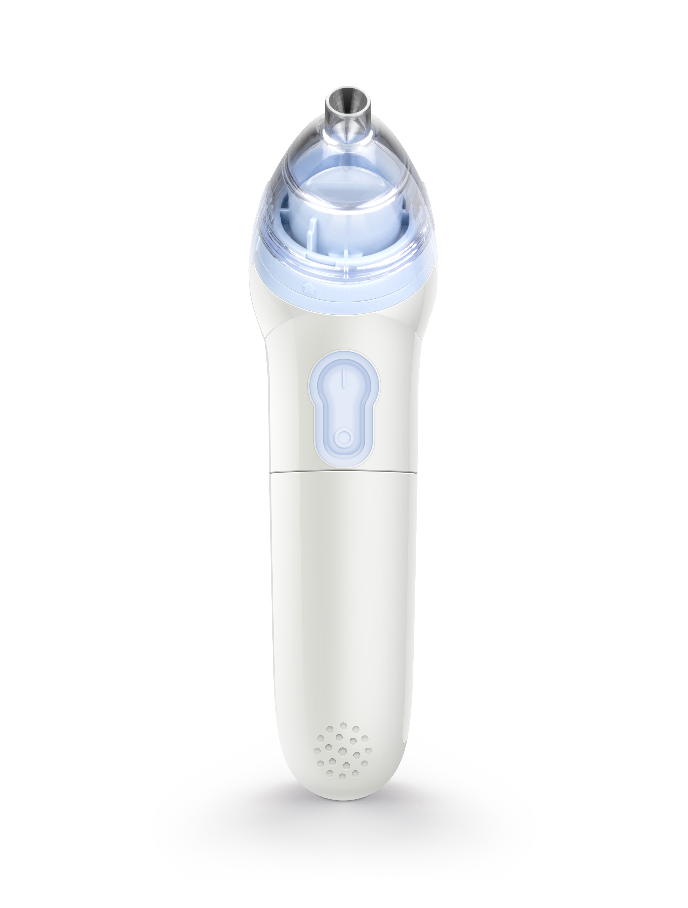
Twist Off

On

Off

