Dear all T-shirt Designers,
We are T-shirt sellers who sell custom T-shirts on http://teespring.com. We need professional T-shirt designs for teachers. Here is the detail for the design we need you do.
- Design Name : Wonder Teacher

Target audiences for this shirt are women teachers who have watched and liked the Wonder Women movie. If you never know the Wonder Women, I suggest you should try this movie.

- Requirements :
- This design must be humor, funny for teachers.
- This design must be related to teaching works, teachers (Ex : book, pen..), and concepts of the Wonder Women (her weapons or things she often wear). Below is an example for her weapons.
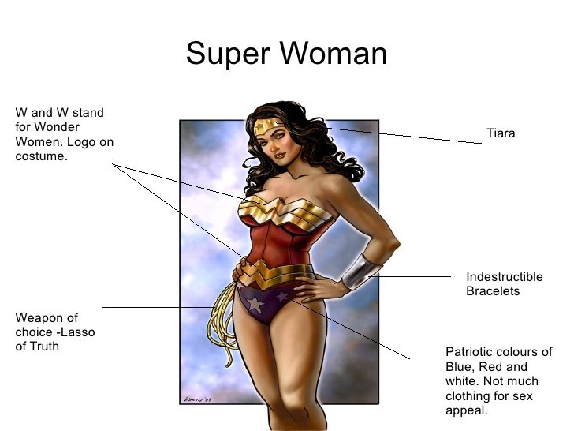
Image 01
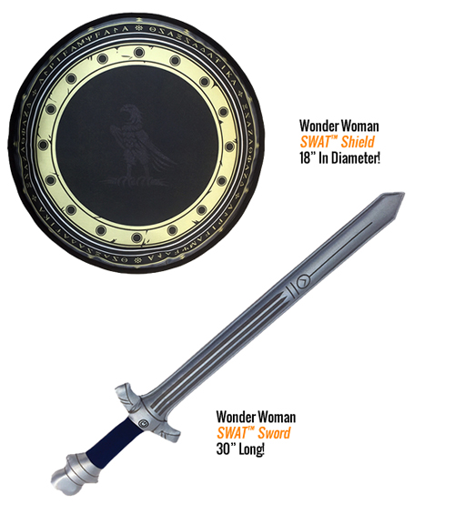
Image 02

- Ideas Suggestion:
This is an idea I suggest for you. If you think your idea is better, just use yours. Everything depends on you.

This is an existing tee (image 03), you can revise it for the Wonder Women. Ex: “My sword broke (or burn*) so now I teach”. Don’t write “5th Grade” because I want this shirt is for all grade women teachers.
* Burn: because her sword is burn at the end of the Wonder Women 2017 movie
You can add some images into designs. Exp: Sword, Lasso of Truth, Pen, book…
Remind that everything depends on you.
I just want that this shirt looks humor, funny, lovely, impressive but little bit polite (because it is for teachers who often wear polite clothing) and they can wear this shirt and stand in front of their students without any problem.
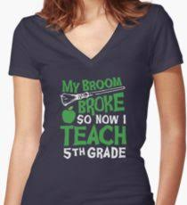
Image 03

- Returning Design: My requirements as below:
1. Design file: We need a design file in vector format (*.ai, .pds, eps...) and an image of design with .png format. We will use this image to add on Teespring shirts.
The prime color for this shirt is black (black ground color). Scale Ratio of the design is 11.9:17.9 as shown in image 04
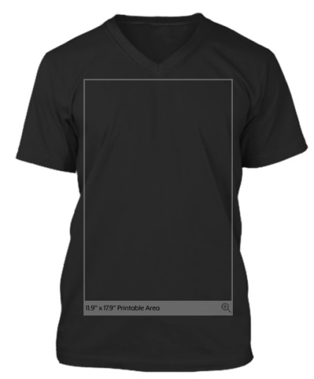
Image 04

2. Promotion Photo: We need a promotion photo (with *.jpg, *.png format) to advertising on facebook like Image 03. The model wears the Teesping’s (image 05) T-shirt with your design. Of course, the model is a US woman (real model or virtual model) – Do not violate copyrights of famous models. You can add more things (Indestructible Lasso or Lasso of Truth…see image 01) for the model so that she looks like the Wonder Woman. Make sure that all details on the shirt are clear and the type of shirt is the same with below one – image 05 (Teesping shirt – V-neck tee):
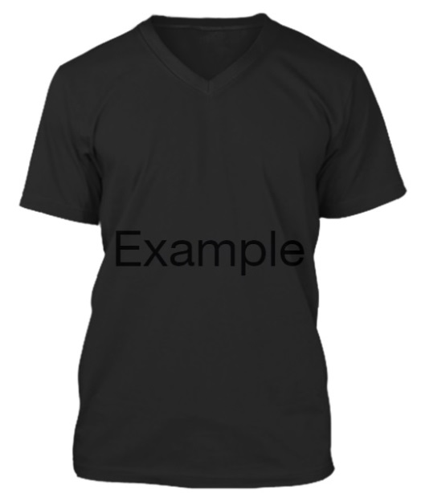
Image 05
3. All details on your designs and Promotion Photo do not violate any copyright or trademark.
We are looking for a professional T-shirt design. If your design is chosen, we will cooperate with you in long term work.
Thank you!
Best Regards,

