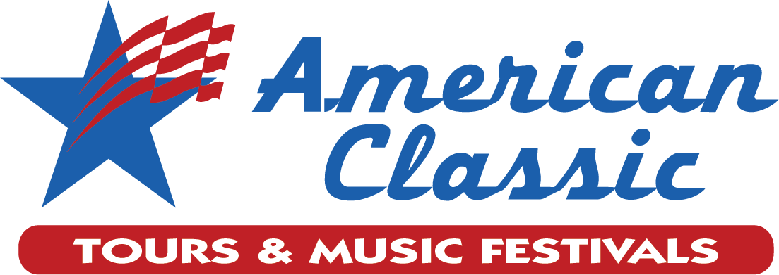

Founded in 1989, American Classic Tours & Music Festivals is distinguished by a strong connection with the educational community. Successful music educators have played prominent roles throughout the company’s history. American Classic brings the passion of dedicated teachers to the planning and operation of student-centered tours and festivals.
Now powered by Gerber Tours, we have joined a team of experts with over 100 years of combined educational student travel expertise. Being a part of the Gerber Family brings new resources so we can provide unparalleled tours and festival experiences for you and your students.

US Tours
New York
Orlando
Chicago
San Francisco
New Orleans
Washington D.C.
...and many more!

International Tours
London & Paris
Italy
Australia
Germany/Austria/Hungary
Scotland & Ireland
Spain
...and many more!

Festivals
Crescent City Jazz Festival
San Antonio & North Texas Madrigal & Chamber Choir Festivals
Puerto Vallarta Jazz Festival
Kidz N’ the Park for young performers
Classic Festivals for Bands, Choirs, &Orchestras in Dallas, San Antonio, Houston, & Corpus Christi

Our Tours
Our Mission is to showcase the performing arts at home and abroad.

Our priorities:
1. To address the unique needs of performing groups.
2. To provide the right mix of sightseeing, cultural immersion & performance

Domestic & International Destinations
Customized Itineraries
Legendary Performance Venues
Extensive Concert Promotion
Knowledgeable Local Partners
Inspiring Educational Experiences

Quote:
“My trips abroad with jazz bands have been worry free because of American Classic Tours detailed planning, personal attention, outstanding service, quality accommodations, and great value.”
~ Mary, Director, Illinois

Our Festivals
American Classic Tours & Music Festivals provides exceptional festival experiences to thousands of elementary, middle school, and high school students in bands, choirs, and orchestras. Our Texas festivals are conveniently located near popular attractions.
Exceptional Venues
Distinctive Awards
Competitive or Motivational Platform
Professional Recordings
Specialty Festivals for Developing Groups
Outstanding Adjudicators & Clinicians
Quote:
“It was a wonderful venue and a great event! The festival is an exceptional learning experience. ~ Dorothy, Director, Texas

Our Services:
We offer expertise, attention to detail, and a passion for providing the highest level of service in the industry.
Our “travel you way” policy gives us the flexibility to design a trip that is aligned with your vision and exceptions.
With over 100 years of combined experience working in student travel, our expertise provides you with unbeatable customer service.

  - We are focused on providing your students with a culturally enriching, fun, and professionally managed experience at a cost which fits your budget.
We strive to make every tour and music festival the best it can be. Our highly experienced staff takes the guesswork out of planning and guides you through every step of the process, providing you with unbeatable customer service.

  - As members of the Student and Youth Travel Association (SYTA), NTA, ABA, and ASTA, we adhere to a strict set of ethical, financial, and professional standards.

  - Student safety and well-being are our top priorities. Our ‘On-Tour’ Mobile app features real-time GPS tracking so tour guides and teachers can monitor students at all times. Doctor’s On-Tour provides 24/7 medical care to all students while on tour

What’s Included
Itineraries
- Customized
- Flexible
- Expertly Planned

Optimum Performance Arrangements
- Instrument/Equipment Coordination
- Warm Up Provisions
- Performance Setting/Acoustics
Safe, Quality Accommodations
- Wide range of choices
- 3-5 star hotels
- Upscale youth hostels
- Student residence halls
Efficient Transportation Arrangements
- Includes instrument transportation
- Based on established relationships with providers
- Both air and land included
Varied Meal Arrangements
- Local cuisine
- Hotel meals
- Specialty restaurants
Comprehensive Online Tools
- Registration
- Payments
- Access to itinerary
- Create, access rooming lists
- View participants’ payments/balance due

Tags you can use:
Explore. Experience. Perform.
Inspire. Encourage. Elevate.

Address and Contact info:

American Classic Tours & Music Festivals
85 NE Interstate 410 Loop, Ste. 616
San Antonio, TX 78216
800.733.8384 | www.amclass.com

