The brochure is a Tri- fold folded like this image.
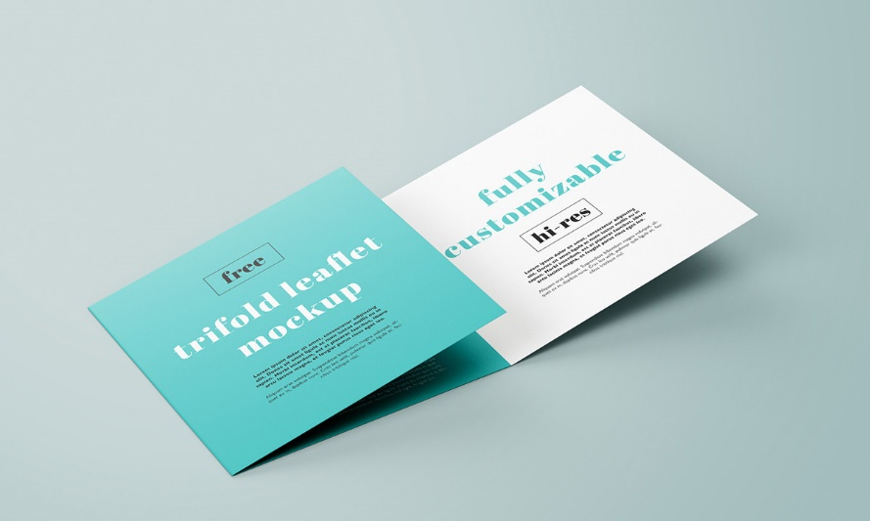
Each panel is US Measurements 7 1/16th wide by 7 14/16th height
- Cover Panel
- Back Panel
- One panel for American Classic overview
- One Panel for Tours
- One Panel for Festivals
- One Panel for Services
We would like the group of the logos to be laid out like this on the back if possible. Even though this brochure is for American Classic Tours this shows all of our brands under the parent Gerber Tours. .
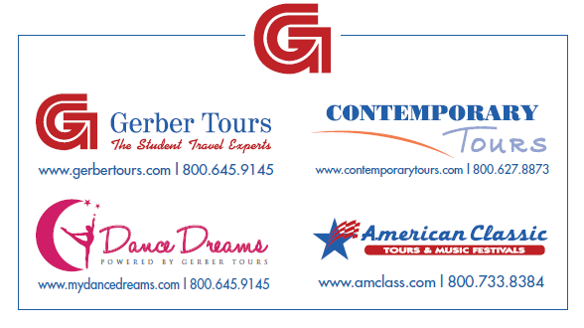
If too large with website and phone numbers we can remove those.
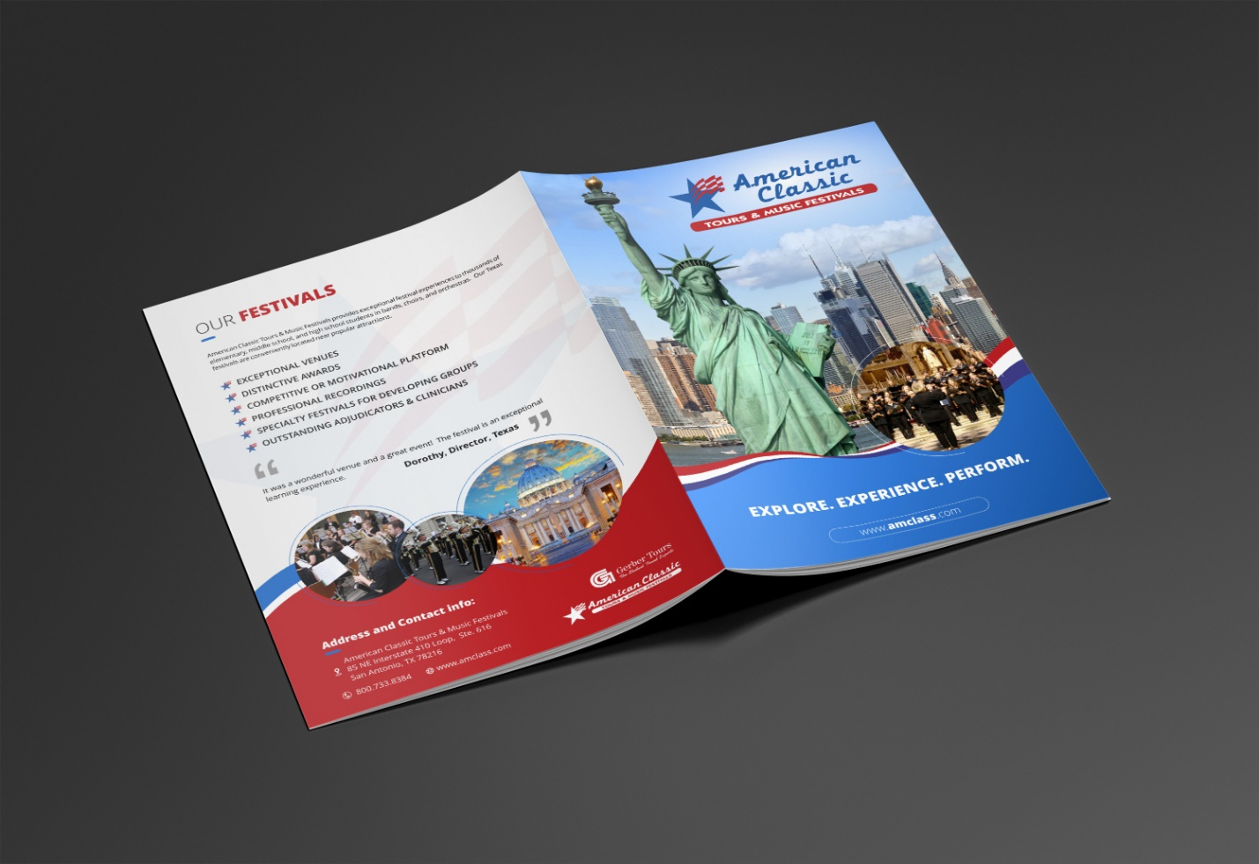
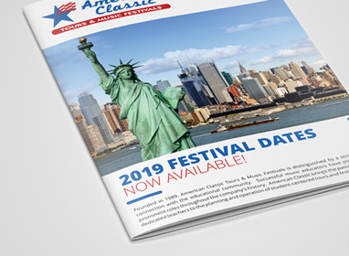
We like the use of the ribbon and the circle elements and would like to see this throughout the piece.
We would prefer a cleaner looking front, but keeping the ribbon and circle elements. Perhaps using white instead of the blue. See the example from another designer here. We don’t like this design but wanted you to see the white.

Also, we like this effect from another designer. It gives the color a bit of dimension, so it is not flat. Can you do something like this?


