Monday
Lunch:  M: Beef Enchiladas with spinach salad  ---------------------  D: Pineapple & banana smoothie | Tea:  M: Tuna mayo sandwiches  ---------------------  D: Fruit yogurt
Tuesday
Lunch:  M: Mixed egg fried rice  ---------------------  D: Vanilla ice cream | Tea:  M: Red pepper tomato pasta  ---------------------  D: Fruit jelly
Wednesday
Lunch:  M: Jacket potatoes with BBQ beans  ---------------------  D: Fruit salad | Tea:  M: Cucumber/ cream cheese sandwiches  ---------------------  D: Banana cake
Thursday
Lunch:  M: Chicken biryani  ---------------------  D: Stewed apples | Tea:  M: Courgette, lemon & chilli spaghetti  ---------------------  D: Shortbread
Friday
Lunch:  M: Homemade fish pie, with summer vegetables  ---------------------  D: Cinnamon & mixed spice cake | Tea:  M: Cheese & tomato soft rolls  ---------------------  D: Strawberry moose

Monday
Lunch:  M: Chicken pasta bake  ---------------------  D: Apple & raisins | Tea:  M: Selection of dips with pitta bread & crackers  ---------------------  D: Carrot cake
Tuesday
Lunch:  M: Jacket potatoes with tuna fillings  ---------------------  D: Frozen berry yogurt | Tea:  M: Cheese sandwiches  ---------------------  D: Fruit smoothie
Wednesday
Lunch:  M: Spaghetti beef meatballs  -  --------------------  D: Semolina | Tea:  M: Tomato & sweetcorn soft rolls  ---------------------  D: Pineapple slices
Thursday
Lunch:  M: Chilli bean stew with white rice  ---------------------  D: Melon medley | Tea:  M: Ploughman’s tea  ---------------------  D: Mango sorbet
Friday
Lunch:  M: Baked lemon cod fish, with crushed potatoes  ---------------------  D: Chocolate cake | Tea:  M: Greek pasta salad  ---------------------  D: Fruit jelly

Week 1
Monday
Lunch:  M: Chicken fajitas with cauliflower cheese  ---------------------  D: Natural Greek Yogurt, with honey | Tea:  M: Tomato sandwiches  ---------------------  D: Fruit Jelly
Tuesday
Lunch:  M: Tuna & Sweetcorn pasta  ---------------------  D: Vanilla Ice Cream | Tea:  M: Mushroom pizza slices  ---------------------  D: Chocolate moose
Wednesday
Lunch:  M: Lamb Kheema  ---------------------  D: Banana custard | Tea:  M: Egg mayo sandwiches  ---------------------  D: Apple & pear slices
Thursday
Lunch:  M: Mixed bean vegetable hot pot, with potatoes  ---------------------  D: Summer fruit crumble | Tea:  M: Turkey soft rolls  ---------------------  D: Peaches & cream
Friday
Lunch:  M: Thai fish curry & white rice  ---------------------  D: Bread & Butter pudding | Tea:  M: Superfoods cous cous salad  ---------------------  D: Fruit smoothie

Week 3
Week 2

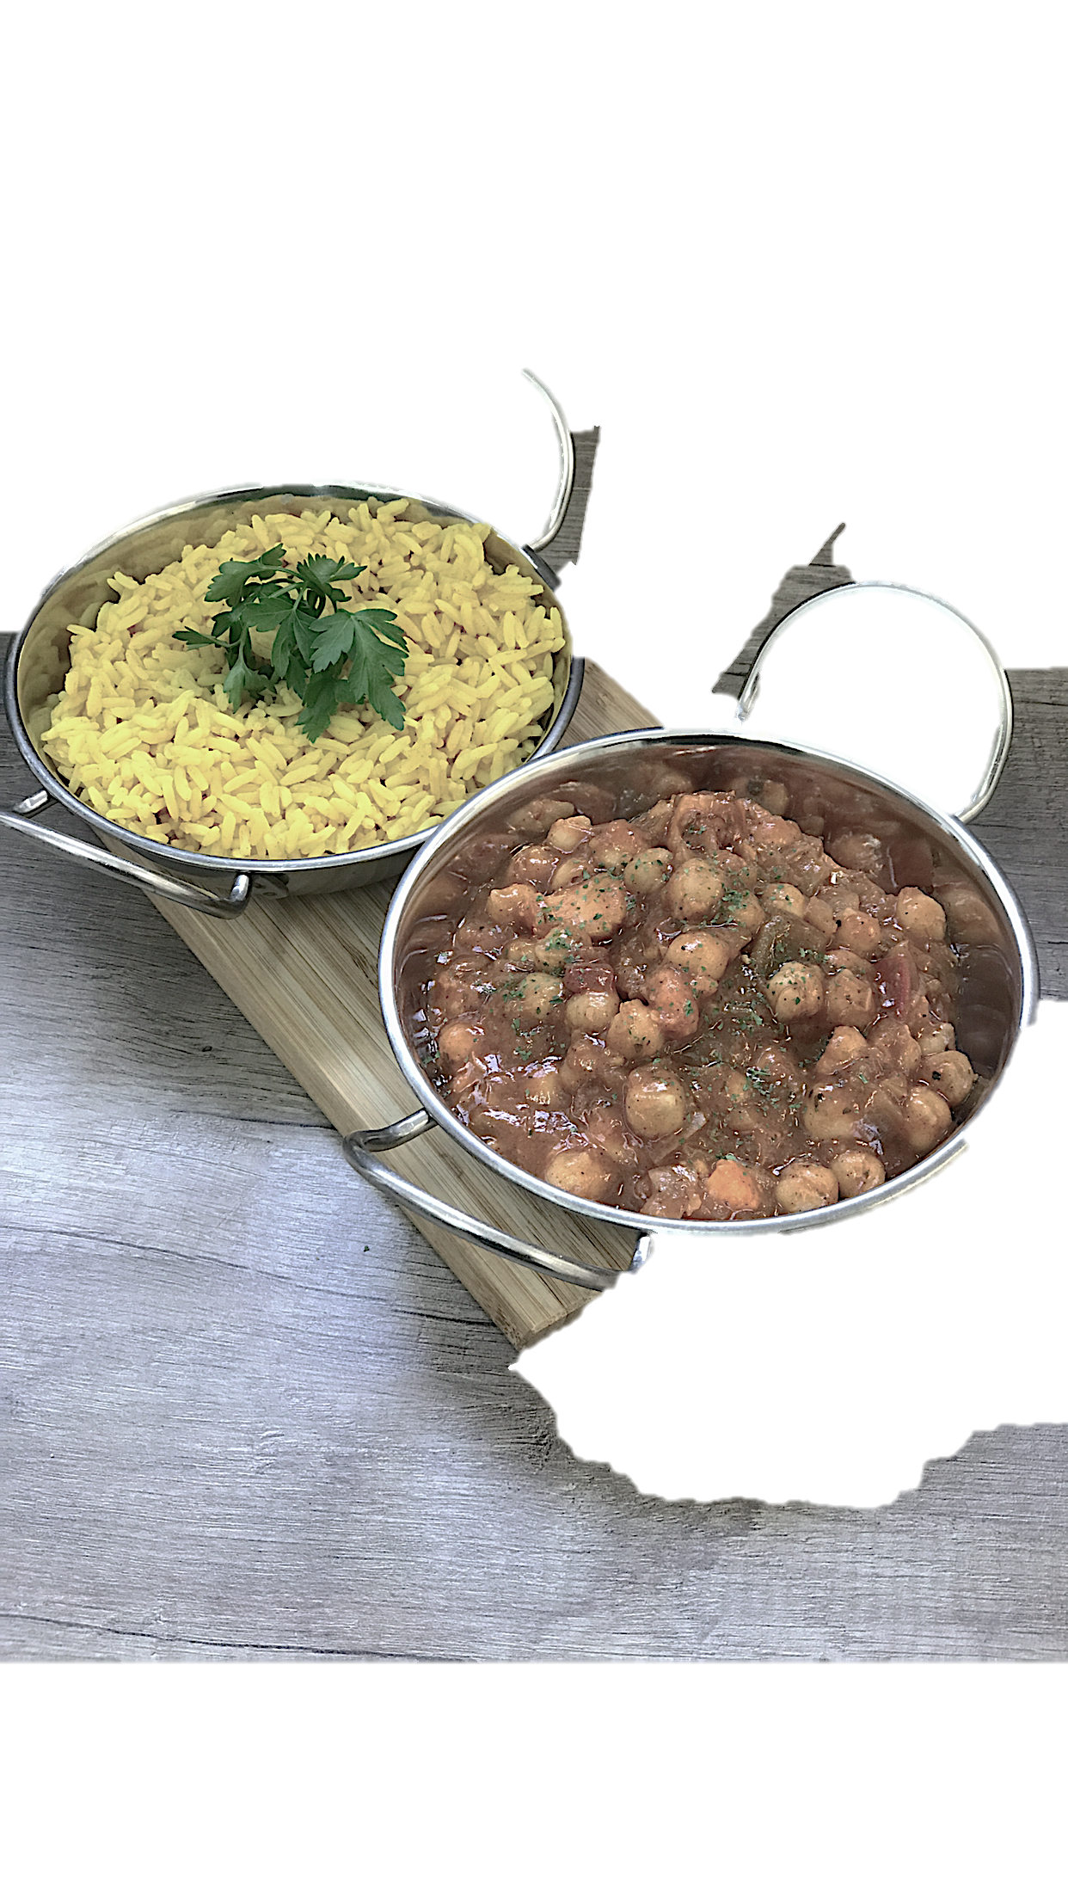
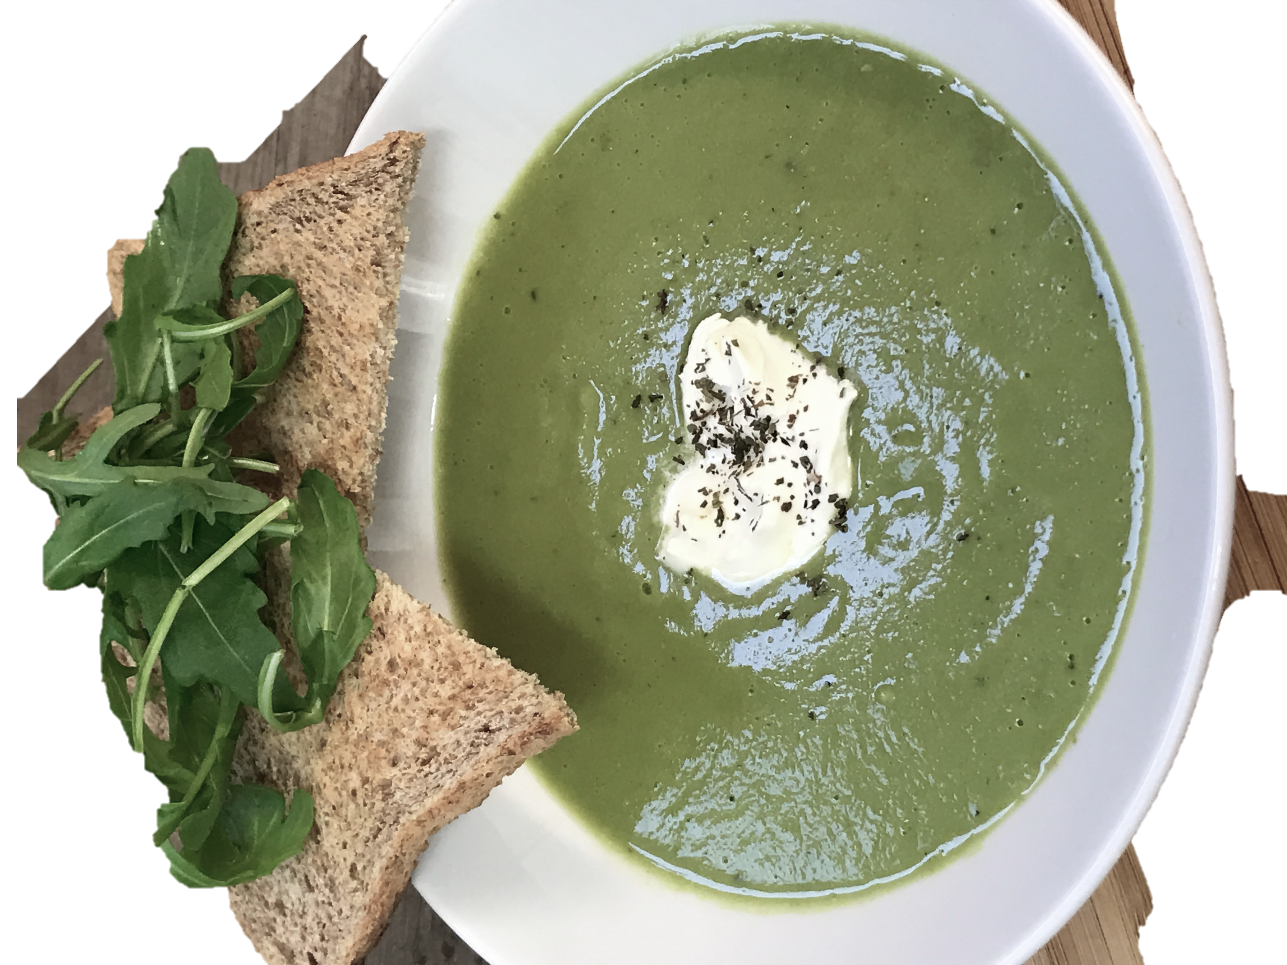
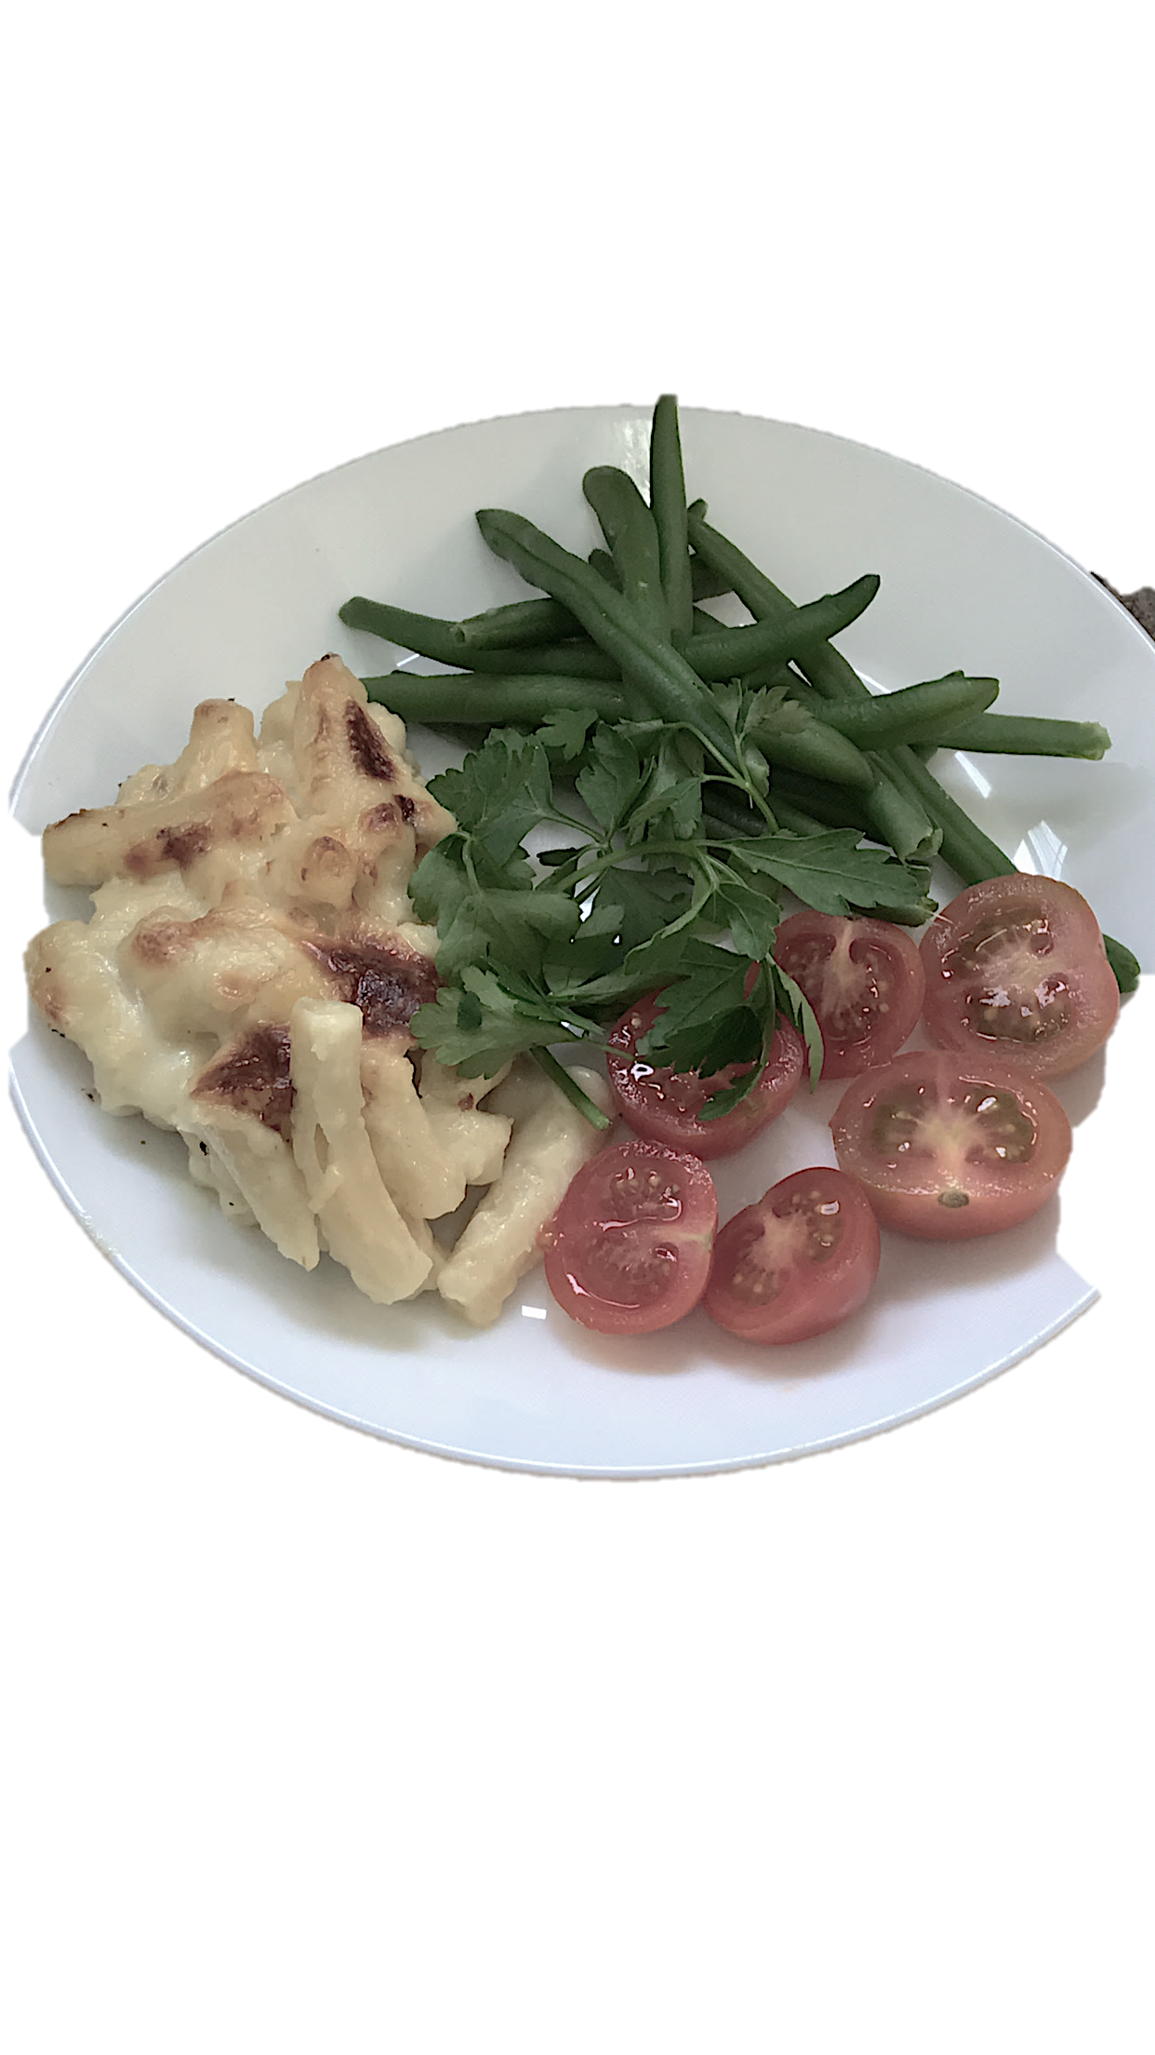





About Us

A professional and affordable contract catering company, delivering “hot food” to your business daily.

We pride ourselves on top quality meals and service, and won’t scrimp on quality.

We serve children’s nurseries and businesses in and around the M25 London area. We are expanding all the time. Contact us a call to see how we can help your business.

CALL US FOR A NO-OBLIGATION TRIAL

0203 773 4288
3 seasons menu
Winter ----------
Spring -----------
Summer ----------

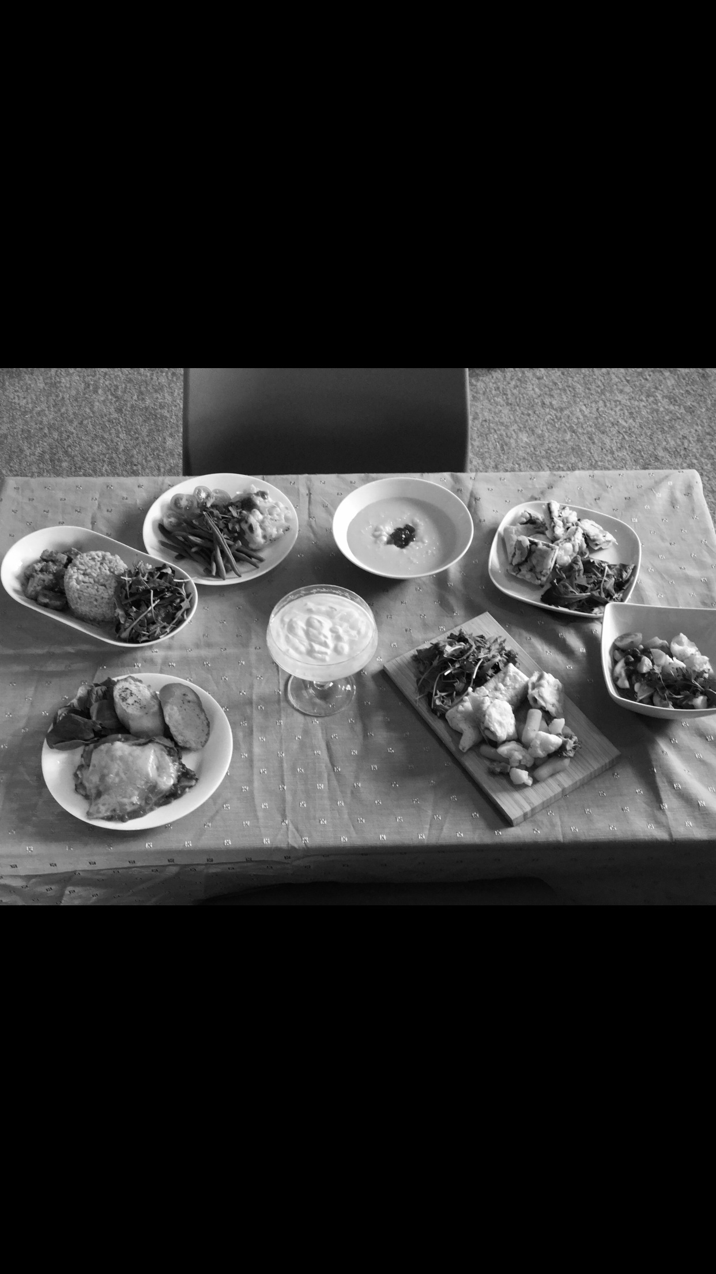




www.TheLunchbox.Catering
212 Becontree Ave,
Essex,
RM8 2TR

Tel: 0203 773 4288

Non dairy, gluten free, wheat free, no soya, Halal, texture specific...
We tailor for all, whilst making well-balanced varied and nutritious meals. Delivered hot.

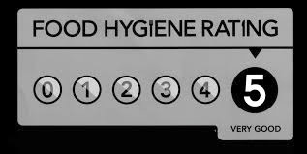



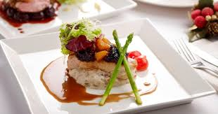



From nurseries to businesses, we offer hot lunches & tea for adults and children.
We are proud to stand behind our dishes on our new 3-week rotation menu.

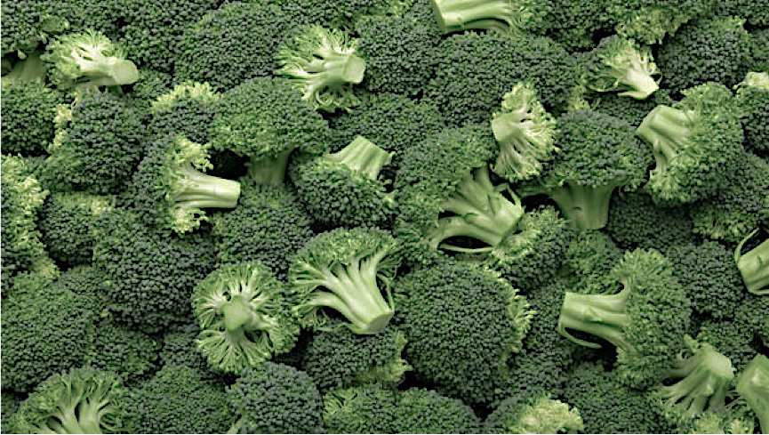
------- Client feedback ------
“Absolutely love it, amazing food & great service every time!“ – Emma Brown, customer

“Great food and service! Perfect for our hungry little ones“ – Jamie Hodgson, Area Manager of local nursery

fresh local seasonal produce, full of flavour for your little one.
Cleaner Greener
One of our many policies, is to promote healthy eating through our abundant use of fresh fruits and vegetables, and our limited use of salts and sugars.
Summer Menu
(June-Aug)

