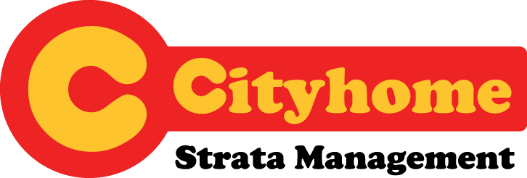

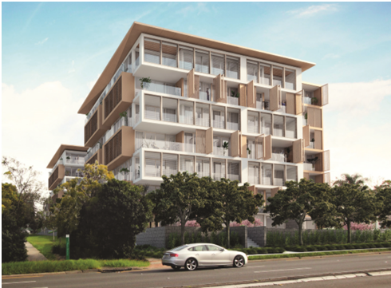
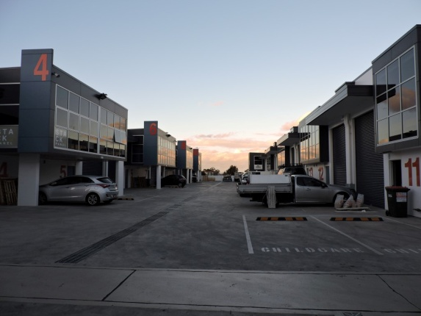
We offer tailor made strata management service to owners/developers of:
- Residential/Mixed use properties
- Commercial/Industrial properties

At Cityhome strata we treat your property like we would our own!


Cityhome is proud a member of

Introduction
CityHome strata management is a boutique strata business catering for the proprietor/s looking for a better way to manage your complex. Our staff has over 35 years’ experience in the industry and keep themselves updated with changes to new strata laws as they are introduced.
We know how important it is for you to make sure your complex is always well maintained therefore we place importance on prompt customer service and making sure, your maintenance is attended in a quick and timely manner. We also use only licensed and professional tradespeople who guarantee all repairs.
Why Cityhome
- We respect people no matter their cultural background. We are a multicultural company and our staff are able to communicate in a number of languages as well as English. We will support your correct entitlements with respect and fairness
- At Cityhome strata we have a commitment to ensure that all repairs and maintenance is attended to ASAP. We have an excellent after hours service which can be reached when the office is closed by just phoning our office number and you will be automatically transferred through to our tradesman.
- Management fee: our management fee includes costs for emails, photo copying, faxes, postage costs and phone calls. We also use the rockend computer system which provides owners with all their information requirements 24/7.
- CityHome understands owners corporations are concerned with costs of maintenance etc and we are committed to provide tradesman who will undertake repairs at the best price while maintaining the highest quality repairs and service. All work is guaranteed for a reasonable time.
- Response times: our office is open 9am to 5pm Monday to Friday. A Staff member will reply to your phone calls within one hour, voice mail within 3 hours and written correspondence on the same day.
- After hours emergency service: residents only need to phone our office and they will be automatically transferred to an afterhours tradesman who will arrange repairs.
- Regularly visit all our buildings to check for repairs and maintenance and all breaches of by-laws.
- Efficient communication. We recommend regular communication with the Executive Committee and we also are able to organise electronic communication with owners which is cost effective and quick.
- We use only fully licensed and experienced tradesmen who guarantee all their work.
Service for owners
Apart all the standard services required by the act, Cityhome is always committed to the following services to ensure you living in a pleasant and clean environment.
- A swift response to requests for repairs and maintenance.
- Regularly inspect your complex and address issues such as: rubbish, poor cleaning, improper maintained garden, parking at restricted areas etc. on a timely basis.
- We proactively communicate with committee members regularly to ensure your complex is well maintained.
- We understands owners corporations are concerned with costs of maintenance etc and we are committed to provide tradesman who will undertake repairs at the best price while maintaining the highest quality repairs and service.
- Our strata manager checks all invoices and authorises them before payment and will provide a copy to the Executive Committee if required. Approval before payment can also be organised, subject to work orders issued.
- Ensuring all properties are adequately insured.
- Applications for mediation. We can provide information and assist with all disputes.
- Ensure the scheme complies fully with all Fire Safety Regulations.
- Comply with the fiduciary obligations of being an agent.
- Provide experience in handling "difficult" or complex strata issues (like disputes, disasters and emergencies)
- Ensure the scheme complies fully with all Fire Safety regulations.
Service for developers from pre-settlement stage:
We understand smooth settlement is a major concern of both developer and buyers. Cityhome's senior staff member has the experience and knowledge to facilitate smooth settlement. The services we provide at no cost to developers include but not limited to the following.
- Liaising with solicitors as required to assist with settlement
- Reviewing and assisting with establishment of the strata plan and title registration
- Discussing and reviewing Strata By-Laws
- Preparation of budget before 1st AGM
- Attending to insurance renewals, ensuring building is covered before AGM.
- Inspecting buildings with builder / developer to discuss any delays / problems
- Liaise with builder regarding any defects advised by owners before 1st AGM.
- Production and posting of documentation for 1st AGM
- Assist owners with maintenance issues before 1st AGM
- Organising inaugural meeting after registration of strata plan
- Establish records, Strata roll and minute books.
- Preparing and issuing section 184 Certificates
- Ensuring new owners are compliant with strata schemes management ACT
- Providing building supervisor to assist owners moving into their units.
3 simple steps to help you out of trouble
- call/email us to make appointment

- We arrange site visit & inspection with owner, chairman or secretary

- We provide proposal/solution to address your issues

P: 02 9683 2695
E: info@cityhomestrata.com.au

www.cityhomestrata.com.au
A: Suite 7, 383 Church St, Parramatta 2150 NSW

