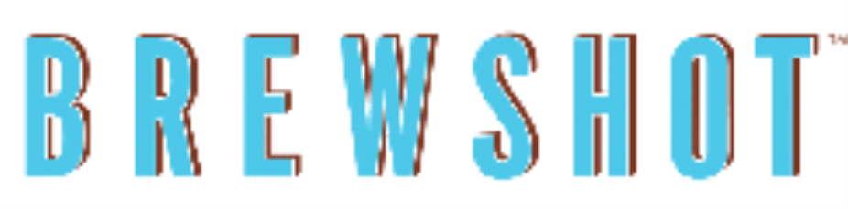

Entrees
Choose Your Side: Home fries, Fruits or Salad.

Double Take
Two eggs any style, two pieces of bacon, two pieces of toast $8.95

Bourbon Apple French toast
Thick cut brioche bread, bourbon caramelized apples orange cream cheese and cinnamon brownsugar $9.95

Classic Eggs Benedict
Traditional Canadian bacon and two poached eggs over a toasted English muffin and buttery Hollandaise on top. $12.95
Breakfast burger $13.95
Angus Beef, sausage patty, cheddar cheese, caramelized onions, lettuce and tomato on toasted brioche roll $14.95

Steak & Eggs
Grilled Skirt steak and two eggs sunny side up $15.95

Omelets

served with home fries and toast.

Egg White Omelet$9.95
Marinated chicken breast and broccoli
Vegetable Omelet$10.95
Mushrooms, peppers, red onion, spinach, and cheddar cheese
Chicken Omelet$12.95
Marinated chicken breast, spinach, tomato, caramelized onions, and pepper jack cheese
Smoked Salmon Omelet$13.95
Green onions, red peppers, cream cheese, and sliced smoked salmon

