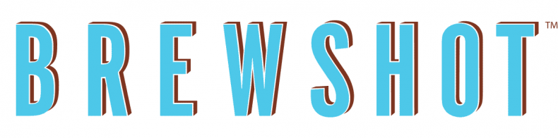
Breakfast

Build Your Own Breakfast Sandwich
Choose your bread: $2.50
- Bagels (daily selection)
- Brioche Roll
- Brioche Toast
- Ciabatta Rolls
- Croissant (add $1.00)
- Gluten Free bagel (add $1.00)
Add Cheese: $1.00
- American
- Cheddar
- Pepper Jack
- Swiss
- Cream Cheese
- Flavor Cream Cheese (add $. 50)
Add Protein: $1.00
- Bacon
- Egg
- Turkey Bacon
- Pork Roll
- Sausage
- Avocado

Sandwiches Served with home fries or fruits
EBLT $7.95
Fried egg, crispy bacon, arugula, tomato, and mayonnaise on brioche roll
SMOKED SALMON SANDWICH $11.95
Sliced smoked salmon, cream cheese, red onion, lettuce, and tomato between a soft toasted brioche roll
Breakfast burger $13.95
Angus Beef, sausage patty, cheddar cheese, caramelized onions, lettuce and tomato on toasted brioche roll
Omelets Served with home fries or fruits
EGG WHITE OMELET $9.95
marinated chicken breast and broccoli stuffed.
VEGETABLE OMELET $9.95
Mushrooms, peppers, red onion, spinach, and cheddar cheese
CHICKEN OMELET $9.95
Marinated chicken breast, spinach, tomato, caramelized onions, and pepper jack cheese
SMOKED SALMON OMELET $11.95
Green onions, red peppers, cream cheese, and sliced smoked salmon stuffed inside an omelet

