The SACS Climate Survey

Organisational Climate & Organisational Performance

Climate surveys, when designed and implemented well, provide organisations with an accurate picture of employees‟ opinions and perspectives at a given point in time on a range of topics. Serving essentially as a „thermometer‟ to measure organisational climate, they provide clear direction in terms of where to focus efforts in order to increase employee engagement, discretionary effort and the organisation‟s overall performance. Research shows a strong link between organisational climate and organisational performance with levels of employee engagement being a particularly strong predictor.

Research tells us that engaged employees approach their work with high levels of energy, they are committed to their work and enthusiastically approach challenges as well as easily getting into a „flow‟ state whereby they are captivated by their work and time seems to pass effortlessly. Engaged employees tend to „job craft‟ focussing on outcomes rather than emotions, they build and manage resources appropriately and redesign their jobs to ensure they‟re most effective. They are also more likely to collaborate with others and importantly, increase the demands of their job meaning they take more initiative and hold themselves to higher and higher standards.

SACS Research & Tool

In 2015, SACS partnered with Deakin University in a study of over 2600 Australian employees to investigate the key drivers of engagement. In this study, engagement was considered to comprise:

Energy: Are people coming to work energised and enthusiastic?
Commitment: Are employees dedicated to their roles?
Flow: Are people “drawn into” their work so time seems to fly?

We found that the critical factors which determine levels of engagement are job, team and organisational resources as well as leadership.

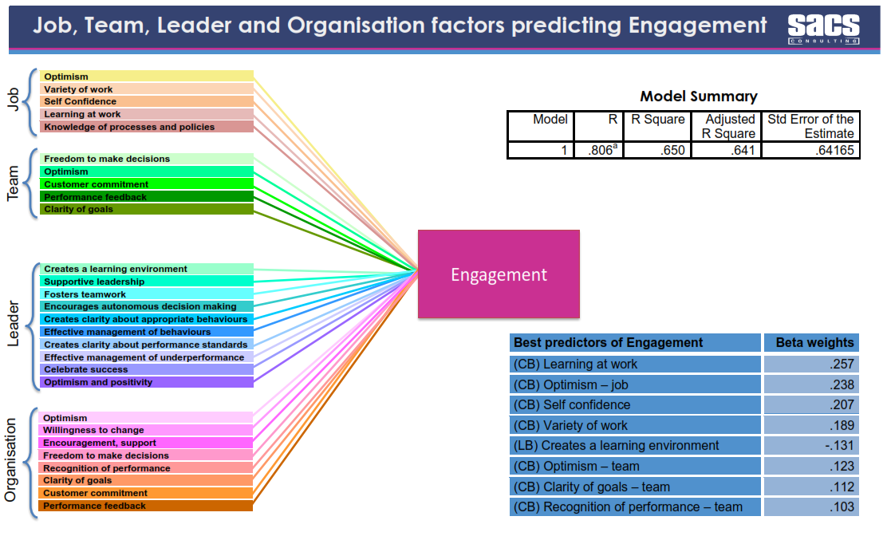
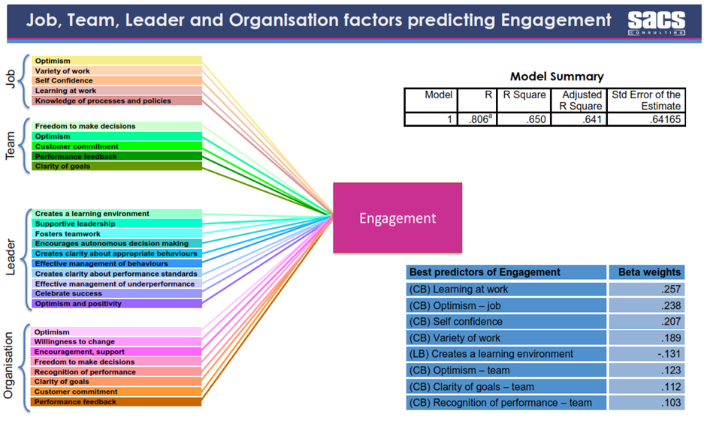

Using insights gained from our own primary research, we have created a set of questions to assess organisational climate giving you the ability to find out how engaged your employees are and win which areas you should focus improvement efforts.

Benefits of SACS tool

♦ Australia normative comparison provided
♦ Option to have us administer the tool entirely or manage it in house
♦ Cost effective
♦ Option to add open ended questions to probe any further areas of interest
♦ Reporting at Organisational, Divisional, Team (etc.) level

Appendix 1: SACS Subset of Questions

Below is a subset of questions from the SACS climate survey. Participants are asked to respond to these items
on a scale of „Strongly Agree‟ to „Strongly Disagree‟.

Overall Engagement
♦ Energy: „I feel energetic at work‟
♦ Commitment: I am determined to be good at my job
♦ Flow: When I am at work I do not think about anything else

Organisation Resources
♦ Optimism: I think things will get better for this organisation
♦ Willingness to change: This organisation readily changes the way that we do things
♦ Encouragesment, support: This organisation wants people to be supportive to each other
♦ Freedom to make decisions: The organisation encourages people to do what they think best
♦ Recognition of performance: We have organisation wide recognition for good performers
♦ Clarity of goals: The organisation has clear goals it is trying to achieve
♦ Customer commitment: We try our best to make customers happy in this organisation
♦ Performance feedback: Staff are told when the organisation is doing well or badly

Leader Resources
♦ Creates a learning environment: The person I report to creates a learning environment
♦ Supportive Leadership: The person I report to is helpful to me
♦ Fosters teamwork: The person I report to encourages us to work as a team
♦ Encourages autonomous decision making: The person I report to allows me to make my own decisions
♦ Creates clarity about appropriate behaviours: The person I report to makes it clear to me how I should behave
♦ Effective management of behaviours: The person I report to steps in when people are misbehaving
♦ Creates clarity about performance standards: The person I report to sets clear performance standards
♦ Effective management of underperformance: The person I report to manages underperformance well
♦ Celebrate success: The person I report to is good at celebrating success
♦ Optimism and positivity: The person I report to is an optimistic person

Team Resources
♦ Freedom to make decisions: In my workgroup I am permitted to make my own decisions
♦ Optimism: I think things will get better for my team
♦ Customer Commitment: Our team tries its hardest to make customers happy
♦ Performance feedback: I get helpful feedback in my team
♦ Clarity of goals: It is very easy for me to know whether I am succeeding or failing in my team

Job Resources
♦ Optimism: I am excited by the way my job is developing
♦ Variety of Work: My work is very varied
♦ Self confidence: I am good at what I do
♦ Learning at work: I build my abilities at work
♦ Knowledge of processes and policies: I know all the necessary policies and procedures at work

