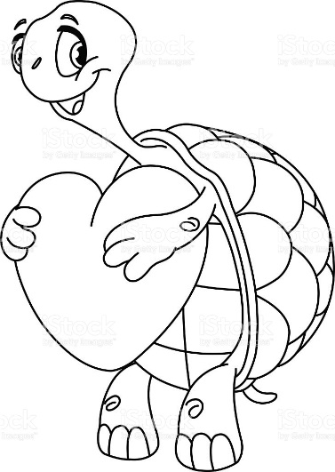

Notes
Company has a 3-color logo (black, red PMS 485, tan PMS 467). Suggested ideas:
- Image above (with color)
- Turtle crawling along a path of hearts
- “Snap Into Action!” slogan
- Add “Greater Northern NJ Heart Walk”
- Add “October 22, 2017”
- Design not need for the front of the shirt since we will just use the logo

