Designer Babies
Should we be better than we are?

a short documentary

A Victoria Sutton Film
Victoria Sutton, writer, director, editor, producer, narrator.

Designer Babies
Should we be better than we are?

a short documentary

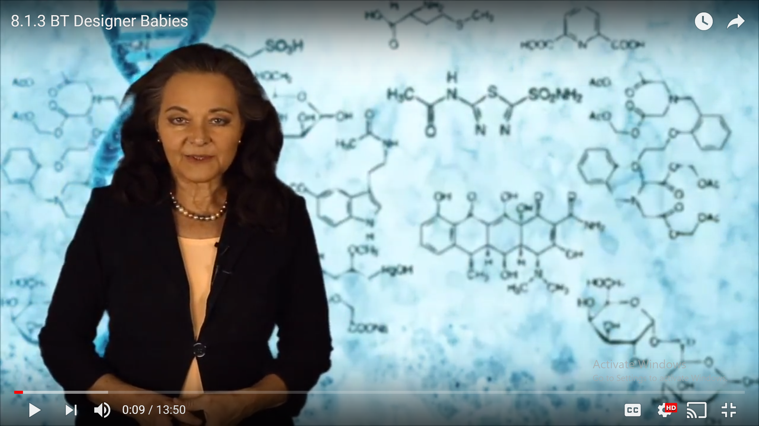



A Victoria Sutton Film
Victoria Sutton, writer, director, editor, producer, narrator.

