

Altus Technology Solutions
“Where Technology, Expertise, and Integrity Meet”

CAPABILITY STATEMENT
Since 2004, Altus has been committed to delivering superior quality, performance-based services and solutions. Altus provides expert level multi-discipline Engineering and Technology support solutions to Commercial, Federal, State and Local government mission partners. Altus is an ISO 9001:2008 certified small business contractor focused on providing mission-critical services and solutions in IT network management, operations and maintenance, cyber security, software and application testing, infrastructure engineering and integration, and telecommunications support.
CORE COMPETENCIES | KEY DIFFERENTIATORS
- Information Assurance\Cyber Support  - Security & Network Boundary Protection  - IT Compliance and Governance  - Program & Project Management  - Infrastructure Operations & Management  - Software & Application Testing  - Telecommunications Support Services | - Extremely Cost Competitive  - Broad Corporate Experience Servicing Diverse Contract Types  - Dedicated Mission and Customer Focused Staff  - Excellent Reputation for Customer Relationships and Satisfaction  - Trained and Certified (CISSP, CEH, ITIL, PMP, RHEL, CISCO) Staff  - 75% of Staff Hold Security Clearances  - DCAA Approved Accounting System
NAICS CODES | RELEVANT PERFORMANCE
517919 – Other Telecommunications  541330 – Engineering Services  541511 - Custom Computer Programming Serv.  541512 - Computer Systems Design Serv.  541513 - Computer Facilities Management Serv.  541519 - Other Computer Related Services  541611 - Administrative Management &  General Management Consulting Services  541612 - Human Resource Consulting Services  541618 - Other Management Consulting Services  541690 - Other Scientific and Technical Consulting Services  561210 - Facilities Support Services  611420 – Computer Training | 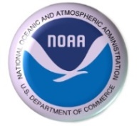  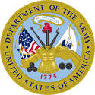 | Altus provides support services to ActioNet, Inc. (ActioNet) for multiple National Oceanic and Atmospheric Administration (NOAA) tasks. The Altus team works with ActioNet to develop the FISMA compliant Assessment & Authorization (A&A) Packages for NOAA. The team is responsible for the analysis of the system security posture in order to create system security documentation including the SSP and Risk Assessment.
 |  | Altus staff provides operation and maintenance of the Yakima Multi-Purpose Training Range (MPTR) and Digital Multi-Purpose Range Complex (DMPRC). Altus support services include program management and facilities support services. The DMPRC responsibilities include support of the range fiber optic and electrical cables, static EODT (Explosive Ordnance Disposal Technologies), Green Targets and a thirteen (13) Connex container village.
  CERTIFICATIONS  ISO 9001:2008: 54246  SBA 8(a) Certification: 304377  GSA Schedule 70: GS-35F-288CA  SeaPort-E: N00178-15-D-8074  MDOT MBE/DBE: 12-547  Maryland SBR: SB12-3036  Maryland CATS+  MWAA LDBE/DBE  Cage Code: 4T9N5  Top Secret Facility Clearance    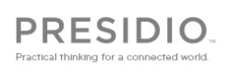    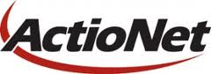    PARTNERSHIPS | 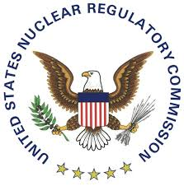  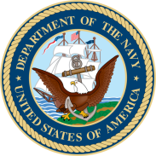 | Altus provides support services to the U.S. Nuclear Regulatory Commission for the Region I Telecommunication System. The Altus team is responsible for the uninterrupted operation of the Avaya PBX system. Services include system security, maintenance, upgrades, and audits. The Altus engineers and support team also provide supplemental technical support including: Unified Communication Manager functionality, Adds/Moves/Changes, and ISDN circuit support.
Altus provides support for the research, development, test, and evaluation (RDT&E) programs under the WSL in the Survivability Division of the Systems Engineering Department at the NAVAIR WD China Lake. Altus personnel provides the following technical support:
- Testing and evaluation of the survivability of U.S. aircraft and missiles against foreign threats
- Testing and evaluation of the lethality of U.S. weapons against foreign aircraft and missiles
- Safe separation testing of free fall and other weapons
- Aerodynamic testing of weapons and recovery systems

CONTACT INFORMATION  Altus Technology Solutions  1121 Annapolis Road #211, Odenton MD 21113  www.AltusTS.com  David Brashear – President  Phone: 443.312.2069 x.101  Fax: 443.296.8393  Email: dbrashear@AltusTS.com | 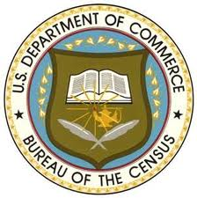  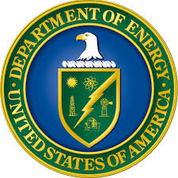 | The Altus team is responsible for systems architecture, development, engineering and management activities for all existing and planned Office of Management (MA) IT systems and management processes. The team provides system and process engineering, and managerial resources for the support of mission applications that support MA functions including: FOIA, Information and Quality Assurance, facilities management, asset and property management, document, business administration, and customer relationship management.
Romica Brashear – Operations Director  Phone: 443.312.2069 x.102  Fax: 443.296.8393  Email: rbrashear@AltusTS.com |  | Altus provided support services to the U.S. Census Bureau. Ongoing IT services were provided to ensure that all Census components that are under the purview of FIPS199 Moderate Security Plan were secure and compliant. Our systematic approach allowed our computer security professionals to work closely with the Computer Services Division (CSvD) leadership to complete a full range of security tasks.

