  Cases we handle  At Dial & Associates, we bring over 30 years of legal experience to every case we handle. Over the years we have helped clients with cases involving:  - Workers’ Compensation  - Workplace Violence  - Construction Accidents  - Roadway Accidents  - Explosions  - Assault and Battery  - Slip and Fall  - Toxic Chemical Exposure  - Wrongful Death  - Defective Products
  Who We Are
  About Us
  Dial & Associates brings legal experience and a sincere commitment to solving the problems of injured individuals and their families throughout Southern California. We care about our clients and we believe in our responsibility to provide them with the skilled legal services they need to help them at a very difficult time in their lives.
  If you or a loved one has been injured in an accident or on the job, we are here to help you provides caring, compassionate representation rooted in more than 30 years of experience.
  Our founding attorney, Harvard Law School graduate Stephen F. Dial, takes a hands-on approach to protecting the rights of injured workers. You can expect to sit down with him, face to face, during a free initial consultation. He will listen to your story, get to know you and help you evaluate your options.
  When you need a compassionate and dedicated advocate, our legal team is here to help. We assist
  injured Orange County workers with obtaining the compensation they need to become emotionally,
  physically and financially whole again.
   |  | Dial & Associates PC  505 S Villa Real Drive  Suite 202  Anaheim CA 92807 US  PH: 714-279-8055  Fax: 714-279-8052
  
  Dial & Associates PC
    - Orange County Injury Attorneys
    - Focusing on Worker’s Compensation & Personal Injury Cases

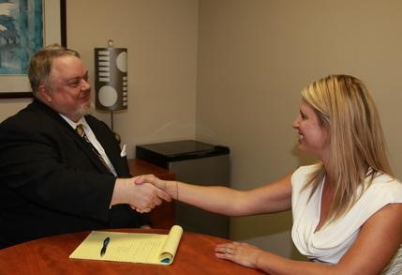  Why hire a Lawyer?  Most people hesitate to hire a lawyer because they “aren’t the kind of person who files a lawsuit” or they have “never hired an attorney before” and believe the insurance company they are dealing with will help them through the process. But that is just what the insurance companies want you to think.  The insurance companies are NOT on your side  In fact, the insurance industry spends billions of dollars each year on advertising to earn your trust but then they use that trust against you when you need them.  Insurance companies regularly:  - Deny legitimate claims,  - Settle claims for less than they are worth,  - Force you to jump through hoops to get the help you need, and  - Delay making payment at all costs. |  |  | Don’t let the insurance companies take advantage of you  If you or a loved one has been injured, you need an advocate, a lawyer who is on your side and is skilled in representing your interests. You want an attorney who will fight against the insurance companies that want to pay out as little as possible on your case.  The team at Dial & Associates knows how to maximize your benefits and guide you through this often confusing and frustrating process. We work hard to get you the largest recovery possible for your injuries.  Dial & Associates brings legal experience and a sincere commitment to solving the problems of injured individuals and their families throughout Southern California. We care about our clients and we believe it is our responsibility to provide them with the skilled legal services they need at a very difficult time in their lives. We are here to help you.  “They made me a priority from the beginning. My case was handle(d) with the upmost concern about my feeling and what I was going through.” - Hazel B. |  |  | Our Guarantee  At Dial & Associates, PC you are not just a case number, you are a person going through a challenging time.  We promise that when you need to, you will meet with your lawyer in person and when you have a question, we will happily return your calls.  “I love that I can call them with any question and they answer it right away” -Karla V.  Hiring an Attorney  We know that when you are injured, the last thing you want to worry about is paying for an attorney, that is why, At Dial & Associates PC, we handle all of our cases on a contingency fee basis.  That means you don’t pay for our services unless we negotiate a settlement for you or are successful at trial. That’s right, you don’t pay ANYTHING out of pocket to hire us.  Call us today at 714-243-8895 for a FREE consultation!

