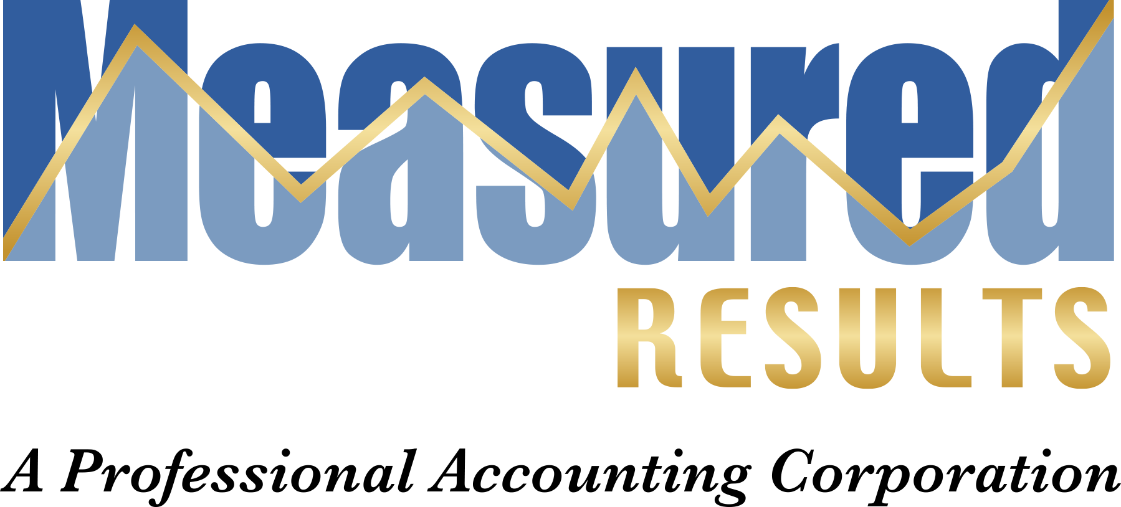
7 – Step Tax Solution Presentation Agenda:

7 Steps Tax Solution Presentation

Agenda

- We will first show you how to eliminate much of your self-employment tax on your return by converting your business into an S Corporation. A business owner making over $120,000 per year can save about $12,000 per year by doing this.
- We will show you how to get tax free income from your corporation by renting you home to the corporation for the board meetings. Many of our clients are getting up to $21,000 in tax free income which could put $8,400 cash into your pocket.
- We will show you the easiest way to track your expenses so that the only thing you will have to do to have rock solid books is to take a picture of the receipt and throw it away. It doesn’t get any better than that.
- Next, we show you the importance of tax planning and why it is critical to meet with your CPA before the end of the year and not just when you do your tax preparation.
- We will show you how to hire your children and get $7,500 per child tax free. This will save you $3,000 per child in income tax reduction.
- We will discuss how to make your child’s college education tax deductible. With college cost spiraling out of control this is a biggie. Most of our clients have a savings of about $12,000 per year of college.
- Our grand finale is to show you how to use, not one, but two corporations to get a several hundred thousand dollar tax deferral, get an interest free loan from the government and use that money to grow your business and your wealth.
If they drive by with a machine gun you don’t have to stand up.

Measured Results, A Professional Accounting Corporation
1444 W. Main St, Ste. C, Ripon, CA 95366
Phone: 209-599-8989 Fax: 209-599-8950
Byron@measuredresultscpas.com Tyler@measuredresultscpas.com www.measuredresultscpa.com

