Label for Weight management products

Brand: NUBIVE (can be used in 2 ways – just Icon – just name - or combined. We prefer Icon separate from the name)

Adobe AI file is attached in the project – can be any colour – ideally negative

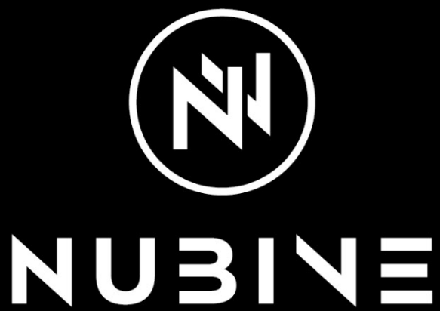

Brand Add on: Smart Dieting (NUBIVE Smart Dieting)

Colour: CMYK

Format: Adobe inDesign (preferable)

Design: modern, clear, minimum design (less is more) – lifestyle product

Buyers: mainly female, young and middle age

Sizes of labels: (we don’t need all sizes but you should keep in mind the sizes we are going to use the design in future for)

Size: 190 x 70 mm
Size: 200 x 75 mm
Size: 210 x 80 mm
Size: 220 x 90 mm
Size: 240 x 90 mm
Size 250 x 100 mm
Size: 250 x 180 mm
Size: 300 x 80 mm
Size: 300 x 150 mm
Size: 320 x 130 mm
Size: 340 x 52 mm
Size: 340 x 66 mm
Size: 420 x 105 mm
Size: 440 x 190 mm

The product consists of two types:

- BIO certified Pro-Biotics as a meal replacement
- Common weight loss products as Proteins, BCAA, L-Carnitine, Omega 3…

Packaging Samples: (labels are used on white and black plastic jars)

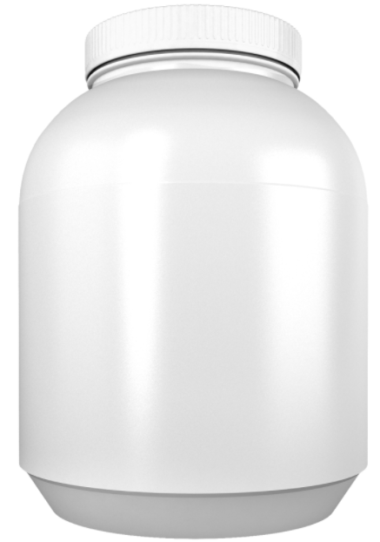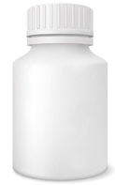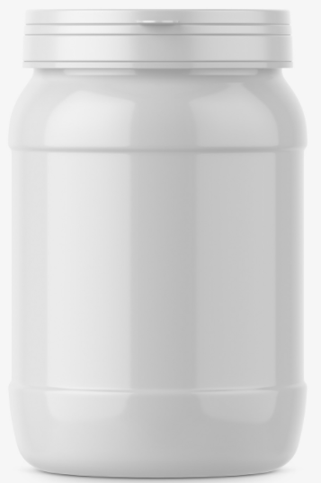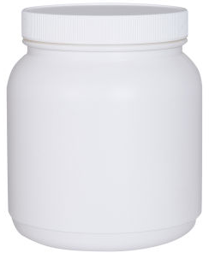

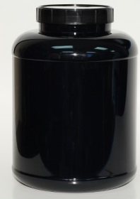

To get a better understanding, I will upload several blank labels which contains text only.

