WORDPRESS WEBSITE - DESIGN BRIEF

The Job | Design WORDPRESS Website for E Commerce Business
About Us | Bear & Kub will be suppling quality baby / kids products
Geographical audience | Global
Target audience | Female / Working Mums / New Mums
THE SPECIFICATIONS
Business name | Bear & Kub
Logo | 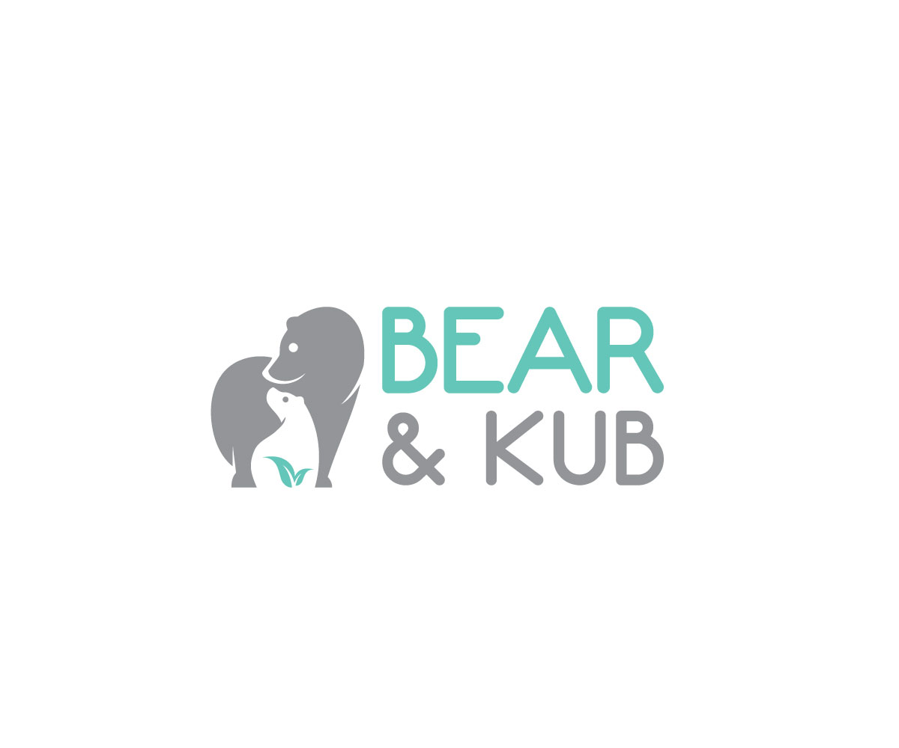
Preferred colours  (if any) | COLOUR COMBINATIONS  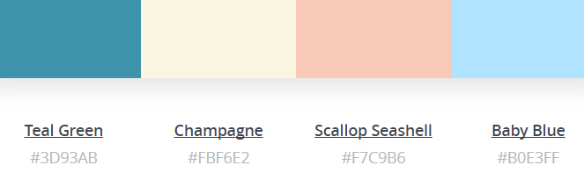  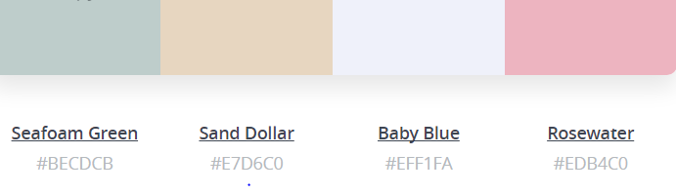  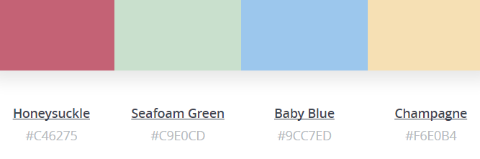
What we don’t like.. | Too many colours and too much detail
Design requirements | The website design must:  - appeal to both boys and girls, but a design that mum likes also (as she does the purchasing). Not too cutesy.  - it must also come across as modern and progressive.
Deadline | ASAP

