Overall Brief

We are looking for a new logo for Digital Post Solutions. This is a refresh of our existing brand to encompass all the other elements that DPS provide in the form of products and services

DPS are personal, adaptable and vastly experienced in helping businesses implement & manage the most accurate & cost-effective postal & print solutions.

We have an excellent reputation across our 2,500+ customer base for our caring and knowledgeable service team.

We provide cutting edge technology from the products we supply, alongside many years of experience across the team to implement the right solutions for our customers that enables them to realise efficiencies across the board.

We would like to see clean, simple, fresh and impactful designs that incorporate the broadness of the products and services that we offer. We are looking to keep DPS as the core brand name, so all designs will need to incorporate this.

Most of the competition have a ‘symbol’ that sits across the brand and pulls it all together. Competitors in the space are Neopost, Pitney Bowes, Mailcoms, The Mailing Room, IMS Franking & European Postal Systems.

There are three core product divisions:
- Franking
- Copiers
- Supplies

We would like to see some experimentation with the logo to provide differentiation for each division.

Logo Design Requirements

Must Have:
- The logo must incorporate the letters ‘dps’ or ‘DPS’
- Ideally it would include a bespoke icon or shape – not product specific please (no tiny printers or envelopes).
- No set colour palette – please keep bold and vibrant but avoid central primary colours of pure red, yellow, green & blue. i.e. #ff0000, #00ff00, #0000ff
  - (alternate shades of these colours is fine)

Should Not Have:
- Please avoid clichés such envelopes – please try to focus technology rather than ‘print solutions’
- No stock icons please – must be bespoke
- No people icons.

Examples of logos that we like:

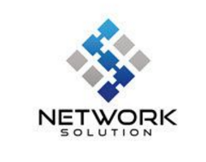
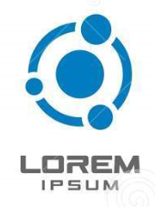
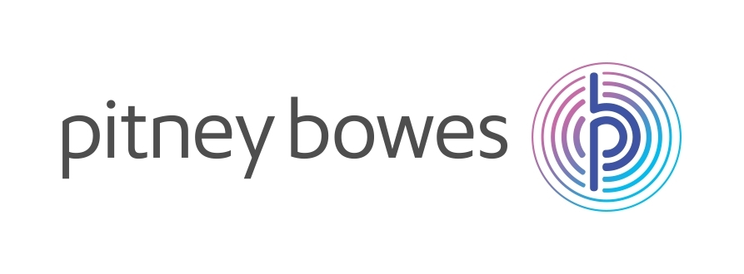

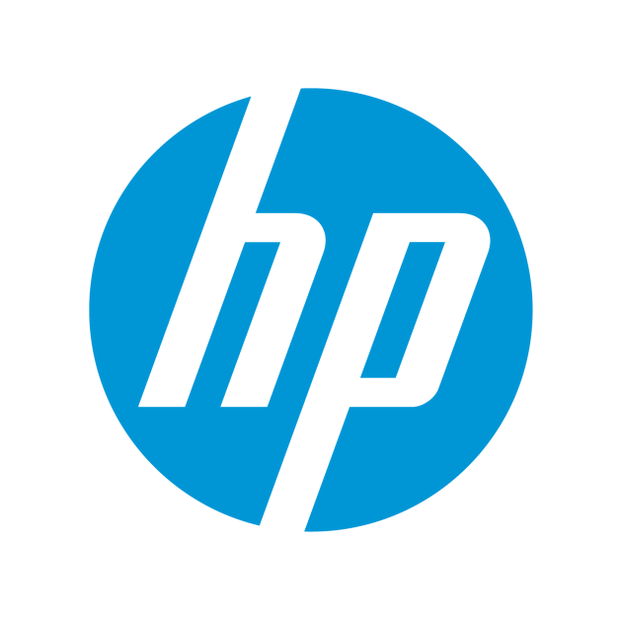
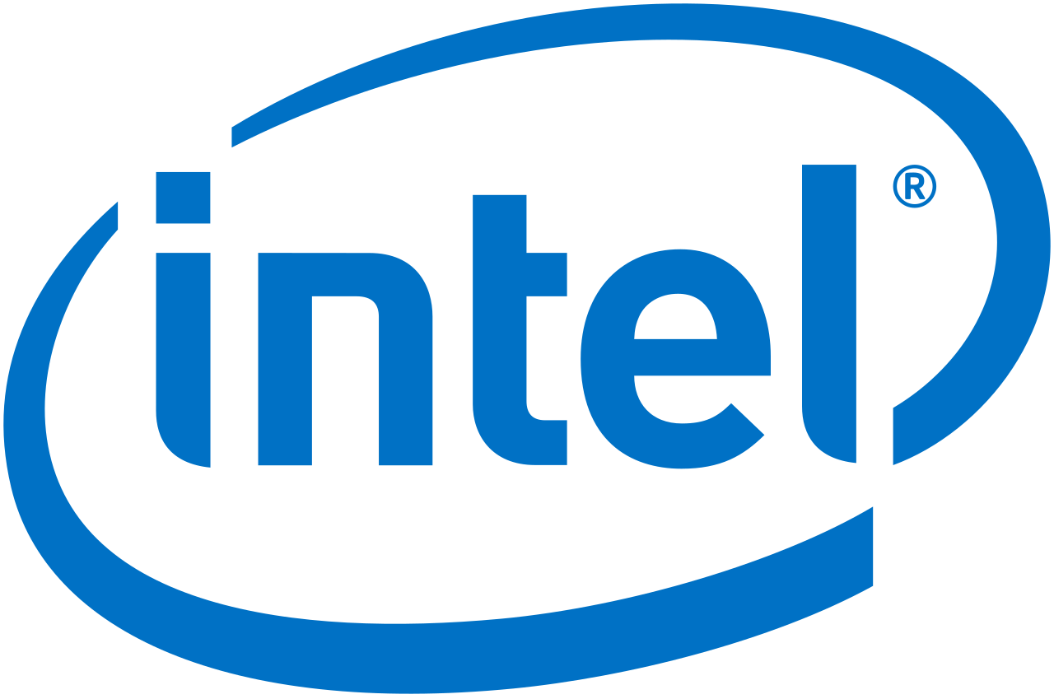

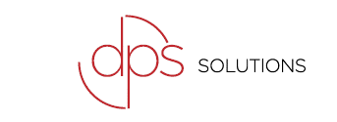
This logo is something the company had through from a series of designs from an agency a few years ago. We quite like the clean style of it, but it doesn’t have a ‘symbol’ that can be used across different areas that the business specialises in.

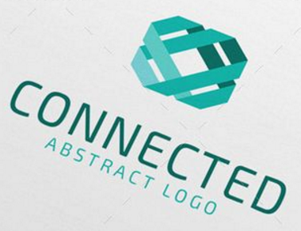

We particularly like the ‘3D’ element of this logo’s ‘Symbol’.

ENDS

