The Well Life

In This Issue:
- Pain Awareness Month
- 15 minutes of fame
- It’s Official
- Don’t Operate, Regenerate!
- Back to School Botox Special
- Your Sinus Solution
- Breast Thermography
- Get Fit for Fall
- Recipe of the Month
- Feedback Wanted

Please like and follow us on facebook! We share regular updates and health tips.

Upcoming Dates
Get Fit For Fall Kickoff 9/18
Back to School Botox Special
9/22-23rd

September is Pain Awareness Month

What You Need to Know
- Nearly 100 million Americans experience chronic pain —more than those who have diabetes, heart disease and cancer combined.
- Pain is a warning sign that indicates a problem that needs attention, don’t just mask your symptoms, let us help try to get to the root of your issue.
Check out some of the many services we have that can help you with your pain:
Osteopathic Manipulation, Acupuncture, Prolotherapy, PRP, and Stem Cell Injections, Spinal Decompression, Infrared Sauna, Hyperbaric Oxygen, 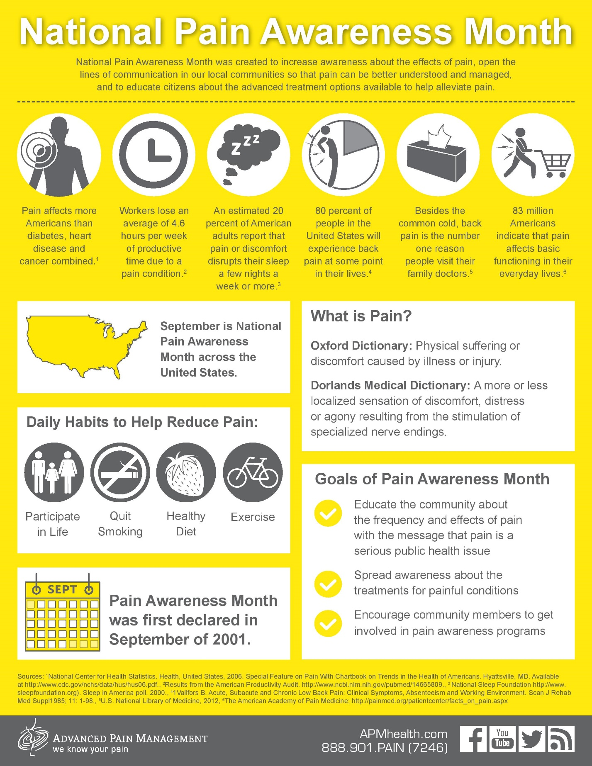

15minutes of fame
Check out our new videos on our website and see some of our great testimonials.
Practice Overview
https://www.youtube.com/watch?v=QOedSirV5oo&t=7s

Our Services
https://youtu.be/ygWAstwfbUo

Testimonial #1
https://www.youtube.com/watch?v=Zw6py22Y0MA
#2
https://www.youtube.com/watch?v=ZPjJ08lejbc
#3
https://www.youtube.com/watch?v=WTq4wpIwcbo
#4
https://www.youtube.com/watch?v=pfztPNNNc7Y&t=5s
#5
https://www.youtube.com/watch?v=OuE7qIHHpMM&t=4s

If you would like to give a testimonial. Please let us know. We would love for you to share your story!
It’s Official
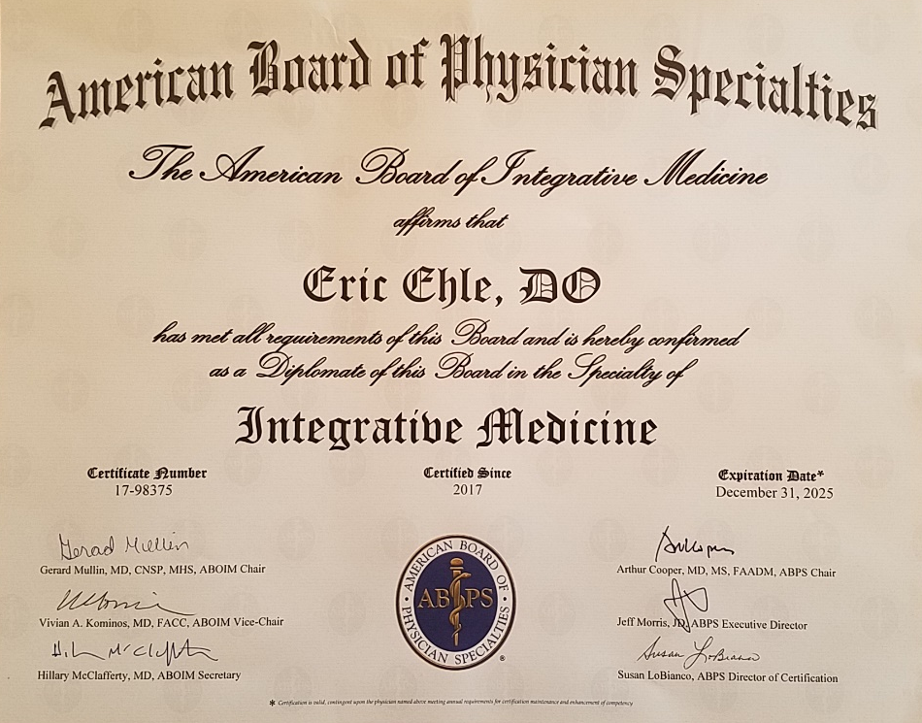
Dr Ehle has added several more letters behind his name. He has now passed the new board certification in Integrative Medicine, the American Board of Integrative Medicine (ABoIM). This is backed by the American Board of Physician Specialties (ABPS), the same certifying board as Emergency Medicine, Dermatology, Orthopedic Surgery, etc. This new board certification will hopefully start to offer some of the respect that Integrative Medicine is deserved. At this point Dr Ehle is the only DO physician in the entire country with all of the board certifications that he currently holds.
Eric Ehle, D.O. ABFM, ABoIM, DABMA, ABIHM
We are constantly striving to offer the best services not only in Amarillo but across the country and I strongly believe we do. There is no other clinic out there that offers all the services we do.
Don’t Operate, Regenerate!

Limited Time Offer
Right now we are offering a significant discount to the next 10 patients that schedule a stem cell procedure. After that the normal price will be $3500 for either Injections or IV Stem Cell Therapy or if combined will be $5000. This is a heck of a deal as most clinics across the US charge $5k -$8900, and the technology most clinics use isn’t anywhere close to what we are doing. We are on the cutting edge.
For the limited time offer the cost is $2500 for everything done on the day of the procedure, which would include both PRP ($600-1000 dollar fee by itself so great value) and Stem Cell injections. Some patients also request IV stem cells. IV Stem Cells would be an additional $1000.

We mainly use IV therapy for more systemic issues like Rheumatoid Arthritis, Multiple Sclerosis, COPD, Chron’s, ALS, Parkinson’s, etc, but can be helpful in many other cases as well.

The following is the website for our Regeneris group. As you can see there are only a few clinics across the country offering this type of therapy. The site has more information about stem cell injections and what the current evidence shows if you look through some of the other pages.
https://www.regenerismedical.com/provider-network/

You can also check out some of our recent blog posts about it here:
http://welllifefm.com/dont-operate-regenerate/

OR our Injection page here:
http://welllifefm.com/ourservices/prolo-prp-stem-cell-injections/

We have financing options available with CareCredit, with 6 months no interest. If you are interested you should call Stacy prior to the procedure to get preapproved.

See the study details here:
https://clinicaltrials.gov/ct2/show/NCT03090672?term=regeneris&rank=1

If you have Blue Cross Blue Shield they have been covering EpiFix which can be helpful for localized tendonois/tendonitis or osteoarthritis and can possibly stimulate your own stem cells to help regenerate.

You deserve to live a life without pain!
Back to School Botox Special

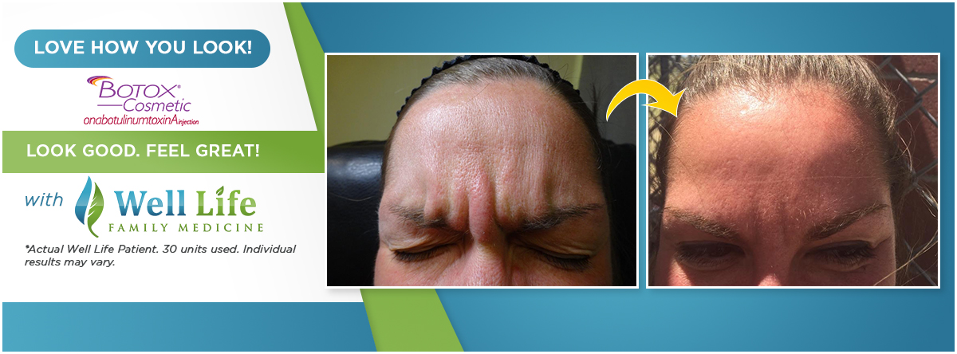Your kids are away for the day so wash the wrinkles of summer away!
Well Life Family Medicine is excited to offer a Botox special for a limited time only!
The first 10 people to sign up will receive Botox at $10 a unit ( normally $11 a unit) with a minimum purchase of 35 units required and receive an additional $110 worth of Botox for free!
Dates available for the special are Friday September 22nd and Saturday September 23rd.
Deadline to sign up for the double Botox special is September 18th, 2017.
Call our office now at (806) 355-9355 now to reserve your appointment.
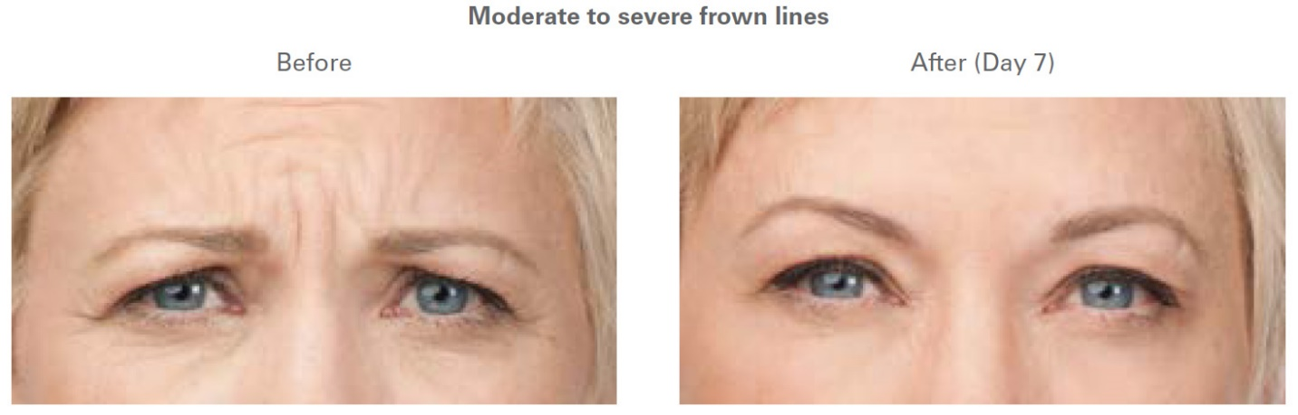
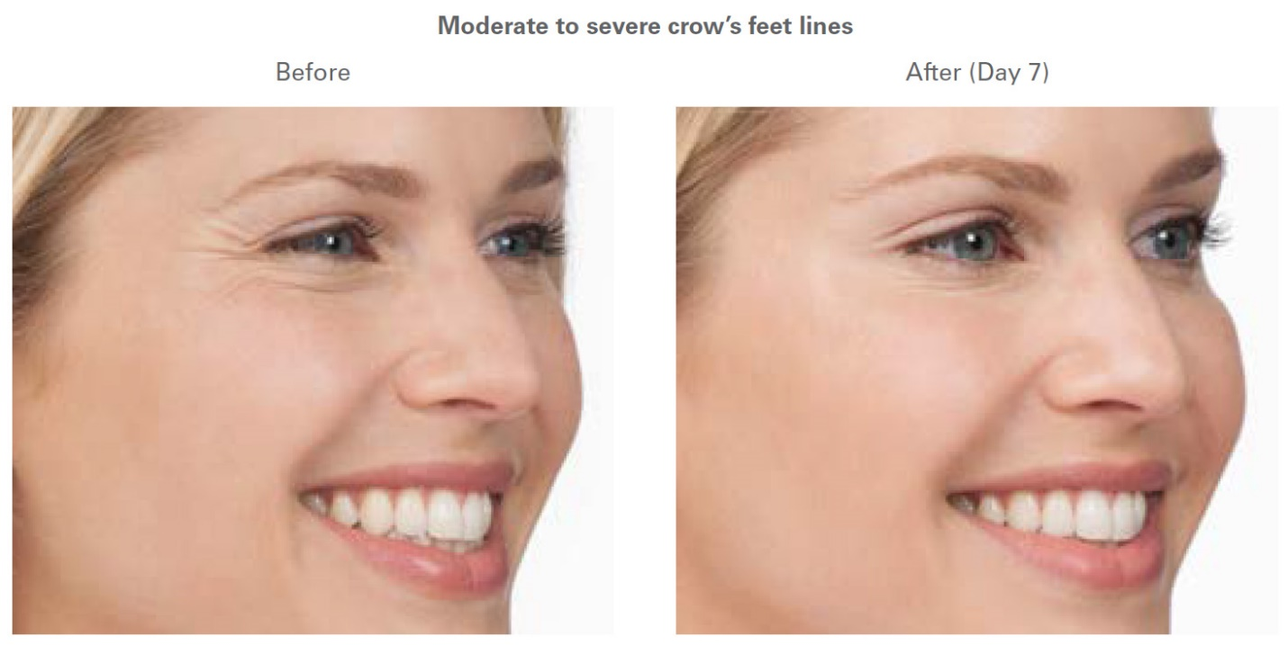

Your Sinus Solution

Did you feel like the seven Spring dwarves this year – itchy, sneezy, scratchy, stuffy, puffy, drippy, and whiny? Call us now to start treating the cause, not the symptoms!
For some insurance plans, allergy testing is as little as a $25 office copay. Too good to not take advantage of! Hurry now if you have already met your deductible and it resets at the end of the year.
Well Life Family Medicine has a comprehensive allergy testing and treatment program. We perform skin or blood testing for food and airborne allergies, and also offer food sensitivity testing. For treatment options, we provide either traditional allergy shots or oral allergy drops. Nutrition, acupuncture, homeopathy, herbal supplements, and oral medications can be added to strengthen and support your immune system and better control your symptoms.
Allergies not only manifest as classic symptoms like nasal congestion and itchy, watery eyes, they can also cause fatigue, joint pain, changes in mood (like depression), gastrointestinal symptoms (like diarrhea or constipation), eczema, asthma, brain fog, and headaches. Are allergies robbing you of your life?
We test for 70 different allergens - 46 environmental (weeds, trees, grasses, dust mites, molds, animals) and 24 foods.
We can also do an expanded food panel of 35 foods by themselves or with airborne testing.
Take our Allergy Quiz Now to find out if Allergies are affecting your health:
http://welllifefm.com/allergy-quiz/
Find out more at:
http://welllifefm.com/ourservices/allergy-testing/
Get tested. Get treated. Get better. Treat the cause, not the symptoms!
Breast Thermography
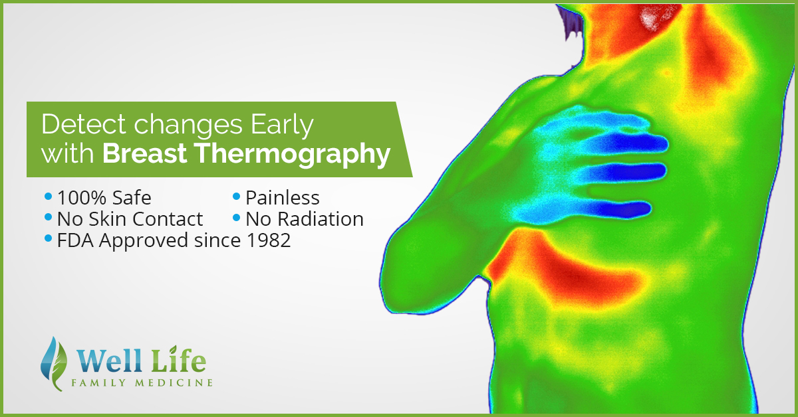
Early Detection is Important, but Prevention is Key. Studies show up to a 61% increase in survival rate when thermography and mammography are used together.
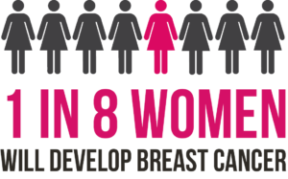
You don’t have to be one of them! Take steps today to be proactive and prevent breast cancer by scheduling your Breast Thermography.

Get Fit for Fall
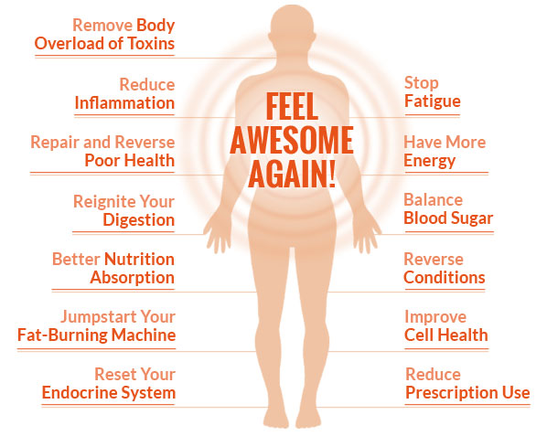Say Hello to Get Fit for Fall brought to you by your Well Life Family Medical team.
This is a 6 week exclusive one on one program with our in house nutritionist and trainer at a time most convenient for you.
Program Includes:
3 one on one 1 hour nutritional sessions with Kyla
3 one on one 30 minute personal training sessions with Jessica
Weekly body composition analysis tracking
Customized eating plan with recipes and grocery lists
Customized on-your-own workouts
Comprehensive calorie goal sheet
Group Grocery Store tour
Daily encouraging emails throughout the entire program
Personal Health Coach Tracking and Advice through our Nudge App
A Closed Facebook group to answer Q&A
Weekly competitions with prizes and general funness!
Tons of online resources including cookbooks, audiobooks, and other handouts
See Discounts above
And most important the accountability and support needed to reach your health goals!
**Easy to follow Recipes and accompanying grocery lists will be posted in the FB group on Fridays so you can shop and prep on the weekend. The weekly workouts will be posted on Sunday night.
Special discounts for those participating in the event (a possible savings of over $400!):
1 Month unlimited infrared sauna (usually $100)
1 Month unlimited whole body vibration session (usually $60)
1 Free Max Pulse Report (usually $50)
Purchase 1 Med Gem Basal Metabolic Rate Analysis for $50 get 5 weeks of follow up readings for free (175 dollar value)
15% off supplements purchased online through fullscript throughout the 6 week program
Fat Burner injections are $15 normally $50
**Over $1600 dollars in special prizes will be awarded for competing in a competition through our Nudge App to get healthy consisting of how many veggies you can eat, water you are drinking, exercise, and getting adequate sleep.
Possible prizes will include things like:
1 hour of coolscupting ($500 value)
6 laser lipo sessions ($200 value)
6 free med gem basal metabolic rate analysis ($225 value)
6 Hyperbaric Sessions ($360 value)
6 Exercise with Oxygen Sessions ($240 value)
CardioCoach VO2 Max Report ($100 value)
How much is the program?
The cash price is $70 per visit, so 6 visits = $420
If you have insurance and pay a copay then it would be your copay (usually 10-35 dollars per visit). If your copay is $15 then the total cost of the program would be $90. If you are double covered then you wouldn’t owe anything! If you have insurance on a deductible plan and would like to still bill insurance then the visit will be billed as a 99213, which is about 70-80 dollars and will go towards your deductible.
If you take advantage of the savings on supplements and services it more than pays for your visits!
HURRY! The Get Fit for Fall begins the the week of September 18th and there are only 20 spots available. Call or email the office to secure your spot. Enrollment for the program must be paid in full to guarantee your spot.
What do you have to lose (besides those extra stubborn pounds and feeling frustrated)?

Feedback Wanted
How likely are you to recommend Well Life Family Medicine to a friend or colleague?

  10
  9
  8
  7
  6
  5
  4
  3
  2
  1
  0

Not Likely | Extremely Likely

We value your feedback and strive to provide you with the best possible experience. If you have any suggestions on ways we can improve our care, please let us know. If we don't know there is a problem we can't fix it.


