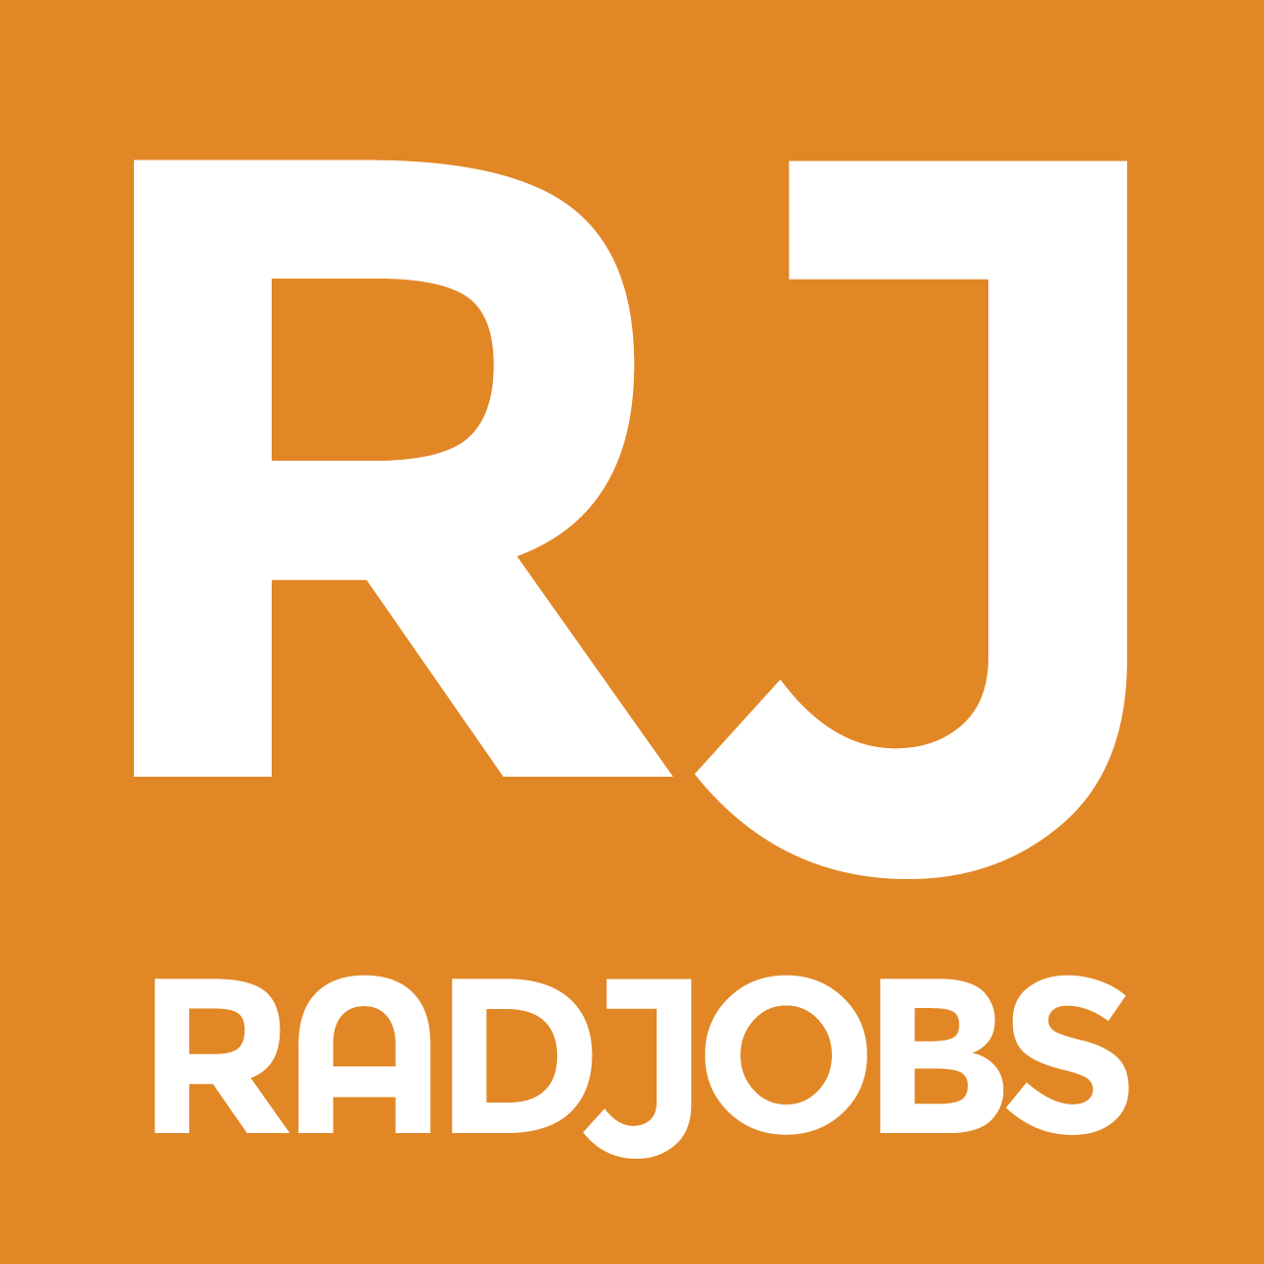

RadJobs - UK's leading radiology jobs website.
As a radiology trainee in Wales, an area like many parts of the UK facing a recruitment crisis, vacancies were not getting adequate exposure in the UK and internationally due to high advertisement costs of traditional job websites or limited impact because of their generic nature. I therefore decided to set up RadJobs, a free service which aims to become the central website for all radiology and clinical oncology jobs in the UK.
What started off as a small project, RadJobs is now fully backed by the RCR as the go-to platform for UK radiology jobs and a big opportunity for employers to showcase British jobs through the various networks and platforms of the RCR in the UK and abroad. Since April 2017, there have been more than 125 jobs posted, with excellent feedback from employers and job seekers and the RCR has been rigours in its publicising of RadJobs.
The site is highly user-friendly to encourage departments themselves in taking an active role in posting jobs without the need for advertising cost approvals, (the BMJ charges £1400 for a two-week advert). It takes less than five minutes to register and post a job. Applicants can apply directly through RadJobs or be redirected to other sites such as NHS Jobs. As a trainee, RadJob allows you to review the radiology jobs market for fellowships and consultant jobs.

RadJobs is managed by enthusiastic registrars. Help make RadJobs a success by spreading the word in your departments, contributing your ideas and providing feedback. For more information visit www.radjobs.co.uk or email s.e.junaid@gmail.com

