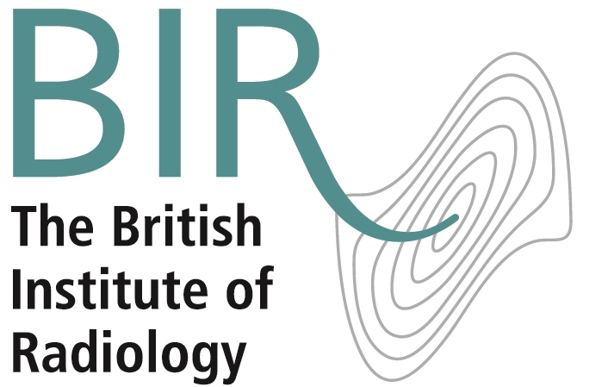

How to successfully climb the radiology ladder
Nassim Parvizi, radiology trainee and Chair of the BIR Young Professional and Trainee Special Interest Group, explains how joining the BIR gave her the support she needs to get to the next level.
If you are a radiology trainee who believes getting your consultant post will be a breeze, then don’t read on. If you are a FY1/FY2 who is confident of success at that ST interview, stop now. I’m pretty sure that most of you will continue to the end of this article. Most of us radiology trainees know that it is a hard slog to get to that next level with exam and clinical pressures at every stage. With this in mind, a few years ago, I attended a course at the British Institute of Radiology (BIR) which has quite simply opened doors for me. “The Future of Radiology” events in December are not only a great event for anyone considering a career in radiology or preparing for their consultant posts, it gives you the boost and the networking opportunities you need to feel confident about your next step. I was so impressed with this event, I wanted to get more involved with the BIR so I joined the BIR’s Young Professional and Trainee Special Interest Group (YPAT SIG) Management Committee and ended up organising the event the following year. After that successful event I didn’t look back. I’m now Chair of the group which as the title reflects, is for trainees and students and a member of both the MRI and Clinical Intelligence and Informatics SIG.
What makes BIR different from other societies is that the membership reflects all the professions in radiation imaging and radiation oncology. So when you come to an event or a SIG, expect to see everyone from your team - physicists, radiographers and oncologists. This gives you an invaluable perspective and broadens your horizons. In our day job we work together with a range of professions so it makes sense to learn alongside and from them.
BIR membership will give you reduced rate entry to events but also free access to a range of useful webinars and videos perfect for viewing in your own time on any device. BJR is free to read online and if you are thinking of getting into publishing you can get a 50% off “Article Processing Charge” for the new case report journal BJR|case reports. I would also recommend the “Imaging SBA” book for the final FRCR Part A, an invaluable resource for anyone working for this exam. Get a 20% discount as a BIR member.
When you go for that important interview, you need to stand apart from the crowd, be informed about the profession and have a varied CV. You can do this by joining an open special interest group, applying for an award or attending an event which will enable you to grow your list of contacts across the professions. The best way to learn and develop is by listening and learning from your peers and the BIR helps you do that. Without doubt, the BIR has been a great resource, amazing confidence booster and a lot of fun! So, if you’ve made it to the end of this article, do one thing today to help yourself. Join the BIR.
Dr Nassim Parvizi is SpR Clinical Radiology at the Oxford University Hospitals Trust.
Special offer for members of the Society of Radiologists in Training (SRT)
Join the SRT and get 20% off membership of the BIR. Just £32 per annum (with discount) Simply join the SRT online and you will be sent an online discount code to join the BIR at www.bir.org.uk

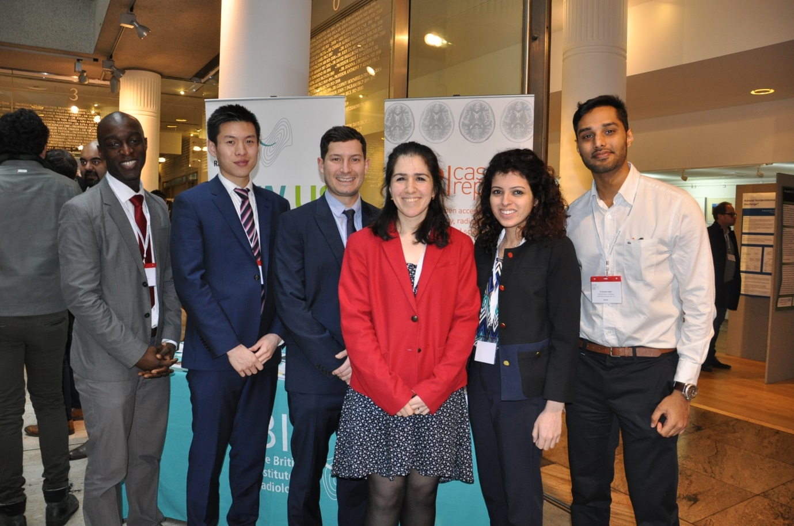
Dr Nassim Parvizi (centre) with the YPAT management committee

