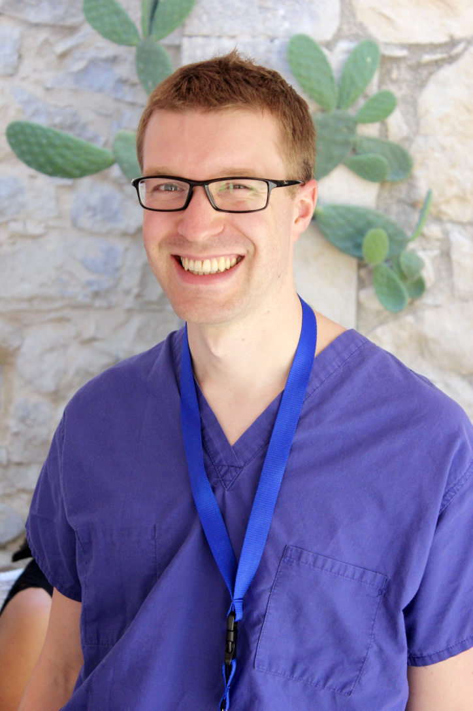

You may or may not have heard of Radiology Café, however now you’ve started clinical radiology training you will soon become familiar with the name! This innovative website is aimed at helping radiology trainees with free mock exams, learning resources and more.
Background
I initially set up the website in 2011 to provide general information about the ST1 application and interview process to help other junior doctors applying to clinical radiology. It was actually my flatmate who helped me come up with the name Radiology Café and it has since stuck! Over the last 5 years the website has expanded to encompass a wide variety of topics from mock exams to portfolio advice, and there’s even a blog.

FRCR exam tips
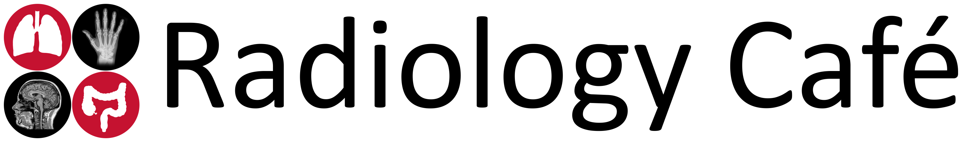
Throughout my training I made notes on the exams and gathered top tips from colleagues, collating them into an extensive guide to the first FRCR, 2A and 2B exams at Radiology Café. There is information on the mark schemes, recommended books, courses and online resources.
One of the most useful pages is a complete up-to-date list of all FRCR courses in the UK to help you in the run-up to your exams. This is particularly useful for the 2B exams as courses fill up quickly so having a list of contacts at your fingertips gives you a great head start when booking your place.
Link: www.radiologycafe.com/exams

Mock anatomy exams
The past year has been busy with the addition of first FRCR anatomy mock exams. This free resource for ST1 trainees contains 1600 high quality images with arrows and clear answer sheets. The mock exams accurately reflect the diversity and difficulty of the real exam and feedback following this year’s first FRCR exam has been excellent. One trainee said “Got 97% for anatomy, thanks for your help!! Yours was my main resource". The success has prompted further work into more exam related resources.
Link: www.radiologycafe.com/mock-anatomy-exams

FRCR physics notes
I have also collaborated with other trainees. One of our top new collaborators is Dr Sarah Abdulla, an ST5 trainee from Norwich. She created a comprehensive set of notes, with fantastic diagrams, for the FRCR Physics exam, which are now all uploaded and available online at Radiology Café. Again, feedback has been superb and with the help of current trainees, we hope to improve these notes over the coming months.
Link: www.radiologycafe.com/physics-notes
These two new exam aids (mock exams and physics notes) have helped increased traffic to the website and we now get on average 35,000 hits a month (and rising), and since January over 1000 users have created a free account.

Mock rapids
I am currently working on producing high quality mock rapid reporting exams for the reporting component of the FRCR 2B exam. They’re not quite ready yet, however if you visit the page below you can sign up for the newsletter and I’ll email you as soon as they’re live!
Link: www.radiologycafe.com/mock-rapids

So, what does the future hold for Radiology Café?
I recently launched more social media platforms to engage with trainees including new Instagram and Twitter feeds (search for ‘radiology cafe’) to add to our current Facebook, Google+ and LinkedIn pages.
I’m also updating the student section of the website to encourage medical students to take up a career in radiology. And additionally, we are undertaking a new project to create a website version of 'Radiology Basics’, a free Apple iBook by Dr Melisa Sia and Dr Vikas Shah, teaching basic cross-sectional imaging to students.
Collaborative working in this way has been so rewarding. I want to add more excellent teaching resources so would love to hear from anyone with material they would be willing to share with trainees. If you have an idea about a new project then get in touch via the website or email me directly.
To find out more visit: www.radiologycafe.com
To get our newsletter: www.radiologycafe.com/newsletter
Look forward to seeing you at Radiology Café soon!
Chris
Dr Christopher Clarke
Radiology Fellow at Leeds Teaching Hospitals
Founder and Editor RadiologyCafe.com
Contact: chris@radiologycafe.com

