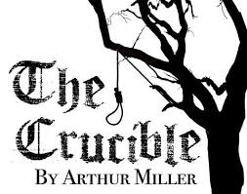 | February 16th -18th  Directed by: Bill Eschbach Auditions: December 2017  A play by American playwright Arthur Miller. It is a dramatized and partially fictionalized story of the Salem witch trials that took place in the Massachusetts Bay Colony during 1692-1693
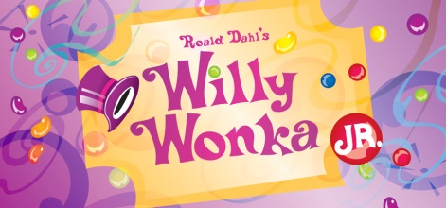 | March 16th - 25th  Directed by Deanne Leech & Sarah Geiger Auditions: December 2017  Roald Dahl's Willy Wonka JR. follows enigmatic candy manufacturer Willy Wonka as he stages a contest by hiding golden tickets in five of his scrumptious candy bars. Whomever comes up with these tickets will win a free tour of the Wonka factory, as well as a lifetime supply of candy. Four of the five winning children are insufferable brats, but the fifth is a likeable young lad named Charlie Bucket, who takes the tour in the company of his equally amiable grandfather. The children must learn to follow Mr. Wonka's rules in the factory – or suffer the consequences.
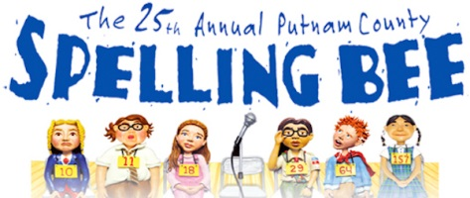 | May 11th-20st  Directed by Drew Boardman Auditions: February 2018  A musical comedy with music and lyrics by William Finn, a book by Rachel Sheinkin and additional material by Jay Reiss. The show centers on a fictional spelling bee set in a geographically ambiguous Putnam Valley Middle School. Six quirky adolescents compete in the Bee, run by three equally quirky grown-ups.
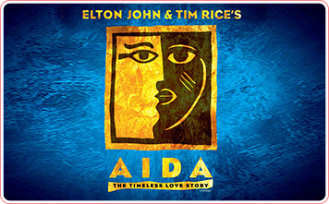 | August 10th-19th  Directed by Melissa Kaufmann Auditions May 2018  Winner of four 2000 Tony Awards, Elton John and Tim Rice's Aida is an epic tale of love, loyalty and betrayal, chronicling the love triangle between Aida, a Nubian princess stolen from her country, Amneris, an Egyptian princess, and Radames, the soldier they both love.
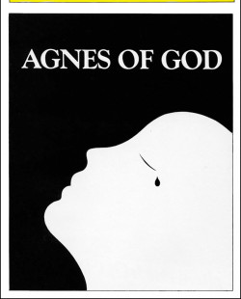 | September 14th -16th  Directed by Chris Sperat Auditions July 2018  A play by American playwright John Pielmeier which tells the story of a novice nun who gives birth and insists that the child was the result of a virgin conception. A psychiatrist and the mother superior of the convent clash during the resulting investigation.
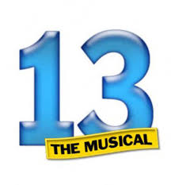 | October 19th- 28th  Directed by Debbi Silas Auditions August 2018  Following a move from New York City to small-town Indiana, young Evan Goldman grapples with his parents' divorce, prepares for his impending Bar Mitzvah, and navigates the complicated social circles of a new school.
 | November 30th- December 9th  Directed by Chris Weiss Auditions September 2018  Based on the beloved holiday film, this hilarious fish-out-of-water comedy follows Buddy the Elf in his quest to find his true identity.  .

