Brief
- Redesign of the header section of http://gocloud.webflow.io (see below)
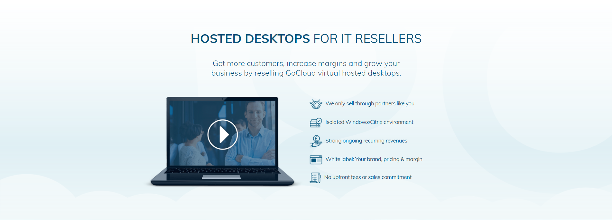
- Same copy as already appears needs using
- Icons, laptop image and background can be used or changed
- New style and layout needs to match the rest of the website
- Goal is to have a high impact and engaging top section of the website

