The View at Hotel Concord
Marketing Materials Creative Brief

Materials required:
- Logo for the building
- Logotype for building signage, apartment number plaques, website, etc.

Project Description: The View at Hotel Concord is a restoration of a 1920's small-town hotel into luxury apartments. Concord, NC, like many southern towns that saw decades of economic decay, is enjoying a renaissance in its downtown area. The Hotel Concord, the grand dame of decades past, was vacant for years. Sitting on a prominent corner at the intersection of Concord's two main streets, the Hotel was a symbol of decay.
The current restoration of the Hotel is the crown jewel of recent revitalization efforts in Concord. The town’s residents eagerly await its completion. The building will contain 40 luxury apartment homes that speak to the grand yet simple past of the Hotel and the town. The Hotel's lobby ballroom will serve as an event space for weddings and celebrations. Panoramic views of downtown Concord and a green tree canopy stretch out in all directions.
The logo and logotype should speak to the Hotel’s rich history and classic design, yet also incorporate the revitalization and the modernization that our redevelopment is bringing to the town and to the building.

Building Details:
- Originally built 1926
- Began renovation December 2016, delivers December 2017
- 40 luxury apartments ranging from studios to 2-BRs, an event-space ballroom, and 9,000 square feet of retail located in the base of the building
- Historic yet refreshed exterior preserving key architectural features, including antique lanterns
- Full gutting and renovation of interior units and common areas
- Downtown, Class-A location within a satellite city of Charlotte, NC
Images
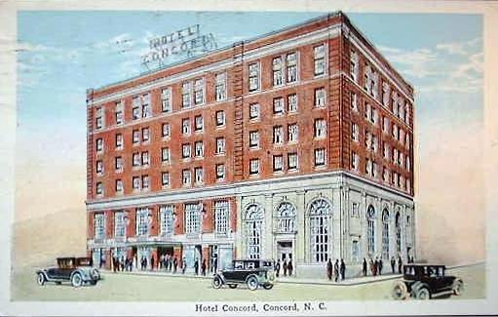
A postcard of the Hotel Concord in its heyday in the 1920s

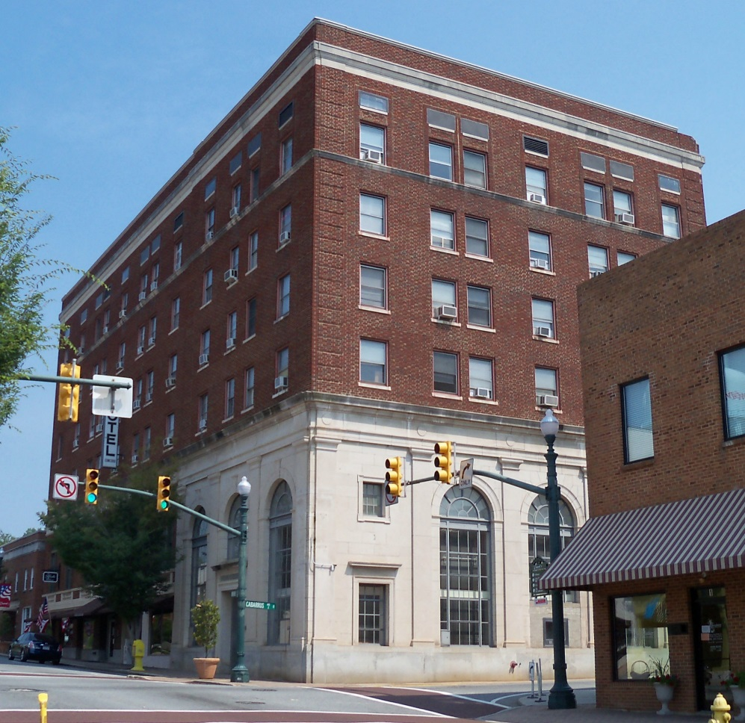
The Hotel Concord prior to Redevelopment
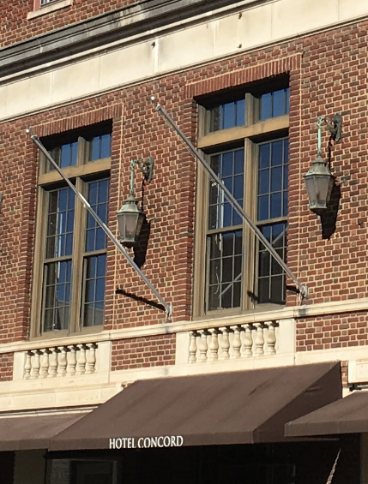
A detail of the Hotel’s historic lanterns, which will be remain after renovation
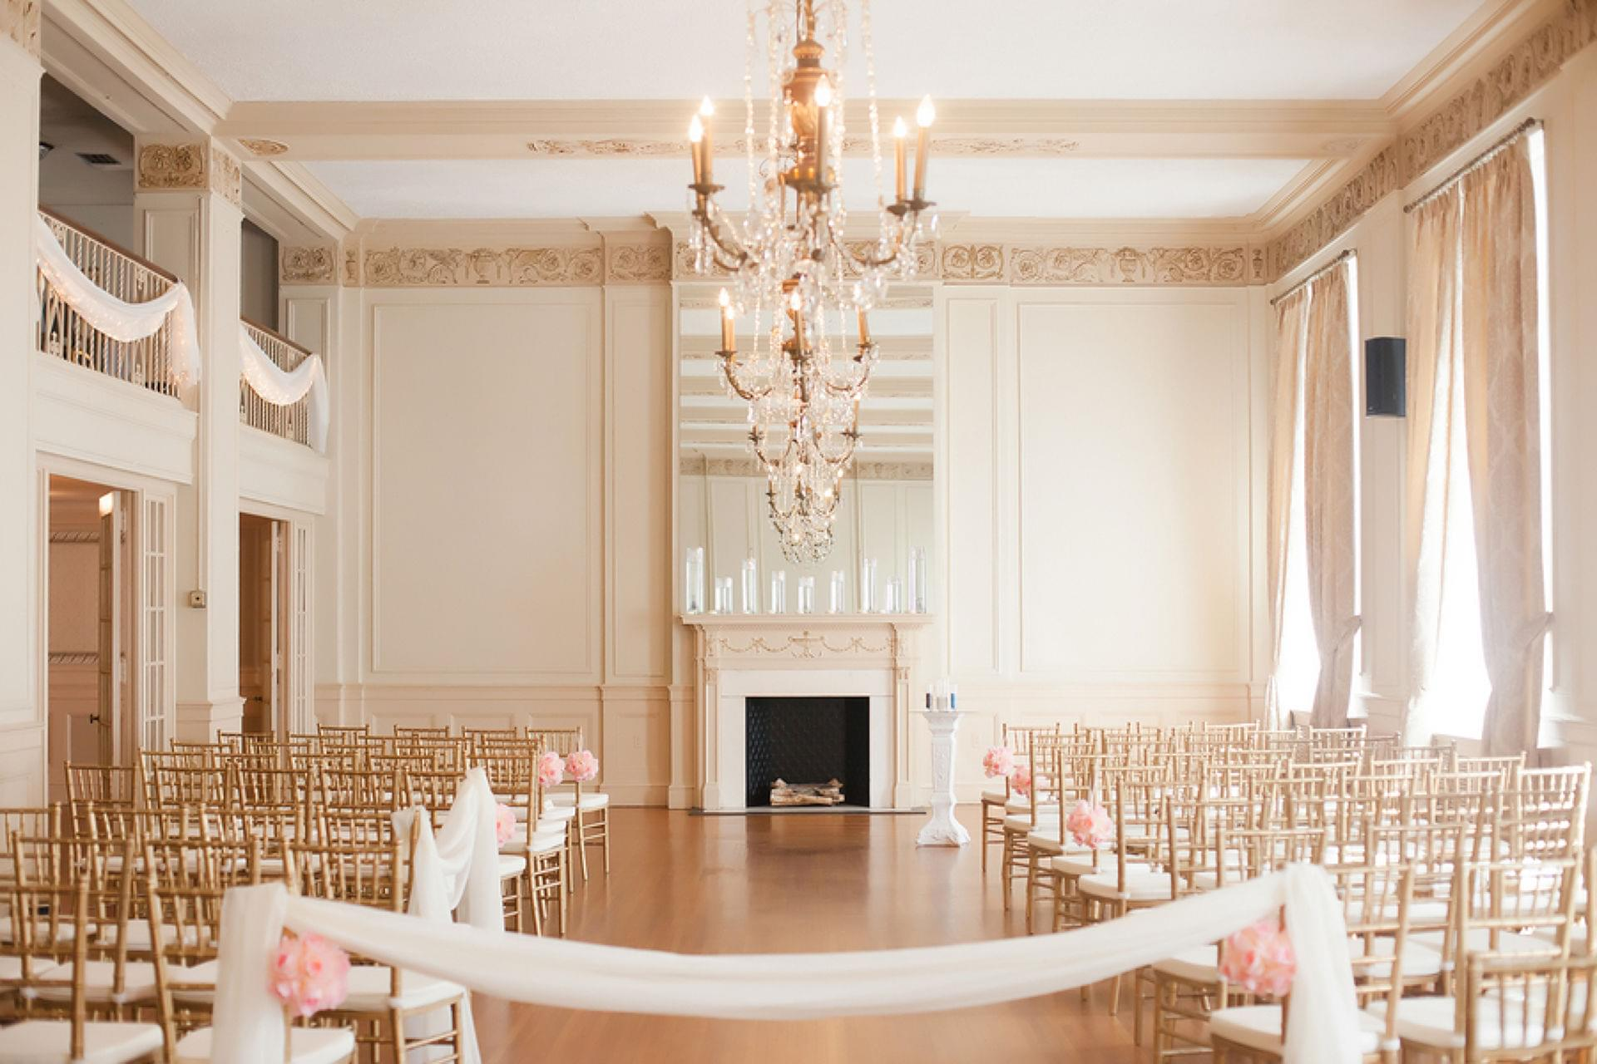
The Hotel ballroom after renovation
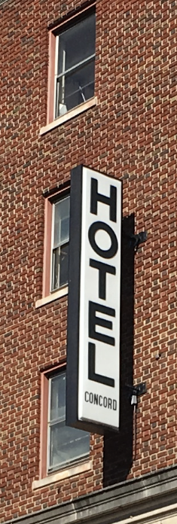
The Hotel’s former logotype

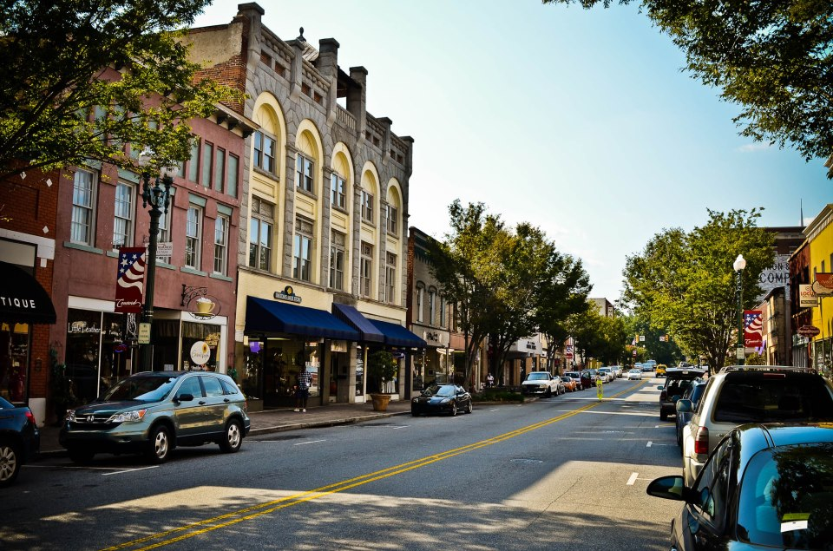
Concord, NC’s main street

