
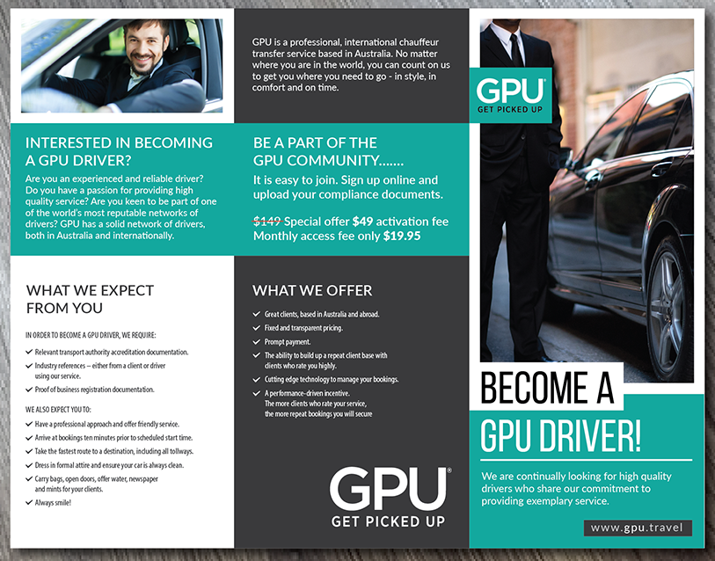
Make special offer stand out, like above but not in black

change – providing exceptional service and want to be a part of the GPU community.
Add – Build passive income from referral customers
Change – arrive at bookings on time
Change - Dress in smart casual attire
Remove – Carry bags etc…
Remove – using our service
Add - Insurance and registration paperwork
Find alternative picture, don’t like this guy
GPU is a professional, global transfer service based in Australia. No matter where in the world you are you can count on us to get you where you need to go – in style, in comfort and on time.
Change picture to less corporate, smiling driver standard sedan car

