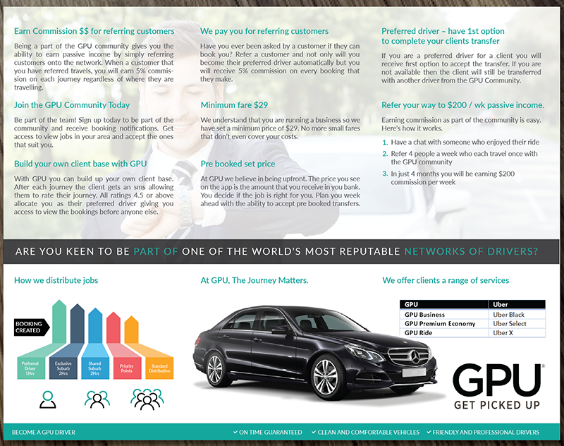
Get more Bookings
We have a range of premium plans available that include suburb selections
Change car to a standard sedan make fit centre fold
Change heading to Comparison Table – remove GPU….. Uber

