PALMECO GROUP of COMPANIES
PROFILE
ABOUT US
COMPANY HISTORY
Palmeco Group Co. Ltd. is a newly incorporated company in Shenzhen, China, as an investment holding company. This company will be the future headquarter and group company that will merge and acquire all its existing and future Malaysia and Indonesia palm oil industry companies into China. Hence the Group pledged to become the world biggest renowned oil palm company based in China.
Palmeco Group Co. Ltd. will be listed on the over the counter (OTC) market, China, in Mar 2017. Thus, allowing the company’s shares to be traded on the OTC market, and also issue new shares to outside investors to raise equity funding.
The Palmeco Group is an integrated palm oil producer which operates the following:
- oil palm plantations
- oil palm traders
- palm oil mills
- trading of palm oils and fats products
- fertilizer and pesticide trading
- transportation
- replanting
- ICT software management
- swiftlet farming
- cattle and goat farming
- fruits farming
- palm oil eco-tourism
From its humble beginnings as a single company, the Group will grow and flourish to achieve its success with the singular aim of constantly creating value for its shareholders and at the same time maximizing their returns and for the betterment of China as a country that owns palm oil businesses.
We know that success does not come easily. It takes hard work, perseverance, tolerance and sheer determination by all concerned to make it work. And this will be achieved with the help of a strong, experienced and dedicated management team who have been in the palm oil industry for more than 30 years.
With its merging and acquisition, the Palmeco Group will be a transnational company with offices in:
- Melaka, Malaysia
- Negeri Sembilan, Malaysia
- Mukah, Sarawak, Malaysia
- Selangau, Sarawak, Malaysia
- Singapore
- Shenzhen, China
VISION, MISSION and VALUES
Our Vision
To be recognised as a renowned integrated global oil palm group of choice and become an integral part in alleviating the livelihood of members in the community.

Our Mission
- Strive towards the highest quality and excellence without compromise.
- To be recognized as one of the world’s top premium palm oil producer.
- Endeavour to accelerate efficiency and operate effectively to achieve consistent satisfactory results for our customers and investors.
- To improve and alleviate the lives of our employees, shareholders and community by establishing good business practices, making sound investments and undertaking social responsibilities.
- Committed to maintaining sustainable and environmentally friendly policies to help keep our world green for future generations.
- To revolutionize agriculture through ICT in achieving precision farming.

Corporate Values
- Customer focus.
- Quality and excellence products and services.
- Innovative products and services development.
- Commitment and follow through.
- Proactive and promptness.
- Teamwork and integrity.
- Corporate social responsibility.

PALMECO GROUP BUSINESS STRUCTURE
Fertilizer & Pesticide
Palm Oil & Fat trading
Palmeco Group Co. Ltd.
(China)
Palm Oil Mill
Oil Palm Plantation
Palm Oil Eco-Tourism
Cattle & Goat Farming
Resort
Oil Palm Trading
Fruit Farm
ICT Software
trading
Swiftlet Farming
Investment
Transport
Replanting

PALMECO GROUP ORGANIZATIONS
Palmeco Group Co. Ltd.
(China)
Oil Palm Plantation
Oil Palm Trading
Palm Oil Mill
Sinong Pelita Matu Sdn Bhd
Igan Estate
Matu Estate
Palmeco Pelita Likau Sikat Sdn Bhd
Kian Hong Sawit Sdn Bhd
Kian Hong Plant Sdn Bhd
Sinong Pelita Oil Mill Sdn Bhd
Air Molek
Solok Menggong
Pondok Batang
Trading
Kian Hong Plant Sdn Bhd

Replanting
Sagil Plant Sdn Bhd
ICT Software
I-Access Solution Computer Specialist Sdn Bhd
Investment
Palmeco Holding Pte Ltd
Transport
Sri Kuala Sdn Bhd / Kian Hong Plant S/B
Kuala Sungai Baru

PALMECO ORGANIZATION CHART
Plantation division
Mill division
Engineering division
OPERATION DIVISION
Managing director
Board of director
General manager
Company secretary
Administration division
investment division
Information system division
Finance division
Eco-tourism division

MANAGEMENT TEAM
 | JP. TAN CHEW CHIN  BCM  Position : Managing Director  Email : tancc@palmecogroup.com |  | MR. TEW HANG SIONG  Position : General Manager  Email : tewhs@palmecogroup.com
 | MR. TAN JIA KENT  Position : Finance Head  Email : tanjk@palmecogroup.com |  | MR. LAI PENG WAH  Position : Operation Head  Email : laipw@palmecogroup.com
 | EN. NAZIM SHAMEER  Position : Plantation Head  Email : nazim@palmecogroup.com |  | To be determined  Position : Mill Head  Email : xxx@palmecogroup.com
 | To be determined  Position : Eco-Tourism Head  Email : yyy@palmecogroup.com |  | MR. GOH NAM KWAN  Position : ICT Head  Email : gohnk@palmecogroup.com
 | MR. WEE ENG LOW  Position :Investment Head  Email : weeel@palmecogroup.com |  | MS. PAULINE NGU YU YING  Position : Administration Head  Email : pauline@palmecogroup.com

OUR BUSINESSES
Oil Palm Production Cycle (Up-Stream)
The Palmeco Group Co. Ltd. with all its group companies is a well integrated oil palm company with complete up-stream oil palm production cycle.
Its businesses cover from land clearing or replanting fleets to nursery plantations that preparing for the oil palm estate plantations to the management of its oil palm plantations to the output production of fresh fruit bunches from its plantations until the transportation of its output of fresh fruit bunches to palm oil mills.

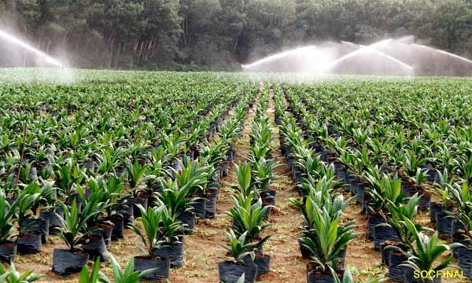
Land Clearing / Replanting Nursery Plantation Transportation to Mills

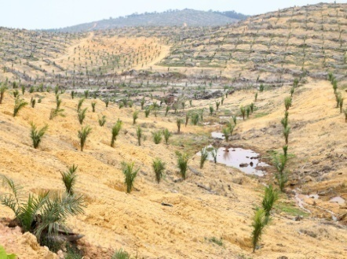
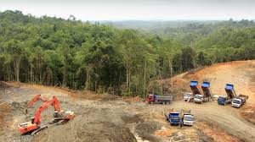

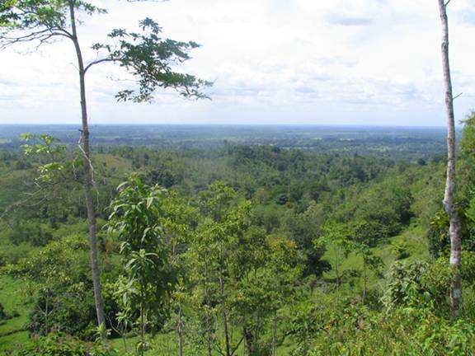
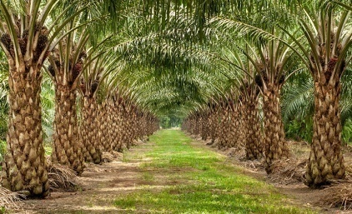

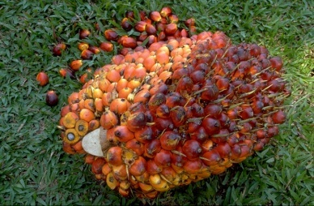

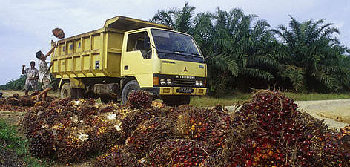

OIL PALM PLANTATION
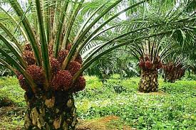
Palmeco Group Co. Ltd. with oil palm as its core business has an approximate total of 13,261.9 hectares of land bank.
Under its investment company, Sinong Enterprise Sdn Bhd (SESB), Palmeco group has its oil palm plantation company, Sinong Pelita Matu Sdn Bhd (SPMSB), with 2 pieces of estate plantations in Mukah, Sarawak, East Malaysia. In 2006, SESB has joint venture with Pelita Holding Bhd & Yayasan Sarawak Bhd, companies under Sarawak government to open 2 lots of lands with a land size of around 4,261.9 Hectares into oil palm plantations. These land bank consisting of 2 matured estates namely Igan estate and Matu estate in Mukah, Sarawak.
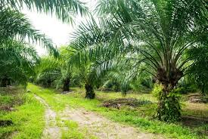
Palmeco Group also manages the MCL Sarawak State land comprising of Koperasi and individual native lot which brings to a total of 9,000 hectares of land. These new estates lands are Likau estate, Sikat estate and Jemoreng estate that will be clear for oil palm planting in the year 2017.
The Group has envisioned expanding its land bank with joint venture estates in the next coming 3 years that will brings to a total of additional 50,000 hectares of land under the management of the company.
Currently, SPMSB produces Fresh Fruit Bunches (FFB) from its existing palm oil plantations (4261.9 HA) with an output of 70,000 MT of FFB per year. This production will be hitting its maximum capacity of 80,000 MT of FFB per year in the next two years to come when both plantations reach their maturity.
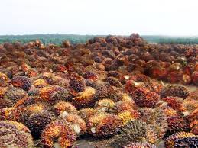
This supply of FFB to the palm oil mills currently is running at a production output rate of 70,000 MT per year, generating yearly sales revenue of RM36,995,000 at a rate of RM528.50 per metric ton.
By the year 2020, the Group will have an approximately 1,000,000 MT of FFB per year from its 63,000 HA of oil palm plantation with estimated yearly revenue of RM 500,000,000.
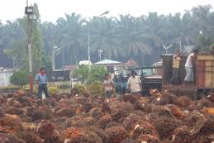
OIL PALM TRADING
Palmeco Group has ventured into the fresh fruit bunch (FFB) dealer sub-sector which is part of the Malaysian palm oil supply chain. It is inter-related with other sub-sectors either directly or indirectly. It serves as an intermediary between the smallholders and the millers.
Its oil palm trading companies are Kian Hong Sawit Sdn Bhd and Kian Hong Plant Sdn Bhd with 4 collection centres and depots with weighbridges around Melaka and Negeri Sembilan state to trade FFB as FFB need to be efficient traded so that the FFB sent to the mills within 24 hours after harvesting remain in good quality that may affect the efficiency of the other sectors, especially the mills as well as the whole industry. In return, the smallholders will also benefit as they will be able to receive a higher income due to an improved supply chain in the industry.
These depots have traded approximately 72,000 MT of FFB per year which generated yearly sales revenue of around RM 38,000,000.
In due course to the expanding palm oil mills, the Group has envisioned expanding its oil palm depots to include additional 10 more depots with joint venture and merging in the next coming 3 years. This will brings an additional 360,000 MT of FFB per year under the group company.
By the year 2020, the Group will have traded an approximately 500,000 MT of FFB per year from its 14 oil palm depots with estimated yearly revenue of around RM 250,000,000.

PLANTING / REPLANTING
Palmeco Group Co. Ltd. has a full team of oil palm management teams that also has its own fleet of machineries for land clearing and planting of idle land for new oil palm plantation and replanting for existing oil palm plantation or conversion from other crops. Our replanting company, Sagil Plant Sdn. Bhd. uses sustainable practices to ensure that the environment and biodiversity are not harmed by cultivation of oil palm plantation through the adoption of Good Agricultural Practices (GAP).
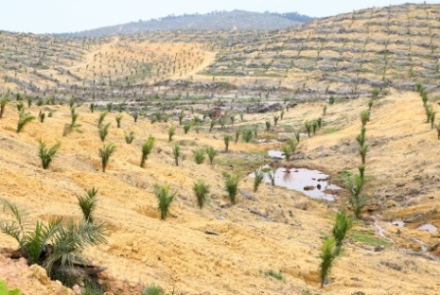

Under the fleet of machineries we have:
- Excavator – 16 Units
- Bulldozer – 2 Units
- Shower – 4 Units

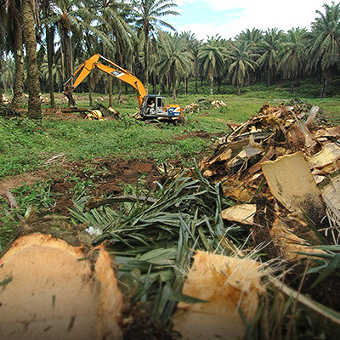
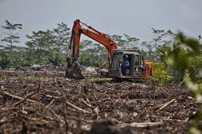
- Lorry – 10 Units
- Truck – 3 Units

For replanting, we practices zero burning. The old palms are pushed over, shredded and left to decompose in site. There is therefore, no air pollution from burning the old palms and, most importantly, the nutrients in the old crop are recycled into the new.

TRADING PALM OIL & FAT PRODUCTS, FERTILIZER & PESTICIDES
Palmeco Group Co. Ltd. also trade CPO via its Kian Hong Plant Sdn Bhd. The current management traded CPO via its group of well connected palm oil millers.
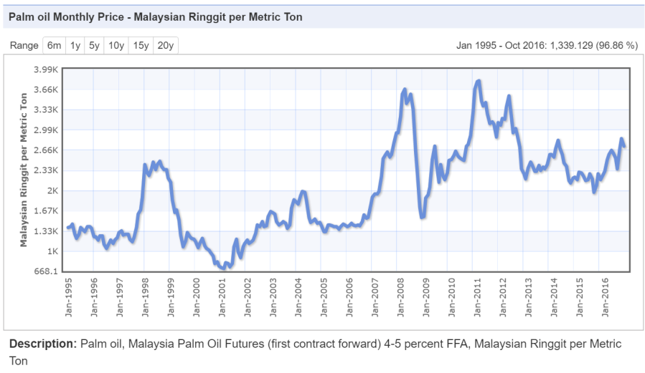
Palm oil has several features that make it attractive to traders participating in commodity trading. It is a very stable substance, even in relatively extreme temperatures, and so has applications in food production, often being used in frying. Palm oil prices and attributes mean it is also a good substitute for the more expensive cocoa butter. It is also the primary exported vegetable oil, with around 80% of palm oil worldwide imported into the primary consumer countries. This obviously makes trading palm oil futures a potentially lucrative undertaking.
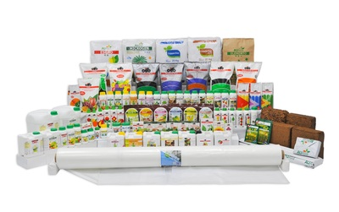
Our team has extensive experience in palm oil trading and futures with several factors to consider in related to palm oil prices fluctuation. The price and demand of competing vegetable oils can obviously affect the price of palm oil futures, and the spot price of palm oil can be affected by changes in the weather, which always has a bearing the price of agricultural commodities. The import policies and laws of various countries where palm oil production takes place can also change periodically, and this too can affect the price of palm oil futures.
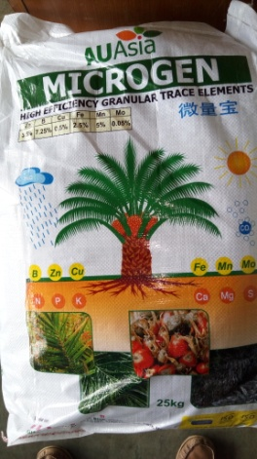
Our company also trade fertilizer and pesticides. We studied and will help our plantations and outside small holders to mix the fertilizer ingredients and the type of pesticides to use as per their palm’s requirements.
Fertilizer and pesticide are steady businesses that show no signs of fading. We like the idea of making a profit by helping people work with the soil and plant which are being part of the fertilizer and pesticide industries.
To avoid polluting the local water supply, we always follow careful storage and handling policies.

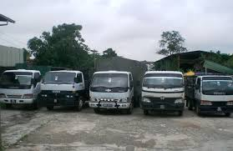
TRANSPORT
Palmeco Group Co. Ltd. has a fleet of lorries and trailers under its Sri Kuala Sdn Bhd and Kian Hong Plants Sdn Bhd companies. We pride ourselves in outstanding services to all our customers. Our customers can count on us for reliability, dependability, efficiency and on time delivery.
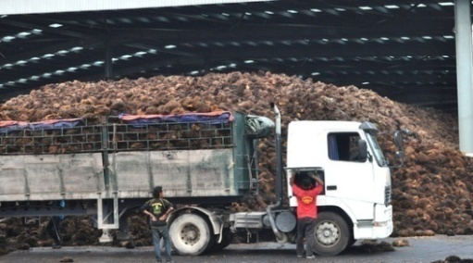
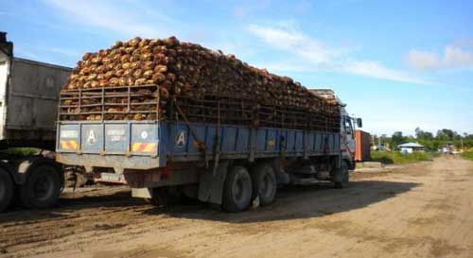
We provide transporting of FFB for plantations to our FFB collection depots or palm oil mills requested by our customers. We also transport palm oil products from palm oil millers to their customers whenever required after delivered of FFB to their mills.

We also have trucks to transport fertilizer and pesticide to buyers, and a warehouse to store our inventory.
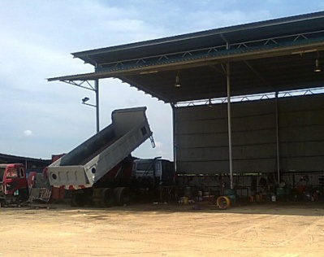
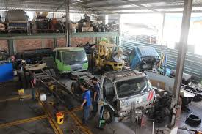
To ensure the smooth operation of our transportation business, we also have our own workshops with team of foreman and mechanics to do in-house repairing and maintenance to ensure that our lorries and trailers are always in great conditions.

We have strict rules and regulations for the lorry drivers and our workshops team to follow to ensure that they will not stress the vehicles and to have a proper and timely maintenance as schedule.

ICT SOFTWARE MANAGEMENT
Palmeco Group Co. Ltd. knowing with its wide range of businesses also involved in ICT business under its company known as I-Access Solution Computer Specialist Sdn Bhd, IAS, which was registered and commenced business on November 24, 1999. IAS is a company principally involved in computer system development, e-commerce solution, system maintenance and consultation services with hardware and software provider related to Information Technology industry.
The main factor contributing to the establish of IAS is its total commitment towards providing an effective and result oriented solution and competitive products which provide uncompromised after-sales support and services to all its customers.
The principal business activities of IAS are System Development and System Integration, E-commerce solution provider and ICT Outsourcing.
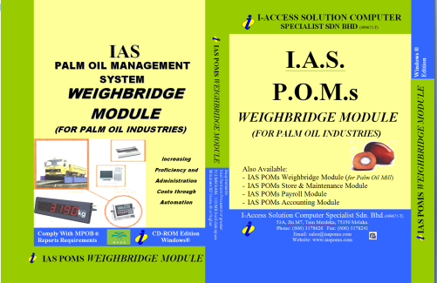
- System Development and System Integration
- Development consultation
- Core program analysis
- Design Development
- Programming and debugging
- Software quality assurance
- Maintenance Contract

- E-commerce Solution Provider
- E-commerce consultation
- Website designing and hosting
- Web Application
- E-commerce hardware and software configuration

- ICT Outsourcing and Software and Hardware Provider
- System administration and maintenance
- Network consultation and implementation
- Server and work-station installation
- ICT department outsourcing
- ICT consultation
- ICT Hardware and software support

Palm Oil Management System
Under its development division, IAS developed the palm oil management system, POMs, which is a total integrated palm oil management system for the palm oil industries. It is the premier palm oil management solution because it’s affordable, ease of use and short implementation and realization time.
IAS POMs solution is a Blueprint for palm oil industries Best Practices. It consists of ready templates with a fast deployment of 12-14 weeks.
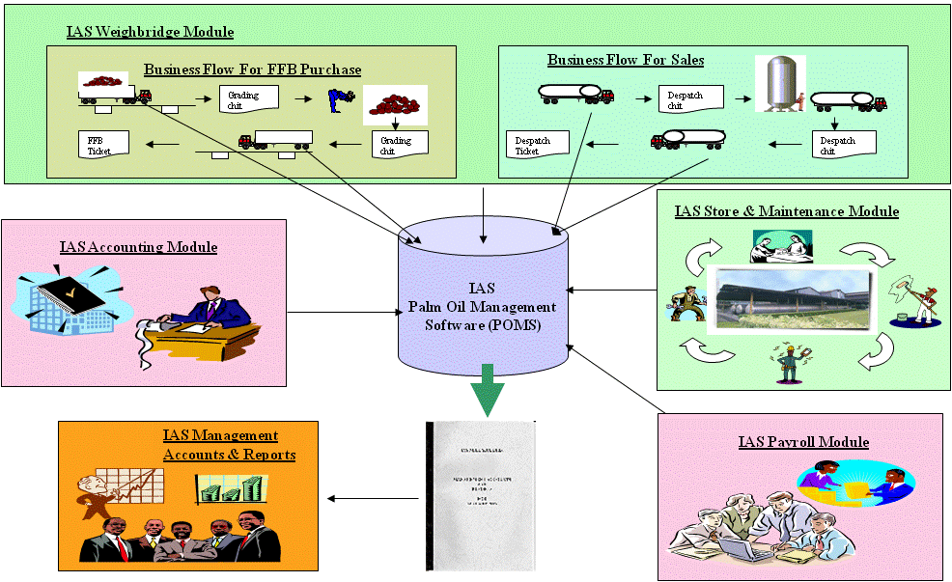
IAS is the biggest Malaysia palm oil management solution provider for private palm oil miller industry sector. Plus POMs offers the most comprehensive set of features available and can be purchased and implemented in modular. IAS POMs is a total integrated system with IAS Weighbridge module that is integrated with other sub modules such as Store Maintenance, Payroll and Account modules into a seamless Management System that is useful for the management to manage their company.

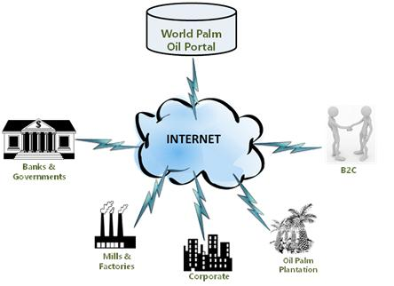
In viewing of the continuing improvement coverage of Internet throughout Malaysia, the company is planning at converting its IAS POM system into web based in the next 3 years. These web based systems enable link from all its relevant modules to inter-change data between suppliers, customers, government bodies and banks.
With these inter-changes of data, IAS will then develop its relevant modules to incorporate financial technology (FinTech) using new technology and innovation to leverage available resources and customers in order to compete in the marketplace of traditional financial institutions and intermediaries in the delivery of financial services.
Palm Oil Production Cycle (Mid-Stream)
Plantation Palm Oil Mill Refinery
With this rapid growth in oil palm planting, Palmeco group management also saw a corresponding growth in the milling and refining sectors.
Our management has already agreed to proceed with the building of our own palm oil mill at our Matu estate to support our own fast growing FFB crops from both Igan and Matu estates.
Nonetheless, we are also able to support our surrounding oil palm estates from big plantations who don’t own any mill and also for those small holders around that area.
Building CPO refinery will also be in the pipe line of the company in the future.
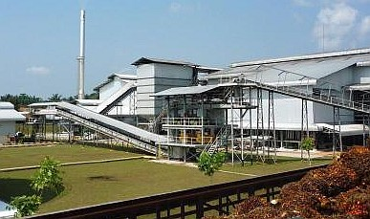
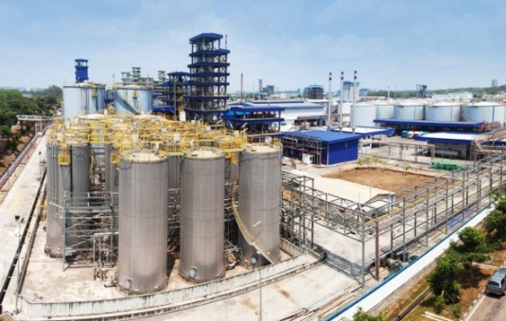

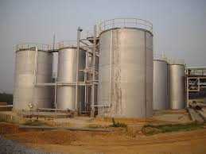
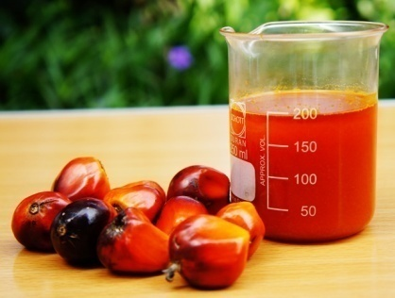
PALM OIL MILL
Palmeco Group Co. Ltd. as a company with large-scale plantation areas, see the need to have an oil palm mill to process the FFB is seen as an important investment for the company. Sinong Pelita Oil Mill Sdn Bhd, located in Matu estate, will be built in 2017 and to start operation in 2019. This factory is capable in processing as much as 60 metric tons (MT) of FFB (fresh fruit bunches) per hour.
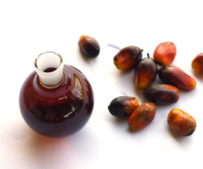
The Group has envisioned including additional 5 more palm oil mills with merger and acquisition in the next coming 3 years which brings to a total of additional 300 MT of FFB per hour under the management of the company.
These factories are to accommodate the increasing quantity of FFB and also to deal with new FFB supplies from the opening of new estates and acquisition by the group.
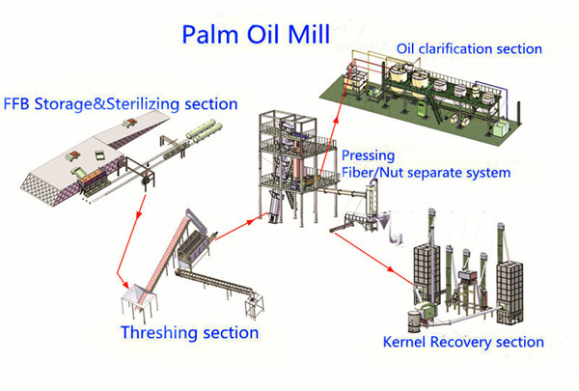
The group will establish to manage all its mills based on MS ISO 9001:2000 which cover aspects such as Obtainment and Processing of Palm Fruits to produce crude palm oil and palm kernel. This system is important in order to guarantee products that have good quality and falls within the industry standards before being sold and dispatched to the purchasers.
By the year 2020, the Group will have an approximately capacity of processing 2,160,000 MT of FFB per year from its 6 palm oil mills with estimated CPO output of 928,000 MT and yearly revenue of RM 2.136 billions.

Palm Oil Production Cycle (Down-Stream)
Refinery production of oils and fats, oleo-chemicals, biodiesel, other palm oil derivatives
Our Palmeco group’s business philosophy for its future is in the manufacturing of a comprehensive range of palm oil-based products is to maintain the highest quality at all times. This will ensured the group an edge in its selling proposition and sets Palmeco group apart from the competition.
The group belief that if we are vertically integrated, we are able to benefit from CPO market dynamics in both ways. Right now, if we are only in upstream and if CPO prices go down then we have no way out of it.
Initially the group will invest in oleo-chemicals technology where oleo-chemicals are mainly derived from palm kernel oil and are used very frequently in our lives daily.
“We start our day with surfactants such as toothpaste and shampoo. Derivatives such as surfactants are a major portion of the oleo-chemicals industry and they are also used in various products such as emulsifiers, personal care and also to improve the performance of some insecticides and herbicides.
The group will also involve in the production of higher value-added palm oil derivatives such as surfactants, agro-chemicals, bio-polynols, bio-lubricants, glycerol derivatives and bio-based chemicals where the facilities will be based in China.
The group will also invest in the production of palm phytonutrients such as tocotrienols and carotenes.
Bio-lubricants can also be used to make greases or hydraulic oils and so on, while bio-polynols can be used in sitting foams, bedding materials, furniture and non-foam products such as coatings.
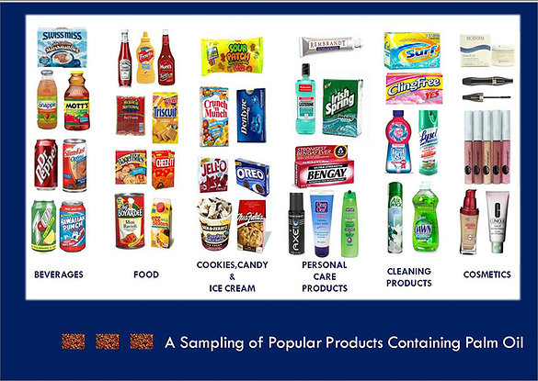
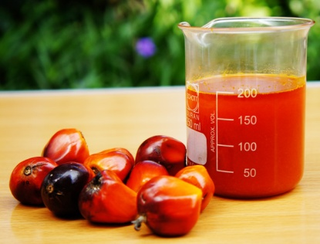

PALM OIL ECO-TOURISM (New Businesses)
Palmeco Group Co. Ltd. down stream business will also include palm oil eco-tourism that the group hope that in its complete cycles of palm oil industries somehow benefits that environment and the people who live there.
The eco-tourism concept is to ensure the environmental sustainability and to encourages proactive nature conservation and the promotion of local cultural values, while at the same time developing local economies and the long term viability of ecotourism destinations.

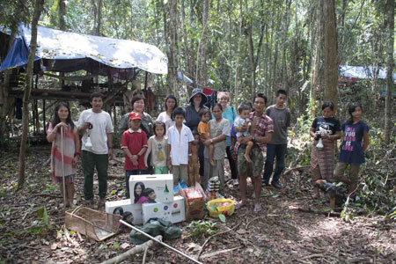
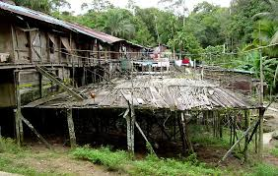
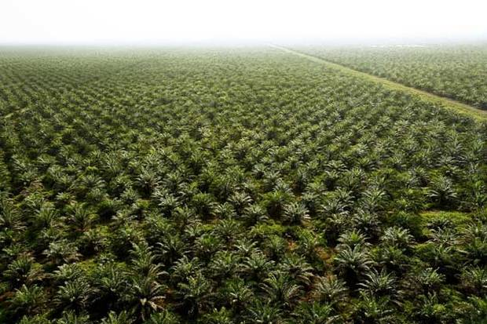

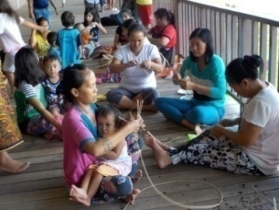

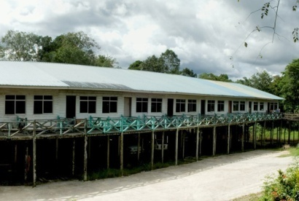
RESORT

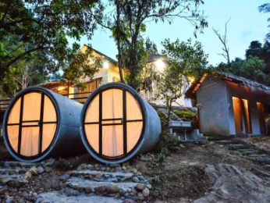

The Ecopalm-Resort Selangau will have a total area of 50 acres and is located at KM 4 Selangau - Mukah road. The concept of vacation and recreation in oil palm plantation, fruit orchard and cattle and goat farms is also enhanced by the beautiful natural surroundings. Various local fruits are available especially durians which is in season in the period of June through July. This well-known resort promises fresh air and beautiful flora and fauna with clear lakes suitable for relaxing and fishing activity.

Moreover, it is situated near Bukit Berkelah waterfall, a mere distance of 5 kilometers from the resort where visitors can opt for a 2-hour nature trekking to reach the waterfall area. Ecopalm-Resort Selangau also rear cattle and goats in its farm as an extra attraction and excitement for its visitors and occupants. Besides that, this resort also provides outdoor and extreme activities such as jungle tracking, kayaking and paintball.
Recreational Facilities
- Forest camp and camping
- Fishing pond
- Obstacle track


- Jungle Tracking
- Beach volleyball court
- Takraw court
- Netball court
- Ping pong court
- Suspension bridge
- Observation Tower
FRUIT FARM
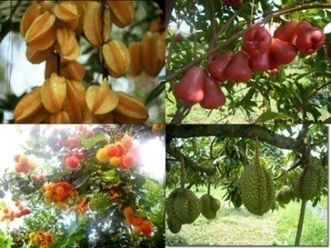
Palmeco will also set up fruit orchards in Selangau area, planted in Jemoreng estate management center. The 20 hectares of orchard under the management of Jemoreng is planted with fruits such as lime, coconut, durian and rambutan.
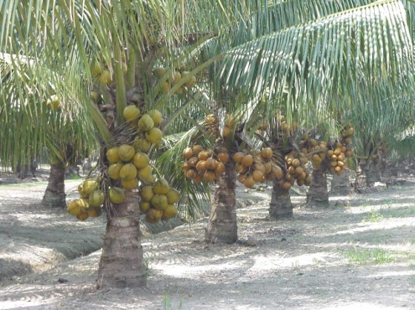
Meanwhile a total of 50 hectares of land will be planted with coconut at the estate. The orchard at the estate will be planted with the famous 'matag' coconut, a favourite among the coconut buyers. The MATAG is a multipurpose coconut variety, being a good variety for producing tender drinking nuts, as well as mature coconuts for the production of coconut milk. The husk fibers are also dense, making it suitable for production of coir.
CATTLE & GOAT FARM
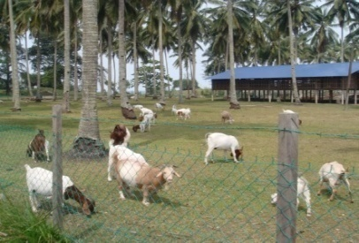
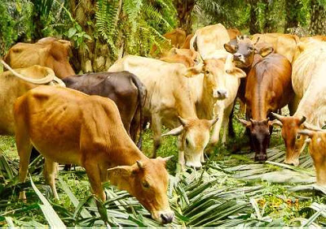
In the Palmeco range, the group will rear beef cattle known as Brakmas and goat-meat known as Boer. These cattle and goat will be reared and placed in a feedlot where the cattle and goat are sold to third party for its meat.

SWIFTLET FARM
Palmeco has its existing swiftlet farms in its Igan estate and has been doing swiftlet farming for more than 10 years now. In its palm oil eco-park, the group will also build a man-made swiftlet habitats that will be opened to its guests to understand more on swiftlet farming. Guests will be able to tour the building and learn how harvesting of edible bird’s nests.
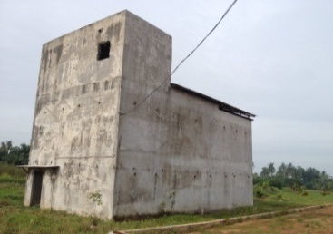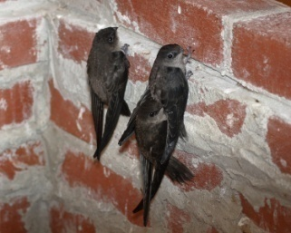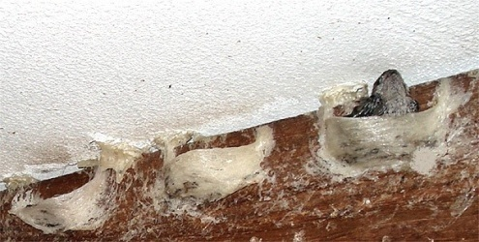

OUR CURRENT & FUTURE PRODUCTS
CURRENT PRODUCTS
FRESH FRUIT BUNCH (FFB)
Oil palm trees start bearing fruits 2½ years after planting and have an economic life of up to 25 years. During this time, they will produce bunches of oil palm fruit which are harvested regularly and taken to the oil mills for processing.
The oil palm plantations are strategically located within close proximity to Igan where the oil palm fruits can be easily and quickly transported to the nearby oil mills and refinery for processing. In 2006, Palmeco had 4,261.9 hectares of plantation land, out of which 4,000 hectares had been planted. As part of its expansion plan, Palmeco is constantly looking at opportunities to expand its plantation land bank to increase the supply of fruits for the production of crude palm oil (CPO).

CRUDE PALM OIL & PALM KERNEL
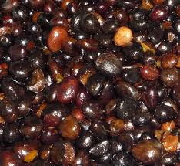
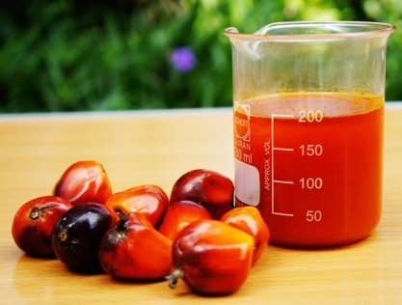
At the oil mills, the fruits are first sterilised in large pressure tanks which soften the fruits as well as eliminate any bacteria on the fruits. Then the fruits are removed from the bunches in the rotating drum stripper. From there, the fruits are passed through a screw press where the oil is extracted from the fleshy fruits, leaving behind the kernels. The oil is then purified in a continuous clarification tank to produce crude palm oil (CPO). This CPO will be delivered to refinery for processing into down stream products.
Palm kernel will be sold to palm kernel mill where it will be processed into palm kernel oil (PK).
Palmeco’ palm oil mills will ensure all its mills consistently achieve one of the highest oil extraction rates (OER) in the industry.

SYSTEMS & SOFTWARE
The principal business activities of Palmeco ICT group are System Development and System Integration, E-commerce solution provider and ICT Outsourcing.
- System Development and System Integration
- Development consultation
- Core program analysis
- Design Development
- Programming and debugging
- Software quality assurance
- Maintenance Contract

- E-commerce Solution Provider
- E-commerce consultation
- Website designing and hosting
- Web Application
- E-commerce hardware and software configuration

- ICT Outsourcing and Software and Hardware Provider
- System administration and maintenance
- Network consultation and implementation
- Server and work-station installation
- ICT department outsourcing
- ICT consultation
- ICT Hardware and software support

SWIFTLET NEST
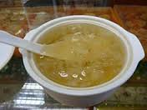
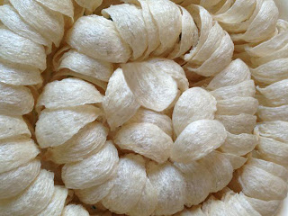
Edible bird’s nests are harvested from Palmeco swiftlet farm. The swiftlet nest, or commonly called bird’s nest, is a Chinese delicacy since the Tang Dynasty of China (618 – 907 A.D.). This bird nest is highly sought after especially by the Chinese. The nests are simmered with broth into bird’s nest soup.

FUTURE PRODUCTS
PALM OIL PRODUCTS
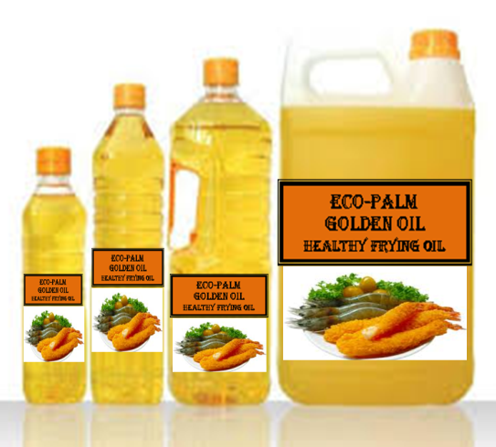
Palmeco group will establish its manufacturing facilities in China and will manufacture a range of palm oil products which are used in manufactured food products, confectioneries as well as non-edible applications products such as soap, cosmetics and detergents.
Palmeco facilities in China will be manufacturing edible oils (palm) for the end-consumer market under our own brand names – Eco-Palm Golden Oil. The edible oils are used as cooking and frying oils, shortening and in fat blends.
The facilities in China will also be producing shortening, which is used in manufacture of margarine, soap, noodle, cocoa butter substitute as well as other palm oil downstream products including edible oils and oleo-chemicals products.


FRUITS
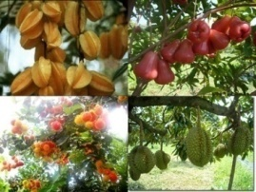
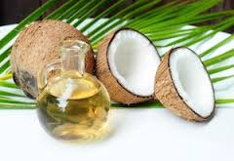
The major fruits from it orchard will be coconut fruit. The young coconut fruit holds within it a refreshing & nutrition packed drink, while the matured kernel is grated and pressed for coconut milk, used in cooking curry. Major multinational companies are marketing coconut milk in powdered form obviating the need for scraping or grating the kernel and expressing the milk, an exacting kitchen chore when making curry. Desiccated coconut kernel is used extensively in the confectionery industry (for example - bounty bars), while from dried kernel or copra, coconut oil is extracted for use widely as a cooking fat which has a very high omega 3 content and also for the manufacture of cosmetics, soaps, margarine, and creams. The residue after the oil extractions is a ready - made poonac or high protein & fat containing animal feed.
Other fruit products will be durian, rambutan and star fruits.

CATTLE & GOAT
In the Palmeco range, beef cattle known as Brakmas and goat-meat known as Boer are sold to third party for its meat.

INDUSTRY ANALYSIS
This is a concise but critical analysis of the palm oil industry from a global perspective, of which Malaysia as the second largest supplier of palm oil in the world next to Indonesia still has great potential especially in Sarawak.
Being one of the two largest producers of palm oil in the world, the industry has grown by leaps and bounds over the last 100 years since its inception in around 1917 and this palm oil industry still has a huge potential in the years to come in view of the rapidly increase in the world population.
Overcoming the multitude of growth challenges in all aspects of plantation area development, oil palm planting and management tasks, product quality improvement will be the main challenges of plantation owners.
Even though second to Indonesia, Malaysia palm oil industry has attained global recognition as a profoundly well integrated palm oil producer with technologically advanced systems in production, process development, research and development, and other ancillary but critical factors.
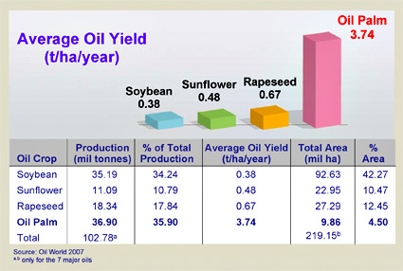
Having attained the world class status, the industry in Malaysia has been able to command pricing mechanisms and predictability, global positioning strategies and elevating palm oil production and quality to the highest position in the seed oil producer list which includes soya oil, sunflower seed oil, rapeseed oil and corn oil and also the highest average oil yield producing crop in comparison.

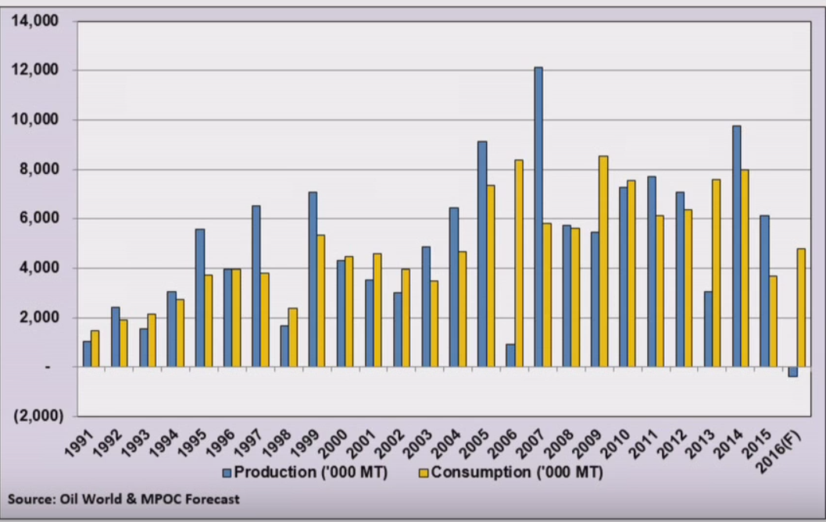

Key factors of reference for plantation companies to focus, monitor and analyse for strategic decision shall be
- Global supply/demand and regional index. This activity will help understand the need to make relative adjustments in production plans and inventory management before supplying to palm oil mills.
- Palm oil day-to-day and month-to-month price movements.
- Sustainability management methodologies.
Consideration of RSPO, MSPO, MOCC certification, which has increasingly become a mandatory requirement in order to provide a competitive edge in the palm oil market, SPMSB is determined in endorsing these in its developments.

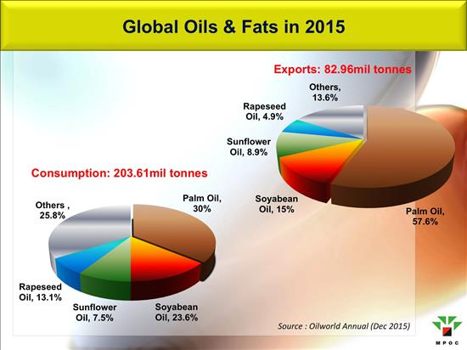
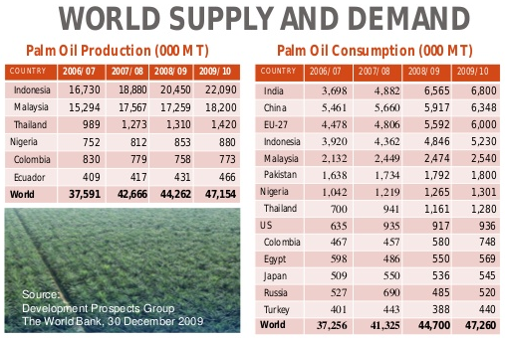
MARKET ANALYSIS
The centrality of palm oil production and consumption is in Oil and Fats requirement by world population. This global requirement driven by the food industry has increased from 36.22 million metric tons to 57.23 million metric tons over the last 10 years and this trend is still increasing.
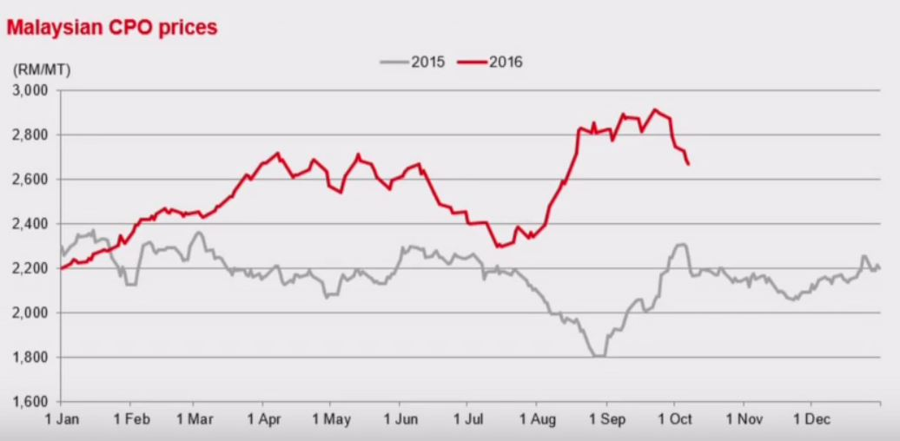

As a result of this substantial increase in the demand for oils and fats for food consumption, the world supply for seed oil plantation has been on the upward trend. Topping this list is obviously palm oil.

However, production of palm oil has not been able to support as the production of palm oil has declined due to the disruptive weather phenomena of El Nino and La Nina of early 2014-2015.

This condition has propelled the supply side of palm oil production to exclude production and output. Coupled with the increase in demand from countries like China, India, Japan, South Korea and the Philippines has recharged the Malaysian palm oil sector to increase production.

This critical factor in the trends of palm oil market indirectly or directly translates to greater need for land arability and planting in the Malaysian palm oil industry. The timing of SPMSB’s venture into the Integrated Palm Oil Project bodes well for SPMSB business strategies.

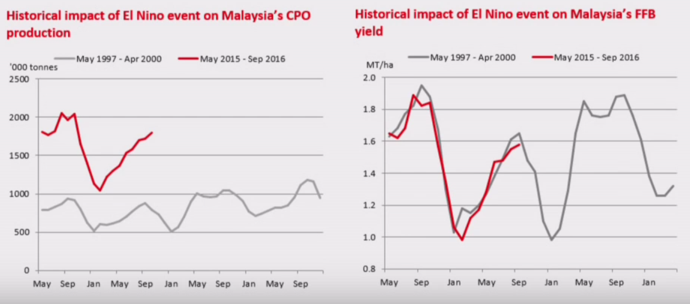

The statistical data indicates that the palm oil price is in the upward trend for the past 15 years due to the ever increase in the demand for vegetable oils.
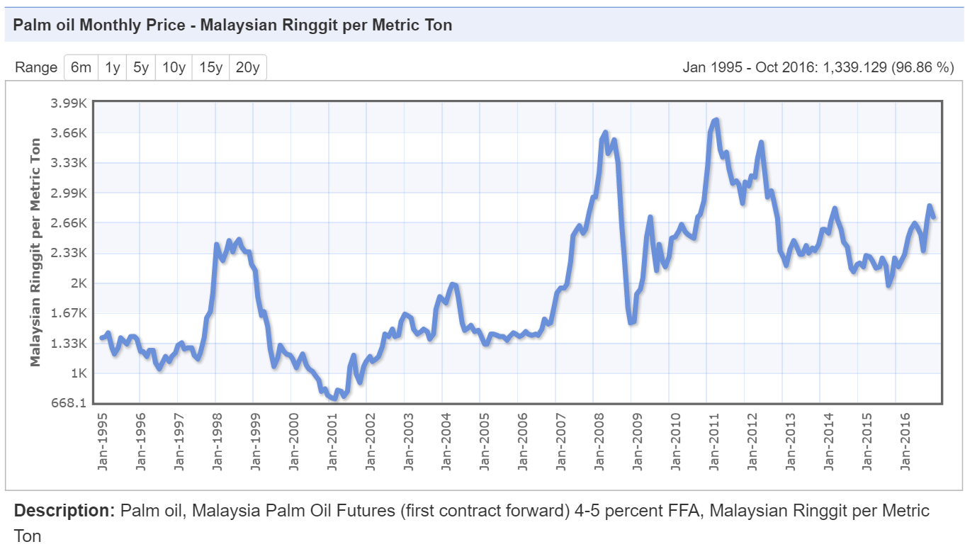

The typical indicative average projected annual return of a palm oil investment is in the range of 20% to 35%.
PALM OIL INDUSTRY – OIL PALM
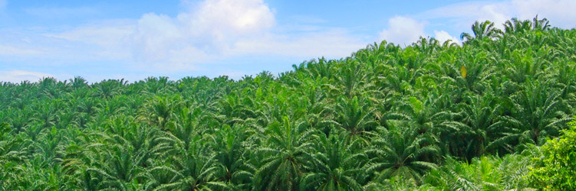
Oil Palm and the Environment
With increased awareness about the impact of uncontrolled economic development on the environment, especially in relation to global warming and climate changes, there is a mounting pressure to ensure that future development is sustainable and environment-friendly. The oil palm industry, with its rapid expansion over the last few decades, is not exempted from such pressure. To provide consumers with a true picture of the oil palm industry, MPOB, with the help of the Malaysian palm oil industry, has evaluated the whole spectrum of Malaysian palm oil production and affirmed that it is indeed environment-friendly and sustainable, as evident from the following facts (MPOC and MPOB, 2007):
Highest Yielding and Lowest Land Use
The oil palm is a perennial crop which starts yielding palm fruits for oil about three years after planting and it has a continual productive lifespan of 25-30 years. Furthermore, with the total yield of about 4.5 t (4 t palm oil and 0.5 t palm kernel oil) per hectare, it is the most productive oil crop in the world, being 10 times more productive then soya bean, which produces only about 0.45 t of oil per hectare. This means that to produce the same volume of oil, oil palm will only need one-tenth of the area required by soya bean. This is an important consideration when comes to land expansion for oilseeds cultivation, production efficiency and consistent supply of edible oils to feed the increasing world population.
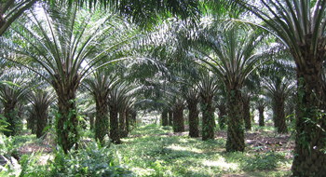
Mature plantation
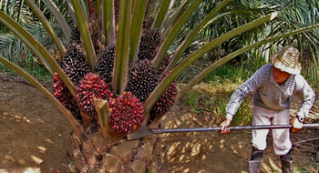
Harvesting of Oil Palm Fruit Bunches
Excellent Source of Biomass
An oil palm plantation is capable of assimilating up to 36.5 t of dry matter per hectare per year, which is higher than the 25.7 t assimilated by natural rainforest. The oil palm is thus more effective than the rain forest in generating new biomass, which has wide uses for wood-replacement and is also a potential source of renewable bio-fuel.
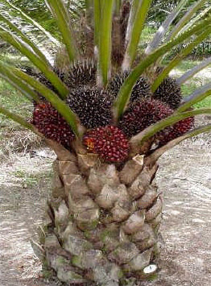
New Variety of Oil Palm Tree
Self-sufficient in Energy in Processing
The extraction of palm oil from its fruit bunches does not require any external energy input because the process uses its biomass – pressed fibres and palm kernel shells as solid fuel for the boiler to generate steam. There is even excess steam to generate electricity for domestic use by the plantation and factory workers.
Effective Carbon Sink
Oil palm plantations are as effective as rain forests in acting as a carbon sink to absorb carbon dioxide much of which is released from the burning of fossil fuels, as shown in Table 1.
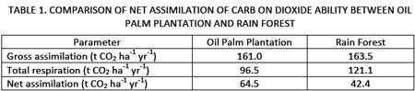
Positive Contribution in Energy Balance
Oil palm is the most efficient crop capable of producing the highest energy output-input ratio. In absolute terms, the oil palm also requires the lowest inputs of pesticides, fertilizers and fuel per unit production of oil. With an energy input of 19 GJ ha-1, the return is 182 GJ ha-1. In sharp contrast, the corresponding figures for soya bean are 20 GJ ha-1 and 50 GJ ha-1, respectively.
Sustainable Practices
The Malaysian oil palm industry uses sustainable practices to ensure that the environment and biodiversity are not harmed by cultivation of the crop through the adoption of Good Agricultural Practices (GAP). Implementation of Integrated Pest Management (IPM) also minimizes the use of pesticides by depending more on biological control of weeds and pests.
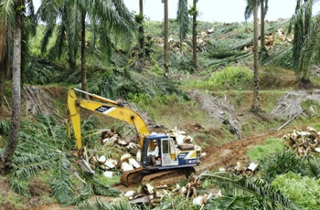
Zero Burning
Zero burning is practiced in clearing the old stand during replanting, i.e. the old palms are pushed over, shredded and left to decompose in the area. There is therefore, no air pollution from burning the old palms and, most importantly, the nutrients in the old crop are recycled into the new.
No Encroachment of Forest Areas
The expansion in oil palm area in Malaysia is either through planting of idle land or conversion from other crops. Oil palm is planted on 4.2 million hectares, less than 13% of the total land area of Malaysia. The country still has at least 18.55 million hectares, or 56.5% of its total area under forest and national parks, wildlife and nature reserves.
Sustainable Achievement
Malaysia produces a sustainable supply of vegetable oils to meet the world’s ever increasing demand. In 2006, it produced 17.8 million tonnes of palm oil, or almost 12% of the global production of vegetable oils. This was achieved with only 4.17 million hectares planted area, or less than 2% of the global area under oil crops.

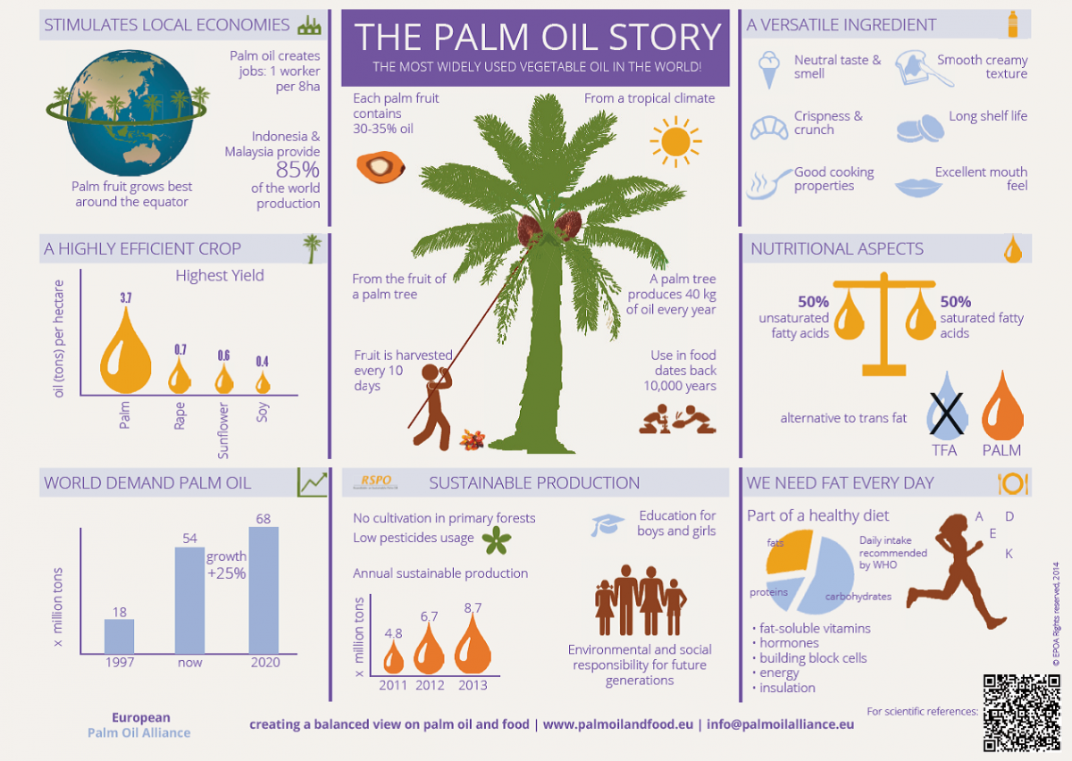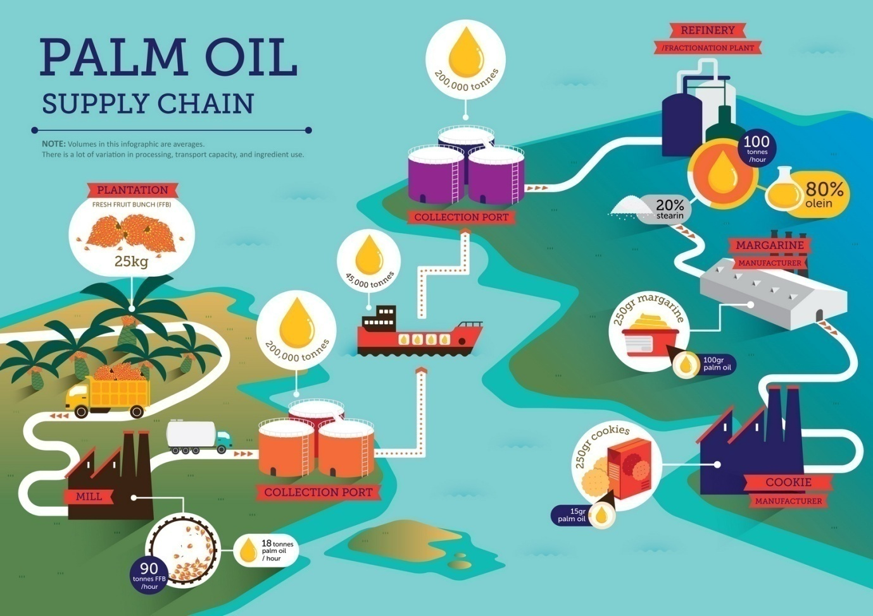
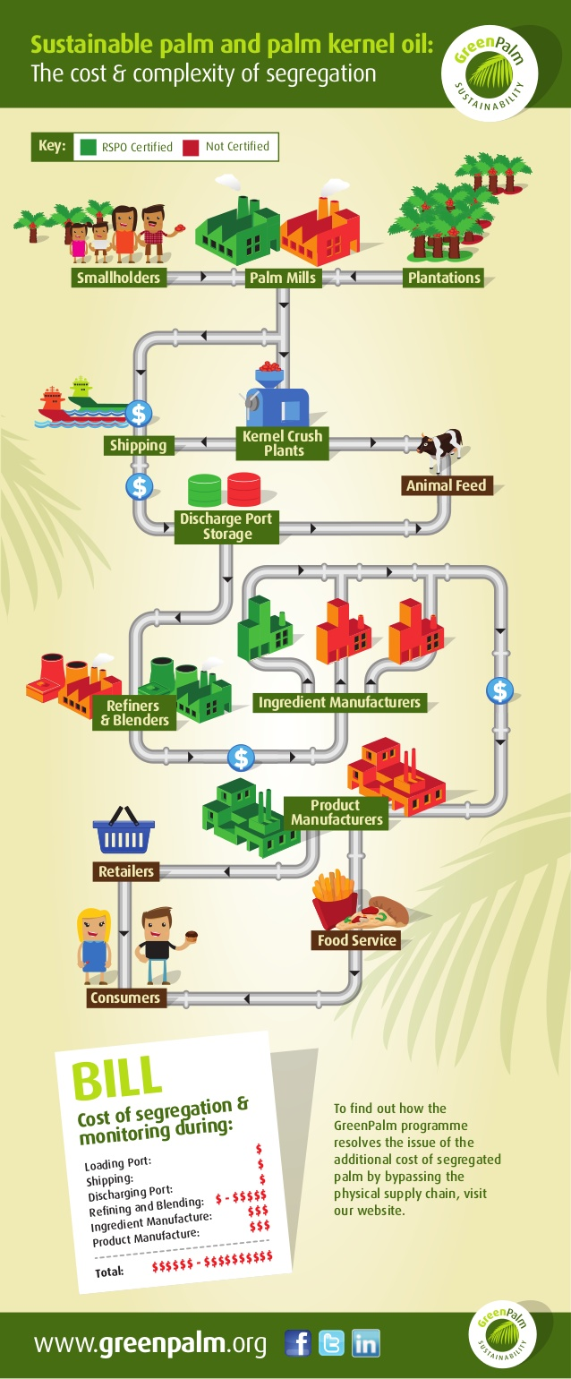

ROUNDTABLE ON SUSTAINABLE PALM OIL (“RSPO”)
It is the objective of Palmeco Group to promote the growth and the use of sustainable palm oil. The Group believes the need to promote environmental awareness and sustainable practices as well as to upkeep the Group’s social responsibility through an effective and responsible Management.
In our quest for efficiency and higher standards, Palmeco is making sure that cutting-edge technology is used throughout the manufacturing and production process. The key feature to such sustainable palm oil is the increasing transparency and traceability within the system.
Further efforts will also lead to attaining of the RSPO Principles & Criteria Certification for the Group. The Group will follows through the eight (8) main principles to ensure strict compliance to the RSPO Principles & Criteria.
Regular key stakeholders’ engagement meetings were conducted to improve practices in line with the requirement of the eight (8) principles.
The Group has in place a time-bound plan for all its strategic operating units to be RSPO certified in times to come.
