- We are looking for a large graphic similar to how you are seeing the below message portrayed.
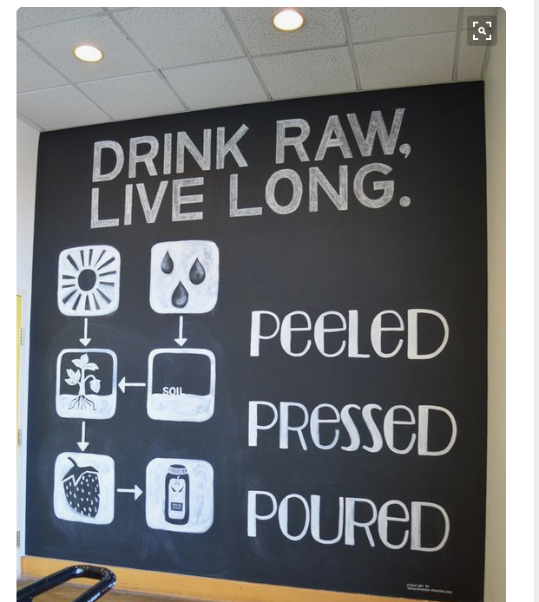

- We are trying to have this big piece of wall art include the information you see below but we want it done in a more creative and colorful design similar to the image you see here.
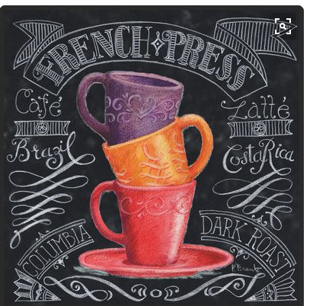

- We are trying to show the elements of an Acai bowl by taking a side a creative look at the side of an acai bowl. We don’t want a picture of an acai
- Below are some examples of how other places have done this.

