We rescued a dog from a shelter on April 1st who was set to be euthanized. She was the most unlikely dog to be rescued because she had basically checked out of life. She had been seized from her owners for abuse and was clearly neglected. Her only way of dealing with the 4+ years of abuse was to withdraw. She would not walk and just lay curled up in a ball in the back of her kennel. Our heart broke for her and we decided to give her a new lease on life and a new home…. A forever home.

Picture of her first night.

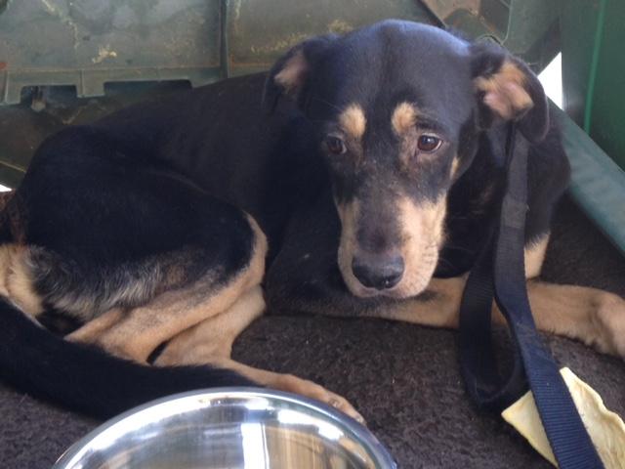

I had to carry her out of the shelter to the car. She was scared of everything. She was so withdrawn that her eyes did not move, her ears did not perk and her nose did not sniff. She lay in a corner and would not move. When we finally coaxed her to move, she did the army crawl to walk outside to go to the bathroom and was in complete fear the entire time.

We believe that speaking confidence into someone makes a difference so we decided to name her Takoda which means friend of everyone. We want that for her….. to love life and love those around her. We call her Koda.

After three months of love, consistency, medical treatment and professional dog training (confidence building) Koda is starting to enjoy life.

See pictures….
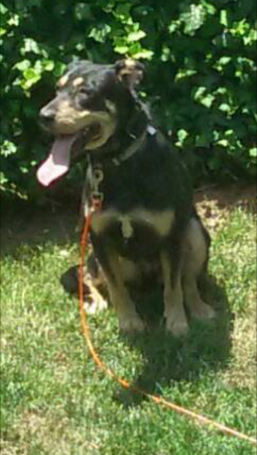

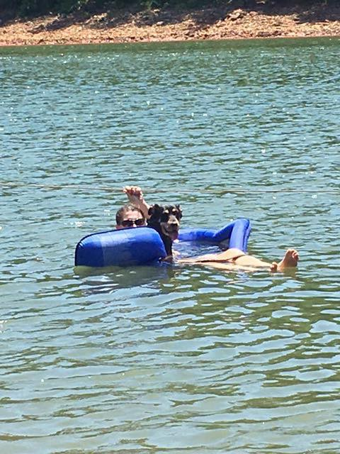

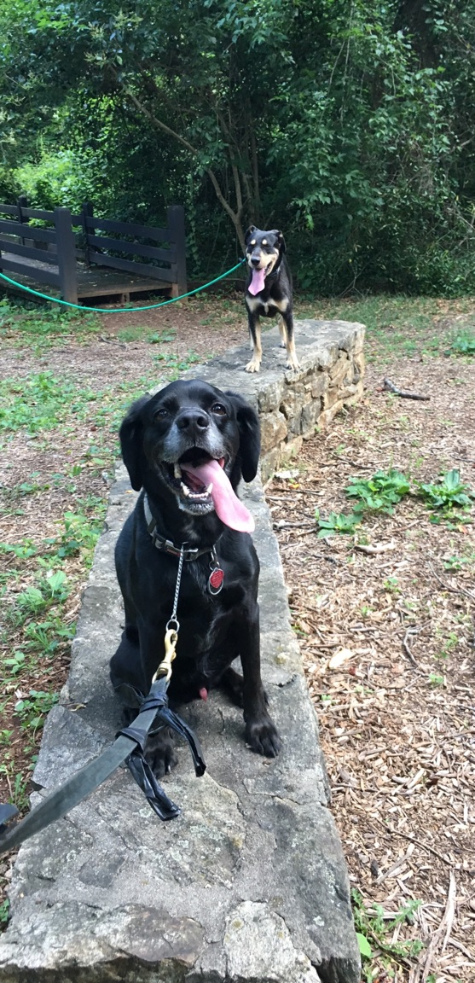

After seeing Koda experience this incredible transformation of no longer desiring to engage in or live life to the place where she is now enjoying life, we are inspired to replicate this on a larger scale than our family can do on our own, so we are starting Rescued Life to inspire others, to encourage others, and to help fund the rescue of many other “Kodas” that are in need of our help.

