
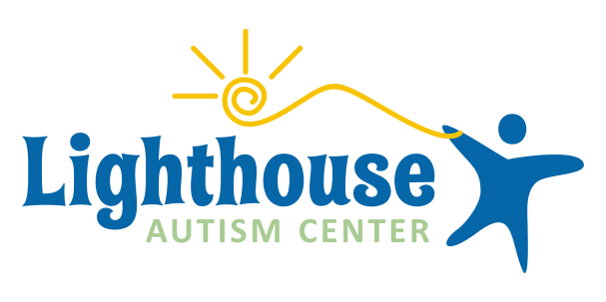
Mishawaka, IN Plymouth, IN Warsaw, IN Portage, MI
574-387-4313
- Full Benefits
- 3 Weeks PTO
- Family Focused
- Award Winning Management Team
- Opportunities for advancement
- Employee Stock Ownership Program
www.LighthouseAutismCenter.com
Now accepting applications at our Indiana and Michigan centers!
Providing 1:1 center based ABA therapy in Northern Indiana and Southwest Michigan

