I’VE RAISED:
£………………………………………..
MY CLASS:
………………………………………..
MY NAME:
…………………………………………………
MY SPONSORSHIP FORM

I’m going to be taking part in a fun fitness circuit alongside a top GB athlete.

Please sponsor me to help raise money for new sports equipment for my school and to help support GB athletes to compete for our country and inspire the next generation.

As a thank you, if I meet these milestones, I’ll receive the following prizes:
Pic of blue wrist band & red wrist band & poster of an athlete
Raise over £15
Pic of blue wrist band & red wrist band
Raise over £15
Pic of blue wrist band
Raise over £5

Name | Amount Sponsored (£) | Paid? (Please tick)

Social Enterprise Logo
Subway Logo
Clubs for Schools logo

The Event:
PRACTICE
I’ll practice the 4 exercises before the event so I can show the athlete what I’ve learnt.

THE DVD ASSEMBLY
I’ll watch a DVD in assembly to reveal which GB athlete is visiting my school and what sport they compete in.
I’ll also learn the exercises that I’ll be doing with the athlete on the day
THE EVENT DAY
I’ll complete the fitness circuit alongside the athlete, listen to an inspirational assembly and ask any questions I may have.

The Exercises:
I will complete as many of the following exercises as I can in 1 minute intervals
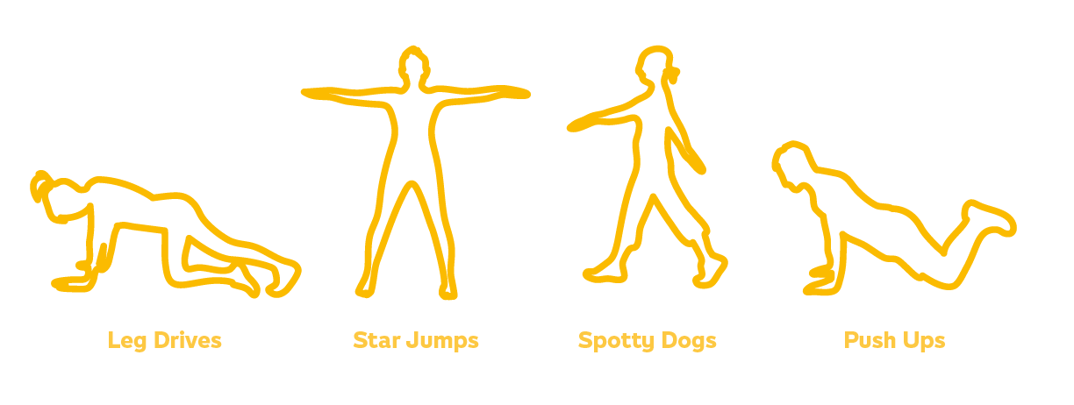
After the Event:
I’ll have one week to collect up my sponsorship money and then I will need to return the front two pages of this form to the school office.
£100
Could buy my school 15 footballs
£250
Could buy my school 2 basketball hoops
£500
Could buy my school a gym mat trolley & 5 gym mats

Get online!

Find out more about your event and the Athlete visiting your schools at www.SportsForSchools.org/MyEvent

- Set up an online fundraising page (takes 90 seconds)
Simply visit www.sportsforschools.org/sponsormychild
- Make the 1st donation
The best way to encourage others to support your child is to be the first to sponsor them. The amount is less important than the act!
- Invite others
Share your child’s fundraising page with friends and family to get the donations rolling in

Follow us on Twitter! @sportsfs

Like us on Facebook! @sportsfschools

Subscribe to our news! www.sportsforschools.org
We’d love to hear from you – post us your pictures and comments on social media
To find out more about Sports for Schools and how we fund the scheme, visit: www.SportsForSchools.org/funding-for-schools/

Quiz Corner
Colouring in?
Spot the Difference?
Maze?

