24/7 call outs
Quality guarantee on all works
Manufacturer’s warranty on all products
Locally owned and run business

Smoke Alarms
Properties that are subject to sale, transfer of ownership, rental or hire in western Australia must have main’s powered smoke alarms fitted and regularly tested.
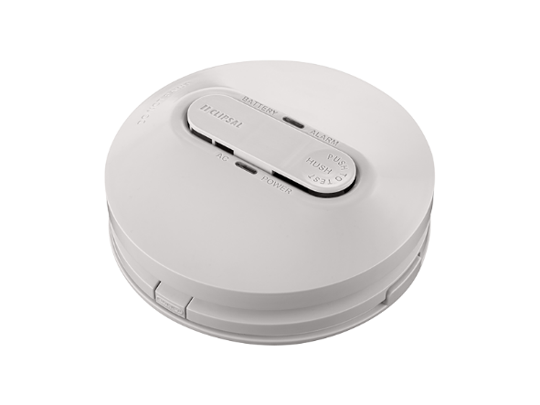
- Make sure your home or investment is safe, rental ready, and legally compliant by having Hayton Electrical inspect/test your current smoke alarms. Regular maintenance and annually battery changing is recommended by the department of fire and emergency services.
- Bring your building up to standard by having us replace any alarms over ten years old, or if you do not have any existing alarms/not as many as required, install and test new units in your premises.
RCD’s (safety switches)
“A minimum of two RCDs protecting all power and lighting circuits must be fitted to a residential property before it can be sold and the transfer of title takes place.”
“Landlords must arrange for a minimum of two RCDs to be installed at their rental premises before offering the property for lease.”
“Real estate agents should inform potential vendors that RCDs must be installed prior to the transfer of ownership of the property. “
List of references,
Energy Safety,
Residual Current Devices (RCDs) / safety switches https://www.commerce.wa.gov.au/energysafety/rcd-rules
Last modified: Thursday, June 29, 2017 - 12:34
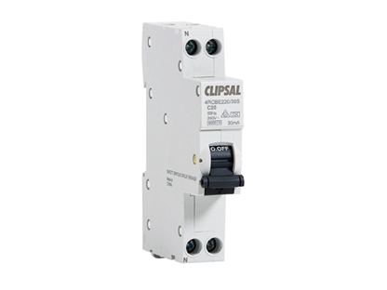
Avoid the legal and moral ramifications of not having a compliant property when tenanting or selling.
- Hayton electrical can bring your house up to standard by installing and testing the minimum 2 RCD’s required by state law.
- Already have RCD’s fitted? Have Hayton Electrical make sure they are installed/functioning correctly and that all required electrical equipment is appropriately protected by the fitted switches.
Electrical Inspections
Hayton Electrical can provide a thorough safety inspection for residential and commercial clients. We will take a look at your electrical system and provide adjustments on fixtures that should be arranged. We can then provide a recommendation and quote on what can be done based on our inspection.
Safety Certificates
After inspection, if your property is compliant Hayton Electrical will provide you with a Safety Certificate, certifying that your electrical installation is safe, up to standard, and ready for change of hands or rental.
Hayton Electrical also provides Safety certificates for any additional works done by us on your property

Renovations
Home renovations can get very costly if they are not planned properly.
Hayton Electrical will take the time to discuss your electrical requirements and work with you to design an electrical system that will function effectively with the architectural parameters of your newly renovated home. We also provide the most up to date and innovative solutions and products for your home that are both energy efficient and cost efficient.
When it comes to electrical installations, our goal is to minimize your stress by providing an electrician who shows up on time, is well presented, professional and carries out your job with care and skill. Through innovation, planning and use of quality systems we take pride in providing you with the highest level of customer service.

Air Conditioning

From $540*, Hayton Electrical can arrange for a standard single storey back to back split system installation to suit most homes. Whether it's a 2.5kW unit for smaller spaces or a 10kW for larger spaces, we can cater to your installation needs.
(terms and conditions apply, contact us for details)

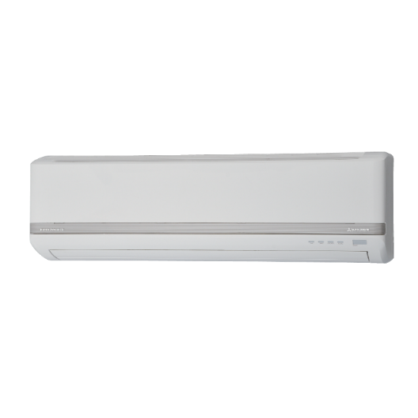
Need us to supply and fit? See our following price guide for supply and installation of split system air conditioning to your home or office.
(supply and fit prices are quoted as back to back installations only additional costs may apply for installations that differ).

Mitsubishi 1.7/2.0kW Split Air Conditioner supply and fit $1272 (price is GST inclusive)
Mitsubishi 2.0/2.5kW Split Air Conditioner supply and fit $1402 (price is GST inclusive)
Mitsubishi 3.5/4kW Split Air Conditioner supply and fit $1506 (price is GST inclusive)
Mitsubishi 5/5.8kW Split Air Conditioner supply and fit $1999 (price is GST inclusive)
Mitsubishi 6.3/7.1kW Split Air Conditioner supply and fit $2304 (price is GST inclusive)
Mitsubishi 8.0/9.0kW Split Air Conditioner supply and fit $2870 (price is GST inclusive)
Mitsubishi 9.2/10kw Reverse Split Air Conditioner supply and fit $3480 (price is GST inclusive)

Test tag:

Electrical testing and tagging is the process of determining if an electrical item is faulty. Our qualified electrician will visually inspect the item then perform a series of tests including:
• Insulation resistance
• Earth Circuit test
• Earth Leakage Tests
• Polarity
• RCD (safety Switch) Test
Our test tag prices start from $5.50 per item

