Website template
RESIDENTIAL, COMMERCIAL, INDUSTRIAL, AIRCONDITIONING, TEST TAG, CONTACT US
Homepage:
Providing you with high quality electrical componentry and proven industry know how, at Hayton Electrical you can rest assured your job will be completed to standard and on time. We pride ourselves on providing you with professional electrical services at competitive prices.
With a qualified workforce, fleet of specialist vehicles, modern plant and equipment, Hayton Electrical provides cost efficient and innovative electrical solutions to a wide range of clients and industries.

15% discount on labour if you are a pensioner
24/7 call outs
Quality guarantee on all works
Manufacturer’s warranty on all products
Locally owned and run business

Contact us:
Name:
Email:
Contact number:
Address:
Suburb:
Subject:
Comments:
RESiDENTIAL
We cover a large variety of domestic work W.A wide. We take pride in each and every job that we do and treat it as if it were our own home. Due to our vast experience in the domestic field we can inform our clients with the most cost efficient and beneficial ideas. At Hayton Electrical no one is treated like just a number; each client is extremely important to us. 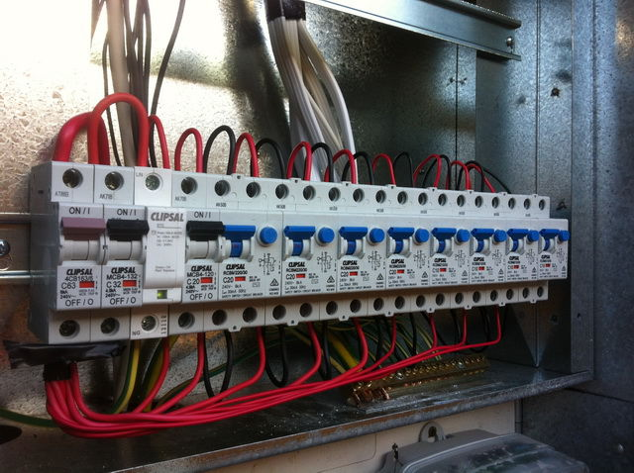
Commercial
We provide our commercial clients with top quality products and services that are delivered on time and to budget. We pledge to provide all of this and more without compromising on quality. All our goods and services are warrantied, and our team will always work to deliver exceptional services and long-lasting electrical work.
When you need lighting for warehouses or offices, security or exit lighting we will have the solution. Our team of qualified electricians have access to an extensive range of lighting products. We can install your lighting, or design a lighting solution for your project, large or small.
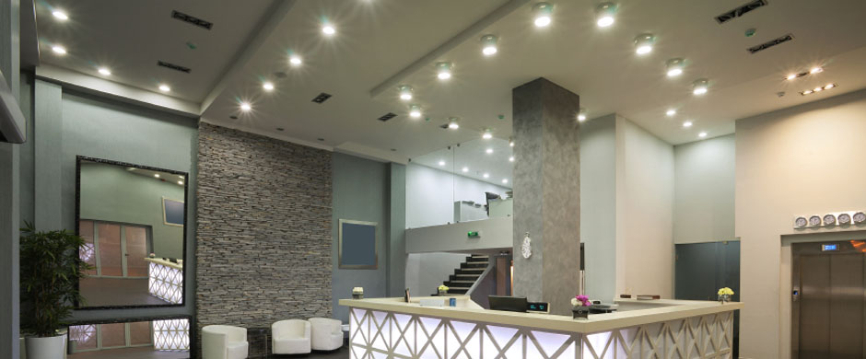Test tag:
Electrical testing and tagging is the process of determining if an electrical item is faulty. Our qualified electrician will visually inspect the item then perform a series of tests including:
- Insulation resistance
- Earth Circuit test
- Earth Leakage Tests
- Polarity
- RCD (safety Switch) Test

This process is then followed by placing an appliance tag on the electrical item which highlights to the operator that this has been serviced and is safe to use.
All employers have a duty of care to provide a safe working environment from all hazards for all employees, visitor and Personal Under the Occupational Health and Safety Act Of 1984
Having your electrical equipment checked regularly will insure you are providing a safe working environment and avoiding possible electric shocks, fires. You also will avoid the legal ramification that follows.
Our test tag prices start from $5.50 per item

Industrial
We are committed to living our values of safety, quality, reliability, trust and loyalty. Our operations are characterised by strong safety, technical and project delivery performance whether in capital and major cities, regional towns or remote and challenging locations.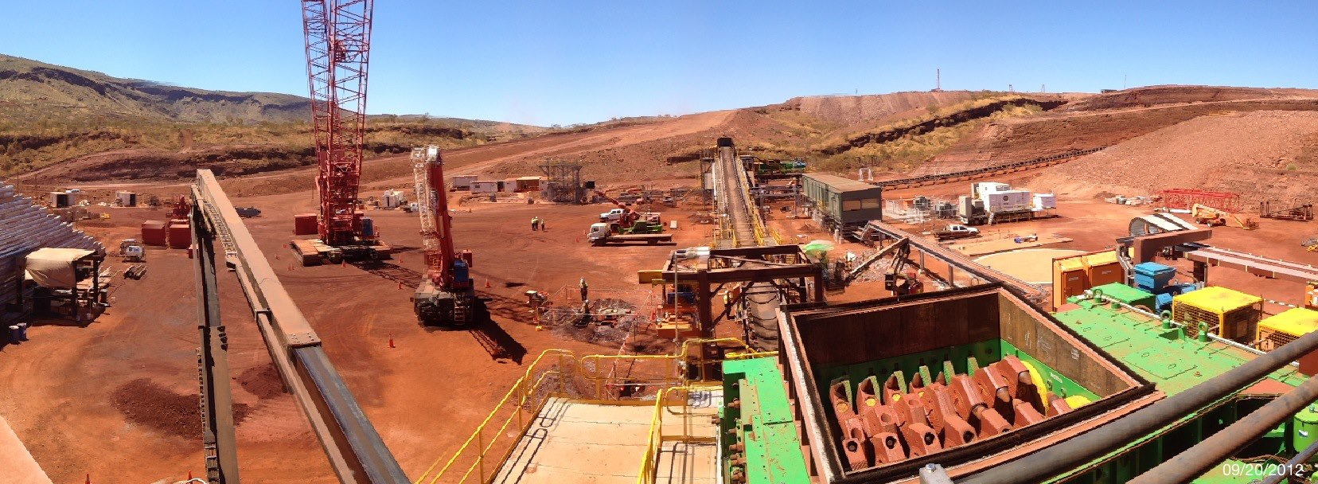With experience in major industrial projects across western Australia hayton electrical has the solution to your needs. We can tailor any installation to your specific requirements or industry specific needs. Please contact us regarding your next installation or maintenance needs. 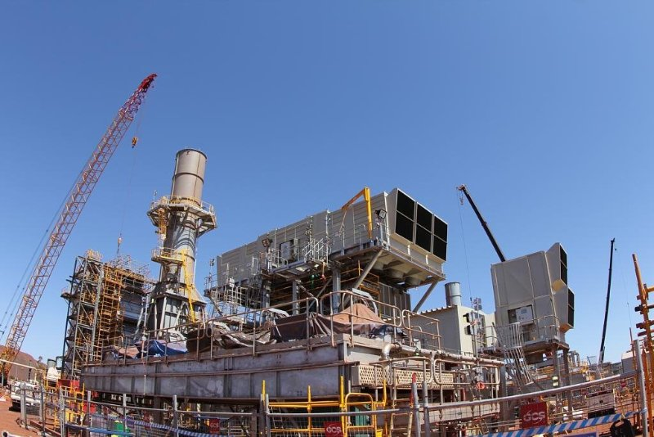
Air conditioning:
Hayton Electrical takes pride in installing & commissioning quality air conditioning systems, from installing a unit you have purchased to complete supply & install packages.
From $540*, Hayton Electrical can arrange for a standard single storey back to back split system installation to suit most homes. Whether it's a 2.5kW unit for smaller spaces or a 10kW for larger spaces, we can cater to your installation needs.
Standard Single Storey Back to Back Split System Installation
Standard 'back to back' installation is a split system with two main components - a wall mounted indoor unit with an outdoor unit positioned directly below on a single storey dwelling.
What you get in a standard installation:
- PVC Ducting to conceal the pipe work and electrical connections
- Up to 20 meters* of internal roof cable in roof
- Weatherproof safety isolation switch mounted near outdoor unit
- Up to 2.5 meters* of pipework between the head unit and the outdoor compressor unit
- *Greater distances are at an additional cost
Some Additional costs may apply:
- Extra piping
- Poly Slab Installation (if not already present)
- Brackets
- Electrical work (e.g. eg circuit upgrades, circuit breaker, single pole enclosure).
- Additional charges for working at heights (roof mount or double story dwellings)

Need us to supply and fit? See our following price guide for supply and installation of split system air conditioning to your home or office. (supply and fit prices are quoted as back to back installations only additional costs may apply for installations that differ).
Mitsubishi 1.7/2.0kW Split Air Conditioner supply and fit $1272 (price is GST inclusive)
Mitsubishi 2.0/2.5kW Split Air Conditioner supply and fit $1402 (price is GST inclusive)
Mitsubishi 3.5/4kW Split Air Conditioner supply and fit $1506 (price is GST inclusive)
Mitsubishi 5/5.8kW Split Air Conditioner supply and fit $1999 (price is GST inclusive)
Mitsubishi 6.3/7.1kW Split Air Conditioner supply and fit $2304 (price is GST inclusive)
Mitsubishi 8.0/9.0kW Split Air Conditioner supply and fit $2870 (price is GST inclusive)
Mitsubishi 9.2/10kw Reverse Split Air Conditioner supply and fit $3480 (price is GST inclusive)
Special offer: when purchasing more than one supply and fit air-conditioning package receive a 5% discount off every extra unit supply and fit cost. (discount applies to the listed price only, any additional costs associated with the installations not being back to back will not be subject to discount)
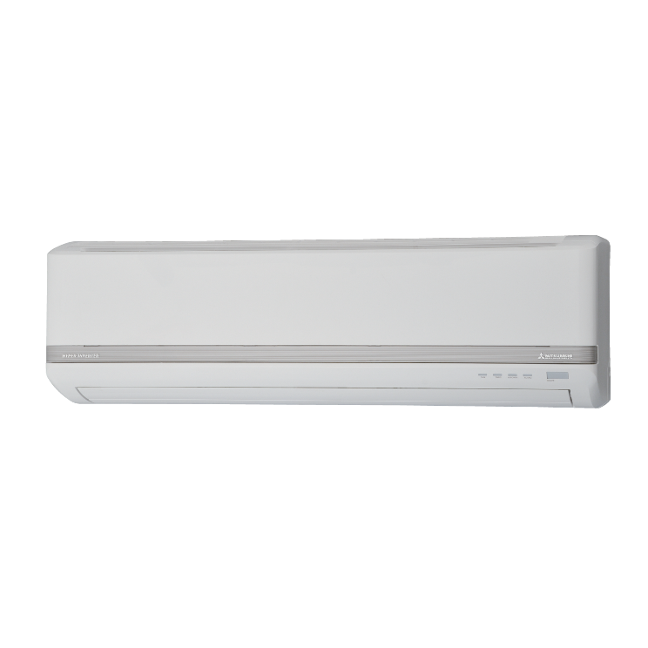
All supplied air conditioners are inverted and come with a 5-year manufacturer’s warranty. We also stock a range of non-reverse cycle air conditioners, please contact for pricing on these units (no heat function).
Want a different unit? We also stock Panasonic and Toshiba as well as cassete style units, or we can price up somthing of your choosing. Send us an enquiry with your needs
