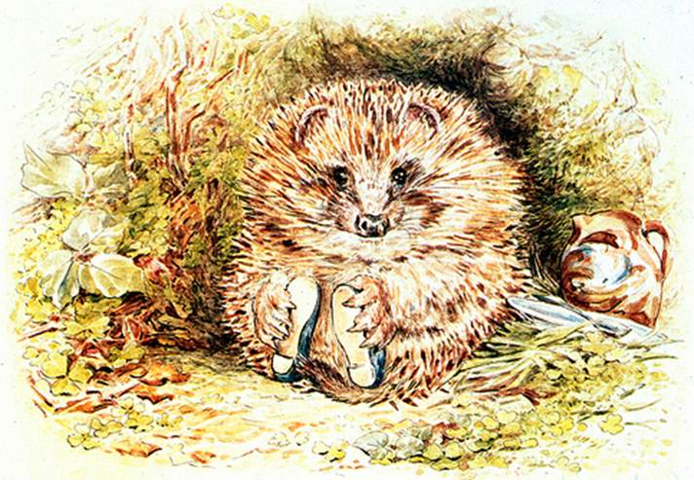
The Hairy Hedgehog who wanted to meet
Name child
Once upon a time there was a young hedgehog who heard that a baby had been born in the house at the end of the garden where he lived.
He was so happy to know that soon a new friend would play with him in the garden. He decided to pay him a visit. When his mother saw him heading to the house, she stopped him immediately. Have you lost your mind little hedgehog? You can not visit a baby, they don’t like us, we prick! Moreover, your hair looks very untidy; you cannot visit a baby looking like that! Desperate, the young hedgehog burst into tears. Then he decided that this was not going to stop him from making a new friend. If he could not meet the baby himself he would leave the baby a present. He took two of his spines and with the finest wool he could find in his mother’s workshop, he started to knit.
By morning, he had made the softest cardigan anyone had ever seen. He wrapped it carefully and left it by the front door. The next day, he saw through the window his baby friend wearing his present and felt the happiest hedgehog in the world…
You see, little baby, prickly people can be gentle, and weakness can be turned into strength.
Only the untidy hairstyle of the hedgehog remains. So if you want him to pay you a visit, remember to leave a hairbrush in the hedge, and he might show up for tea…
Cover: picture of the little hairy hedghehog
Style: nature, English garden, flowers, green, butterflies, little animals dressed with cute little outfits

