15% discount on labour if you are a pensioner
24/7 call outs
Quality guarantee on all works
Manufacturer’s warranty on all products
Locally owned and run business
Call us for all your electrical maintenance and renovation needs, no job too big or small.
RCD’s (safety switches)
Avoid the legal and moral ramifications of not having a compliant property when tenanting or selling.
- Hayton electrical can bring your house up to standard by installing and testing the minimum 2 RCD’s requiered by state law.
- Already have RCD’s fitted? Have Hayton Electrical make sure they are installed/functioning correctly and that all requiered electrical equiptment is appropriatly protected by the fitted switches.
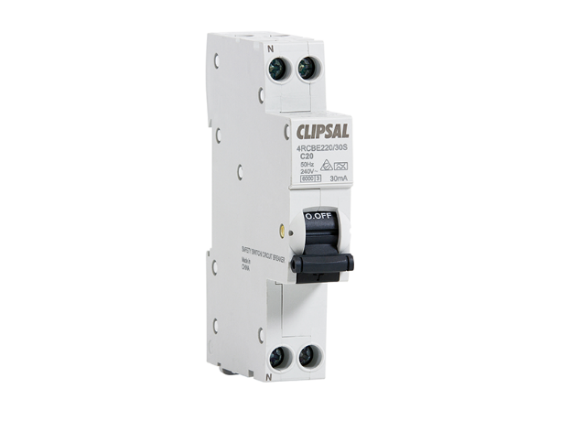
Hayton Electrical can supply, fit and test 2 clipsal RCBO’s to your switchboard from as little as $248.50 (terms and conditions apply, Call us for details)
Smoke Alarms
Properties that are subject to sale, transfer of ownership, rental or hire in western Australia must have main’s powered smoke alarms fitted and regularly tested.
- Make sure your home or investment is safe, rental ready, and legally compliant by having Hayton Electrical inspect/test your current smoke alarms. Regular maintenance and annually battery changing is recommended by the department of fire and emergency services.
- Bring your building up to standard by having us replace any alarms over ten years old, or if you do not have any existing alarms/not as many as required, install and test new units in your premisis.
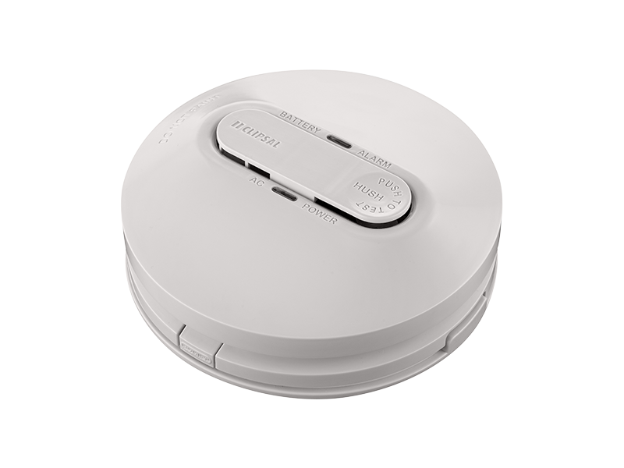
Hayton Electrical can supply, fit and test 2 inter connected clipsal photoelectric smoke alarms to your premisis from as little as $389.80 (terms and conditions apply, Call us for details)
Air Conditioning

See our following price guide for supply and installation of split system air conditioning to your home or office.
(supply and fit prices are quoted as back to back installations only additional costs may apply for installations that differ, call us for terms and conditions).

Mitsubishi 1.7/2.0kW Split Air Conditioner supply and fit $1272 (price is GST inclusive)
Mitsubishi 2.0/2.5kW Split Air Conditioner supply and fit $1402 (price is GST inclusive)
Mitsubishi 3.5/4kW Split Air Conditioner supply and fit $1506 (price is GST inclusive)
Mitsubishi 5/5.8kW Split Air Conditioner supply and fit $1999 (price is GST inclusive)
Mitsubishi 6.3/7.1kW Split Air Conditioner supply and fit $2304 (price is GST inclusive)
Mitsubishi 8.0/9.0kW Split Air Conditioner supply and fit $2870 (price is GST inclusive)
Mitsubishi 9.2/10kw Reverse Split Air Conditioner supply and fit $3480 (price is GST inclusive)
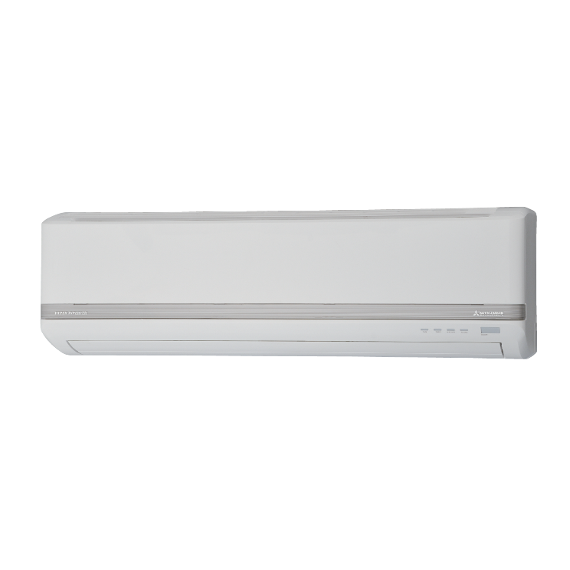

From $540*, Hayton Electrical can install a supplied standard single storey back to back split system to most homes.
(terms and conditions apply, contact us for details)

LED Downlights

Want to swap an existing light or fan with a 9W led downlight?, or add additional downlights switched of an existing fitting? 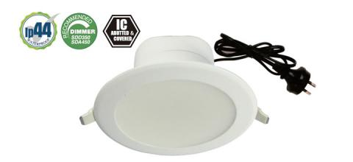
Hayton electrical can supply and fit wave led downlights for as little as $60 per light.
Swap out those dangerous Halogens for a low heat, high efficiency I.C rated LED downlight today

