These few, executions are not shown because we want to emulate them, but just to give an idea of what is on the market. There are many more that can be easily found via Google to get an idea of the competitive landscape. You will see lots of blacks and greys which we see as a pretty predictable way of going after our demographic. If you Google “men’s cosmetics” you will see loads of dark colors and loads of lines that look pretty similar. MaxM Camouflage can use colors and have fun to create point of difference, provided we still communicate with our primary demographic of heterosexuals males 15-25 years old.
Retro concepts:
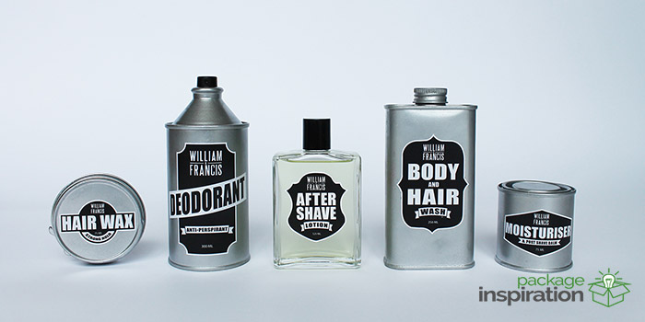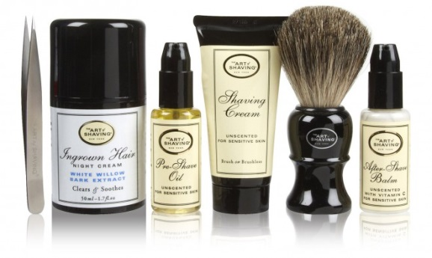
Using symbols rather than imagination:
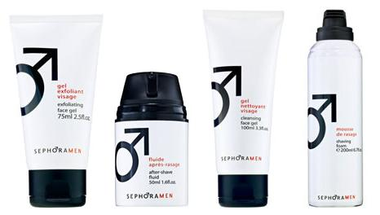
Dove, Clinique, #7 – big brand entries. Safe, predictable and probably fairly effective. Nothing that demands attention on-shelf.
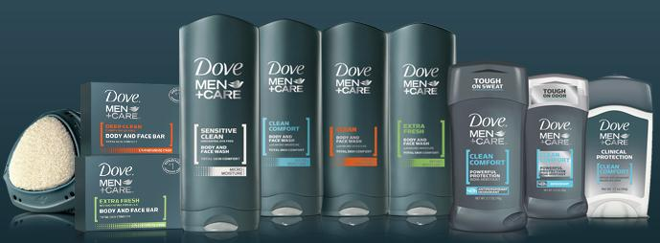
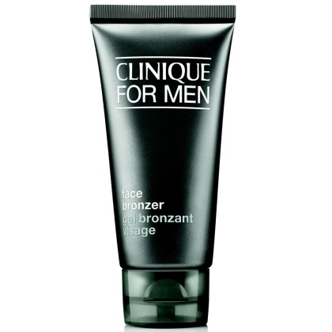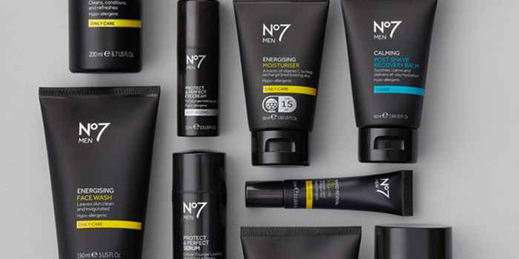

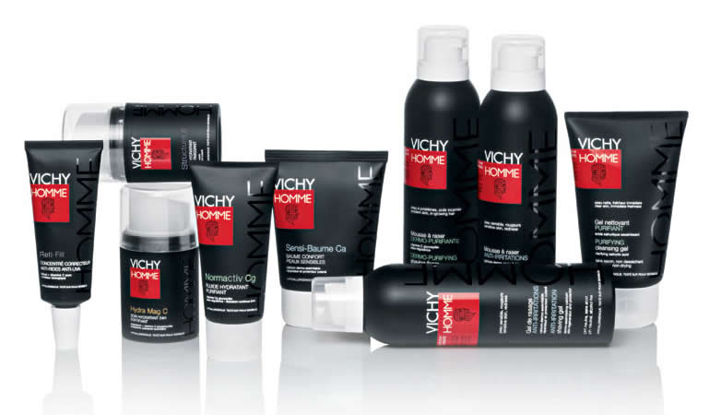
Other safe concepts using dark executions:
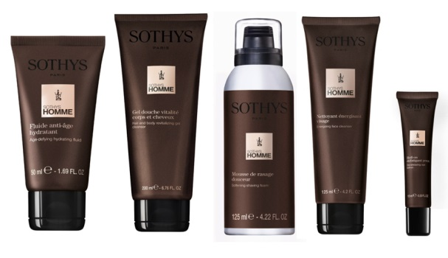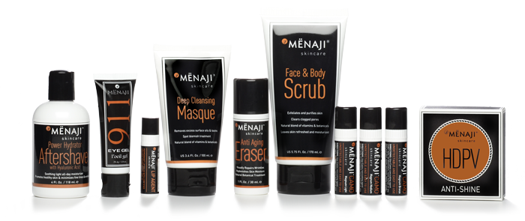
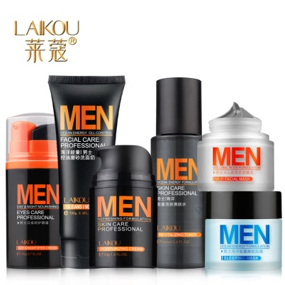
Brands with a bit of color, differentiation:
