- Foundation bottle and also a box (like NARS below)
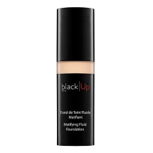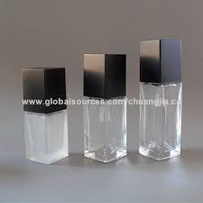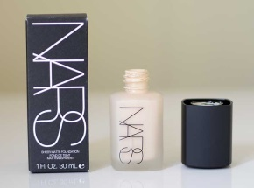
Additional Copy for lower on bottle:
Anti-Acne Facial Cover
For Guys
30 ML e 1 FL OZ

- Concealer bottle only (no box), either shape below is fine
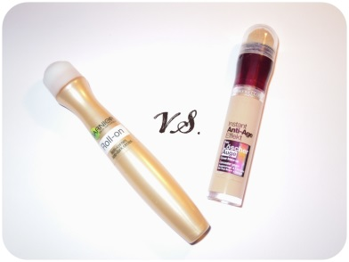
Additional Copy for lower down:
Anti-Acne Spot Concealer
For Guys
- Cleanser bottle only – pretty much what you already did
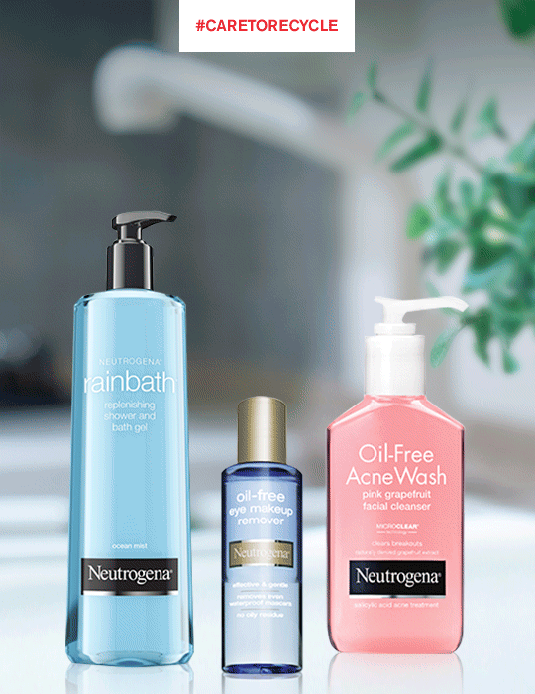
Additional Copy for lower down:
Acne Control Facial Cleanser
For Guys
200 ML e 6.6 FL OZ
- Square Compact only
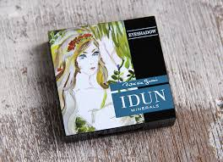
Additional Copy:
Facial Powder
- Round Compact and also the look of a box with logo that it could fit in:
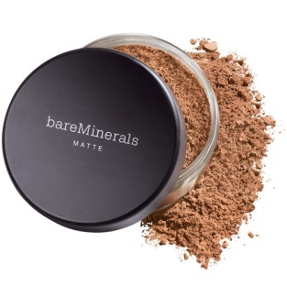
Additional Copy:
Loose Facial Powder

