- Foundation and Concealer:
- We would like you to do these packages with all black packaging (white text for the logo) and the shape you used for both foundation and concealer last time are fine.
- We would like the left to right logo, not the up and down.
- We would like something like what I am showing below in that we need a clear, undecorated area at the bottom that shows the color of the product. On the one below, you can see that the silver decoration ends near the bottom so the product is visible. The product below is not for bottle shape.
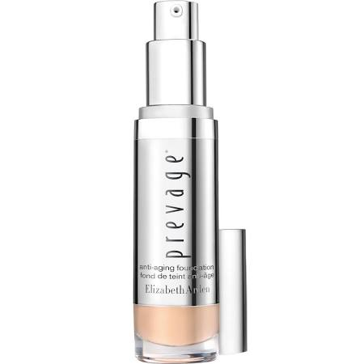
- Cleanser:
- We would like to see the same bottle shape as you had for the black version you have (with the pump) already done, but with a transparent bottle showing a light green product on the inside.

- Mascara:
a. We would like the logo to wrap around the bottle neck like IDUN Minerals does here.
- We then want the product name and descriptor to run up and down the barrel like it does here. We trust you to choose a clean looking font that works with our logo.
  - Our product name is: Bitchin’ Betty (larger type)
  - Our descriptor is: Instant Max Volume Mascara (smaller type)
  - The final thing we would like to see is camouflage deco on the cap. We can leave it up to your creativity as to what that could be. Maybe just straight camouflage and maybe something else.
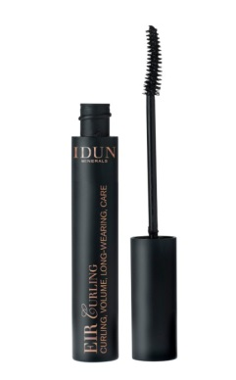
- Loose powder: what you did looks great. Thank you.

- Pressed Powder:

  - We would like to see a straight version just like the loose powder. Pretty much what you did except without the pattern on the side.
  - We would also like to see it like the jar you did in the earlier submission with the camouflage pattern surrounding a black box in which there is the logo. The jar to the far right.
  - 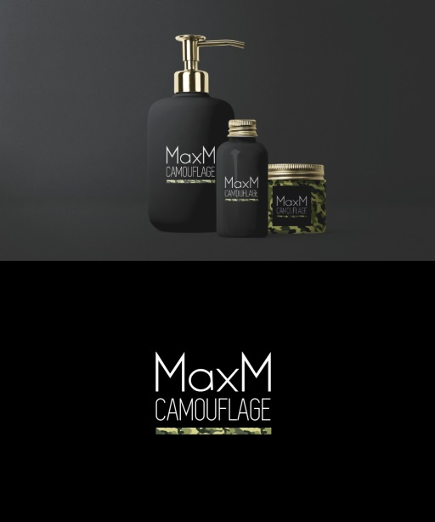

- One more thing: could we see the logo placed on a black tube.

