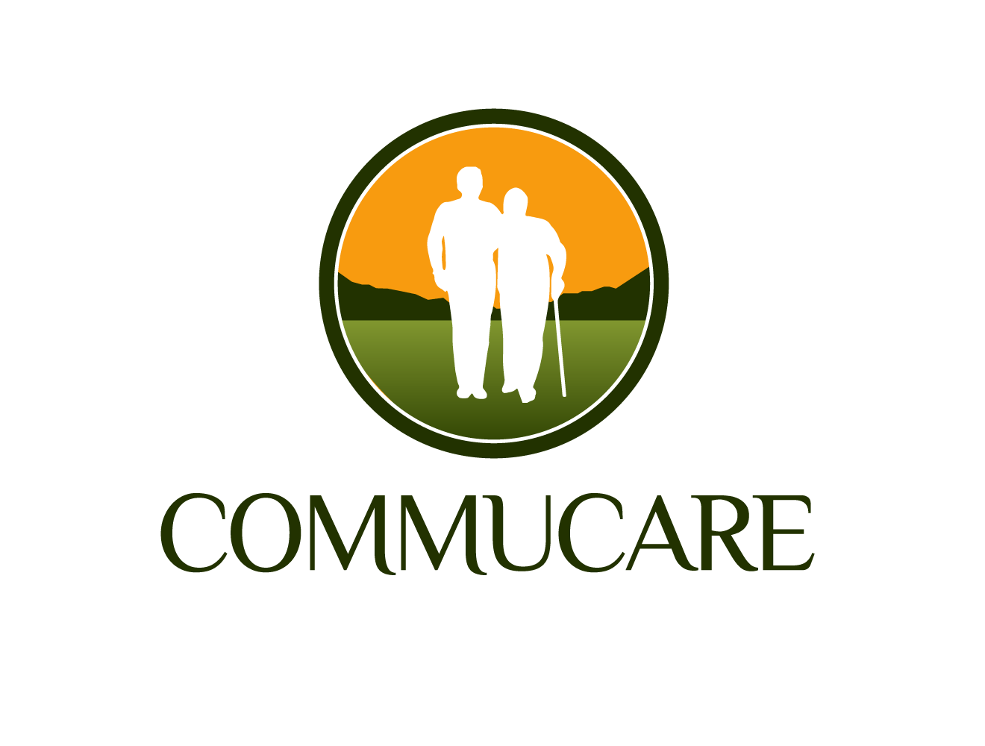

- Home
- Assisted Living
- Skilled Nursing
- Independent Living
- Home and Community Based Services
- Respite Care
- Rehabilitation
- SAIDO Learning
Center
- SAIDO Learning®

STAY HOME
Commucare offers home and Community Based Services for adults who wish to continue to live independently in the comfort of their communities.

We provide on site services and deliver high quality healthcare at your door. Our experienced physicians coordinate care with our certified nurse practitioners and provide chronic care management, physical therapy, rehabilitation and medications management.

Services

Comprehensive primary care services
Coordination of speciality care
Chronic disease management such as COPD, Asthma, Diabetes mellitus, Heart disease like congestive heart failure, Alzheimer’s dementia, etc…
Transitional Care
Skilled nursing visits for wound care, catheter care, ostomy
Social services assessment
Home health assistance
Physical therapy
Mental health
Dental health
Transportation

Sites of operations

Quiet Waters

